Hanover Terrace – Noise Report
LC-12-0047-RP1_REV A / April 2013


LANSETT CONSULTING

Project Sheet

Issue

Issue | Date | Status | Changes | Author | Approved
REV A | 30/04/2013 | Draft | N/A | A.E MIOA | A.E/F.S
 |  |  |  | 
This report has been prepared by Lansett Consulting Ltd with all reasonable skill, care and diligence, and taking account of the resources devoted to it by agreement with the client. Information reported herein is based on the interpretation of data collected and has been accepted in good faith as being accurate and valid. This report is for the exclusive use of the client named above; no warranties or guarantees are expressed or should be inferred by any third parties. This report may not be relied upon by other parties without written consent from Lansett Consulting Limited. Lansett Consulting Ltd disclaims any responsibility to the client and others in respect of any matters outside the agreed scope of work.


Lansett Consulting Limited (www.lansettconsulting.co.uk) Registered in England and Wales (Reg No. 06567451)
Registered office : Thames Innovation Centre, 2 Veridon Way, Erith. DA8 1AE
York Street W1 London: 02071835481 | Erith Kent: 08458621547 | Sheffield: 01143030359

TABLE OF CONTENTS
EXECUTIVE SUMMARY 4
1. INTRODUCTION 5
2. GUIDANCE AND METHODOLOGY 6
3. NOISE SURVEY RESULT 9
4. PLANT INFORMATION AND APPLICABLE NOISE CRITERIA 10
4.1 ENVIRONMENTAL NOISE CRITERIA 10
5. DISCUSSION 11
6. CONCLUSION 12
FIGURE 1 & 2: SITE LOCATION AND LAYOUT PLAN 13
APPENDIX 1: NOISE SURVEY RESULT 16
APPENDIX 2: GLOSSARY AND ACOUSTIC TERMINOLOGY 20

EXECUTIVE SUMMARY
Lansett Consulting was commissioned by Crofton Design to undertake a noise impact assessment in support of the proposed planning application submission for the refurbishment of the residential property at 18 Hanover Terrace, London.

This is a revised version of the original report which was produced on the 5th October 2012 due to the change in the proposed location of plants.

Relevant guidelines and standards have been considered, including British Standard BS4142: 1997, Method for Rating Industrial Noise affecting Mixed Residential and Industrial Areas; British Standard BS8233: 1999, Sound Insulation and Noise Reduction for Buildings - Code of Practice, and World Health Organisation (WHO) ‘Guidelines for Community Noise’,

Noise from the proposed plants is predicted to comply with City of Westminster Council criteria applicable to new items of plants and fixed installations and as a result is unlikely to lead to complaints at closest residential receptor (19 Hanover Terrace) and other residential properties bordering the application site.

.

INTRODUCTION

  - CONTEXT
Lansett Consulting Limited was commissioned by Crofton Design to undertake a noise impact assessment in support of the proposed planning application submission for the site at 18 Hanover Place London.

The proposal is for the refurbishment of the existing residential property which will include the installation of new items of plants. Noise Assessment Report dated 5th October 2012 (LC-12-0047- RP1) was submitted to Westminster Council as part of the planning application, however the council has requested that the proposed locations of the plants be changed from the roof to the external areas of the lower ground floor. Consequently, this report takes into account the impact of the proposed plants at the new location recommended by the council.

The noise climate at the site is dominated by road traffic noise emanating from the Outer Circular (which is dominant) and the surrounding road network.

This report will use appropriate guidance to assess existing noise in the area surrounding the application site and likely impact from the proposed items of plants. In particular, the assessment methodology that has been applied and reported in this document considers the guidance detailed in National Planning Policy Framework (March 2012), and British Standard BS4142: 1997, Method for Rating Industrial Noise affecting Mixed Residential and Industrial Areas.

  - SITE DESCRIPTION
The site is bounded to the north and east by Outer Circular, boating lake and mixed use properties beyond; and to the south and west by residential properties on Hanover Terrace and Hanover Terrace Mews.

Figure 1 shows the proposed development site

GUIDANCE AND METHODOLOGY
National Planning Policy Guidance published in March 2012 sets out the Government’s policies on noise related planning issues. Paragraph 109 and 123 states as follows;

109. The planning system should contribute to and enhance the natural and local environment by preventing both new and existing development from contributing to or being put at unacceptable risk from, or being adversely affected by unacceptable levels of noise pollution; and,

123. Planning policies and decisions should aim to:

- avoid noise from giving rise to significant adverse impacts on health and quality of life as a result of new development;
- mitigate and reduce to a minimum other adverse impacts on health and quality of life arising from noise from new development, including through the use of conditions;
- recognise that development will often create some noise and existing businesses wanting to develop in continuance of their business should not have unreasonable restrictions put on them because of changes in nearby land uses since they were established; and,
- Identify and protect areas of tranquillity which have remained relatively undisturbed by noise and are prized for their recreational and amenity value for this reason.

Reference is made to well established and recognized national standards and guidelines as well as any relevant local authority guidance, standards or policies including;

- British Standard BS4142: 1997, Method for Rating Industrial Noise affecting Mixed Residential and Industrial Areas.

- British Standard BS8233: 1999, Sound Insulation and Noise Reduction for Buildings - Code of Practice which provides general guidance on acceptable noise levels within buildings; and,

- World Health Organisation (WHO) ‘Guidelines for Community Noise’.

British Standard BS4142: 1997, Method For Rating Industrial Noise Affecting Mixed Residential And Industrial Areas

BS4142 is intended to be used for assessment of whether noise from factories, industrial premises or fixed installations and sources of an industrial nature in commercial premises is likely to give rise to complaints from people residing in nearby dwellings. The Standard states that:

‘It (BS4142) may be found helpful in certain aspects of environmental planning and may be used in conjunction with recommendations on noise levels and methods of measurement published elsewhere.’

The procedure contained in BS4142 for assessing the likelihood of complaints is to compare the measured or predicted noise level from the source in question, the ‘specific noise level’, at the assessment position with the background noise level. Where the noise contains a ‘distinguishable, discreet, continuous note (whine, hiss, screech, hum etc.) or if there are distinct impulses in the noise (bangs, clicks, clatters or humps), or if the noise is irregular enough to attract attention’ then a correction of 5 dB is added to the specific noise level to obtain the ‘rating level’. British Standard, BS7445: Part 2: 1991: Description and measurement of environmental noise - Guide to the acquisition of data pertinent to land use contains a more objective method of assessing whether a sound is tonal. It states:

‘In some practical cases, a prominent tonal component may be detected in one-third octave spectra if the level of a one-third octave band exceeds the level of the adjacent bands by 5dB or more.’
To assess the likelihood of complaints, the measured background noise level is subtracted from the rating noise level. BS4142 states:

‘A difference of around 10 dB or higher indicates that complaints are likely. A difference of around 5 dB is of marginal significance. At a difference below 5 dB, the lower the value the less likelihood there is that the complaints will occur. A difference of -10 dB is a positive indication that complaints are unlikely.’

However, in addressing the potential for noise intrusion the standard also states that:

‘For the purposes of this standard, background noise levels below about 30 dB and rating levels below about 35 dB are considered to be very low.’.

British Standard BS 8233:1999 – Sound Insulation and Noise Reduction for Buildings – Code of Practice

The scope of BS8233 is the provision of recommendations for the control of noise in and around buildings. It suggests appropriate criteria and limits for different situations, which are primarily intended to guide the design of new or refurbished buildings undergoing a change of use rather than to assess the effect of changes in the external noise climate.

BS8233 suggests suitable internal noise levels within different types of buildings, including residential dwellings. It suggests that an internal noise level of 30dBL_{Aeq,T} within bedrooms is a ‘good’ standard, whilst 35dBL_{Aeq,T} is a ‘reasonable’ standard. For living areas in the daytime, the standard recommends 30dBL_{Aeq,T} as a good standard and 40dBL_{Aeq,T} as being a reasonable standard. BS8223 also states that individual noise events should not exceed 45dBL_{AFmax} in bedrooms at night.

The design range of indoor ambient noise levels in spaces when they are unoccupied are given as:

- Reasonable speech or telephone communications, for such room-spaces as kitchens, corridors and wash-rooms is 45 – 55dBL_{Aeq,T} dB.

World Health Organisation (WHO) ‘Guidelines for Community Noise’

This document states that, in dwellings, the critical effects of noise are on sleep, annoyance and speech interference. According to this document, to protect the majority of people from being seriously annoyed during the daytime, the sound pressure level on balconies, terraces and outdoor living areas should not exceed 55 dB L_{Aeq} for a steady, continuous noise.

To protect the majority of people from being moderately annoyed during the daytime, the outdoor sound pressure level should not exceed 50dBL_{Aeq}. To avoid any possibility of sleep disturbance, indoor guideline values for bedrooms are 30dBL_{Aeq} for continuous noise and 45dBL_{Amax} for single sound events. These indoor noise levels correspond to sound pressure levels at the outside façades of the living spaces of 45dB L_{Aeq} and 60dB L_{Amax}. These values have been obtained by assuming that the noise reduction from outside to inside with the window partly open is 15 dB.
City of Westminster
Policy ENV 7 (Controlling Noise from Plant, Machinery and Internal Activity) of City of Westminster Unitary Development Plan (adopted 24th January 2007) states that where development is proposed, the City Council will require the applicant to demonstrate that this will be designed and operated so that any noise emitted by plant and machinery and from internal activities, including noise from amplified or unamplified music and human voices, will achieve the following standards in relation to the existing external noise level at the nearest noise sensitive properties, at the quietest time during which the plant operates or when there is internal activity at the development.

1. where the existing external noise level exceeds WHO Guideline levels of LAeq,12hrs 55dB daytime (07.00 – 19.00); LAeq,4hrs 50dB evening (19.00 – 23.00); LAeq,8hrs 45dB night-time (23.00 – 07.00):

either

a) and where noise from the proposed development will not contain tones or be Intermittent sufficient to attract attention, the maximum emission level (L_{Aeq15min}) should not exceed 10db below the minimum external background noise at the nearest noise sensitive properties. The background noise level should be expressed in terms of L_{A90,15min}.

Or

b) and where noise emitted from the proposed development will contain tones, or will be intermittent sufficient to attract attention, the maximum emission level (L_{Aeq15min}) should not exceed 15dB below the minimum external background noise at the nearest noise sensitive properties. The background noise level should be expressed in terms of L_{A90,15mins}.

2. where the external background noise level does not exceed the above WHO guideline levels, policy ENV 7(A)(1)(a) and (b) will apply except where the applicant is able to demonstrate to the city Council that the application of slightly reduced criteria of no more than 5dB will provide sufficient protection to noise sensitive properties.

Further consultation was held with Rebecca St Rose of City of Westminster Environmental Health Consultation Team on the suitability of measured background noise data collected in August 2012 in determining the impact of proposed plants at the proposed new location.

NOISE SURVEY RESULT
Prevalent noise levels on the site were measured on the 30th and 31st of August 2012. The monitoring positions are presented on Figure 1. The climatic condition during the survey was warm and dry with light winds (< 2m/s). Conditions were therefore considered suitable for environmental noise measurement.

Sound pressure levels were recorded at the monitoring locations to determine the equivalent continuous sound level, L_{Aeq}, the maximum noise level, and the percentile L_{A90} background noise level.

Noise measurements were made with a calibrated precision grade sound level meter which achieves the requirements of BS EN 61672:2003. The survey was carried out in accordance with the principles of BS 7445: Part 1 (2003) & Part 2-3 (1991), ‘Description and Measurement of Environmental Noise’, and BS 4142:1997.

The continuous monitoring location MP1 was located on the roof of the proposed development site as detailed in the original report and has been considered suitable for use as part of this assessment by Westminster Council Environmental Health Department. The microphone was in a free-field location and at a height of 1.5 m above the roof floor area.

Table 1: Mean measured noise level at MP1 (30th and 31ST August 2012)
Period | L_{Aeq} | L_{AMax} | L_{A10} | L_{A90}
Daytime (0700 – 2300hrs) | 49.0 | 77.0 | 48.0 | 44.0
Night-time (2300 – 0700hrs) | 44.0 | 68.0 | 42.0 | 42.0

PLANT INFORMATION AND APPLICABLE NOISE CRITERIA
Two (2x) Daikin mini VRV (RXYSQ-P8) external condensers are proposed at the site. Noise data provided by the manufacturer for individual unit at a distance of 1metre is detailed in Table 2 below.
TABLE 2: WORST CASE PLANT NOISE LEVEL MP2
OCTAVE BAND  (Hz) | 63 | 125 | 250 | 500 | 1000 | 2000 | 4000 | 8000 | dB(A)
Noise Level | 62 | 55 | 54 | 52 | 48 | 42 | 35 | 28 | 53

It can be inferred from Table 2 above that noise from the proposed condensers is likely to be tonal in nature as the level of a one-third octave band exceeds the level of the adjacent bands by 5dB or more. Consequently, applicable local authority criteria for items of plants likely to emit noise with tonal contents will be taken into consideration as part of this assessment.

  - ENVIRONMENTAL NOISE CRITERIA
City of Westminster Council noise limit applicable to the proposal requires that the maximum emission level (L_{Aeq15min}) should not exceed 15dB below the minimum external background noise at the nearest noise sensitive properties.

The closest residential receptors to the proposed location of the condenser units are external windows of 19 Hanover Terrace which are located approximately 3m sideways to the proposed location of the air conditioning units. It should be noted that the building and existing boundary wall will provide a barrier effect which will be taken into consideration as part of this assessment.

To ensure compliance to City of Westminster criteria, it is recommended that plant noise at the nearest residential property should meet the noise limits detailed in Table 3 below. The proposed plants will operate during the day and night-time.

Table 3: APPLICABLE NOISE CRITERIA
Period | Recommended Plant Noise Level At Worst Affected Receptors ( L_{Aeq} dB)
Daytime (0700 – 2259hrs) | 29
Night-time (2300 – 0659hrs) | 27

DISCUSSION
Noise levels generated by mechanical plant and experienced by local receptors depends upon a number of variables, the most significant of which are considered to be as follows:

- Noise generated by plant or equipment used on site, generally expressed as sound power levels (SWL);
- Distance between the noise source and the receptor;
- Attenuation due to ground absorption, atmospheric and barrier effects; and
- Periods of operation of the plant on the site, known as its “on-time”.

The predicted plant noise level at the noise sensitive receptor is detailed in Table 4. It should be noted that the assumed attenuation and the distance between the plant locations and the nearest residential receptor (19 Hanover Terrace) are approximates.

TABLE 4: PREDICTED PLANT NOISE LEVEL AT CLOSEST RECEPTOR
OCTAVE BAND  (Hz) | 63 | 125 | 250 | 500 | 1000 | 2000 | 4000 | 8000 | dB(A)
Noise Level | 65.0 | 58.0 | 57.0 | 55.0 | 51.0 | 45.0 | 38.0 | 31.0 | 56.0
Distance Attenuation | -9.0 | -9.0 | -9.0 | -9.0 | -9.0 | -9.0 | -9.0 | -9.0
Enclosure Attenuation | -14.0 | -16.0 | -23.0 | -30.0 | -37.0 | -38.0 | -39.0 | -39.0
Building Barrier Effect | -5.0 | -5.0 | -5.0 | -5.0 | -5.0 | -5.0 | -5.0 | -5.0
Receptor Level | 37.0 | 28.0 | 20.0 | 11.0 | 0.0 | 0.0 | 0.0 | 0.0 | 17.0

Noise level specifically attributable to the condenser units will comply with the recommended external noise criteria during the day and night-time of -15dB below the prevalent background noise level specified by City of Westminster Council at the external windows of 19 Hanover Terrace which are considered to be the closest receptors.

Resultant internal noise level i.e. based on predicted noise emissions from the condenser units, at the nearest sensitive receptor could be around 7dB(A) during the day and night-time (these values has been obtained by assuming that the noise reduction from outside to inside with the window partly open is 10dB).

This complies with the internal noise criteria recommended in British Standard BS 8233: 1999 ‘Sound Insulation and Noise Reduction for Buildings - Code of Practice’ and the World Health Organisation (WHO) guideline.

Nevertheless, control of noise from proposed plants will be driven by the need to minimise resultant impact within the application site (No 18 Hanover Terrace). Plant noise level is predicted to be no more than 25dB(A) at the external areas of 18 Hanover Terrace ensuring compliance to Westminster Criteria.

CONCLUSION
Noise survey and assessment has been carried out to determine the likely impact of condenser units proposed as part of the refurbishment of 19 Hanover Terrace London . Throughout, the assessment has been undertaken with reference to relevant British Standards and national guidance on noise impacts.

Noise from the proposed condenser units is predicted to comply with City of Westminster criteria thereby ensuring that the proposal is unlikely to lead to complaints from occupants of surrounding residential properties.

FIGURE 1 & 2: SITE LOCATION AND LAYOUT PLAN

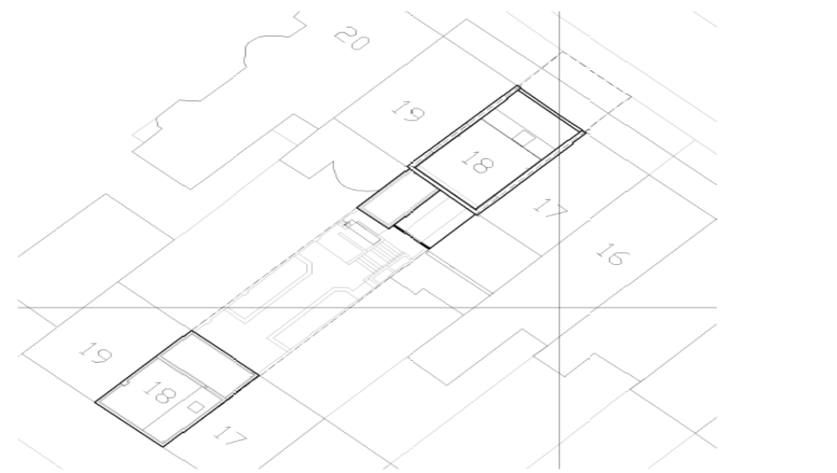
MP1 ROOF

 | Hanover Terrace | LC-12-0047-RP1_REVA
 | Hanover Terrace | Figure No 1

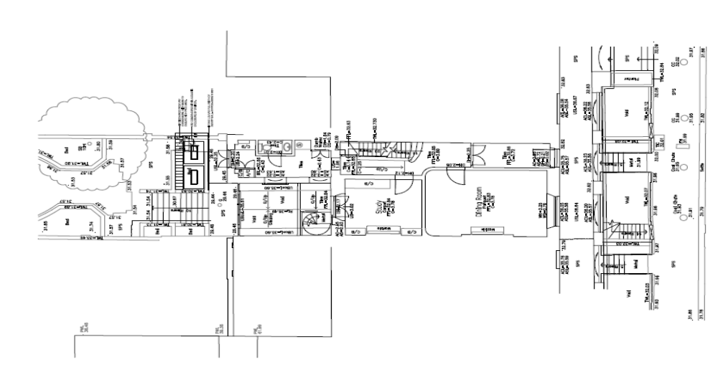

 | Hanover Terrace | LC-12-0047-RP1_REVA
 | Hanover Terrace | Figure No 2

APPENDIX 1: NOISE SURVEY RESULT
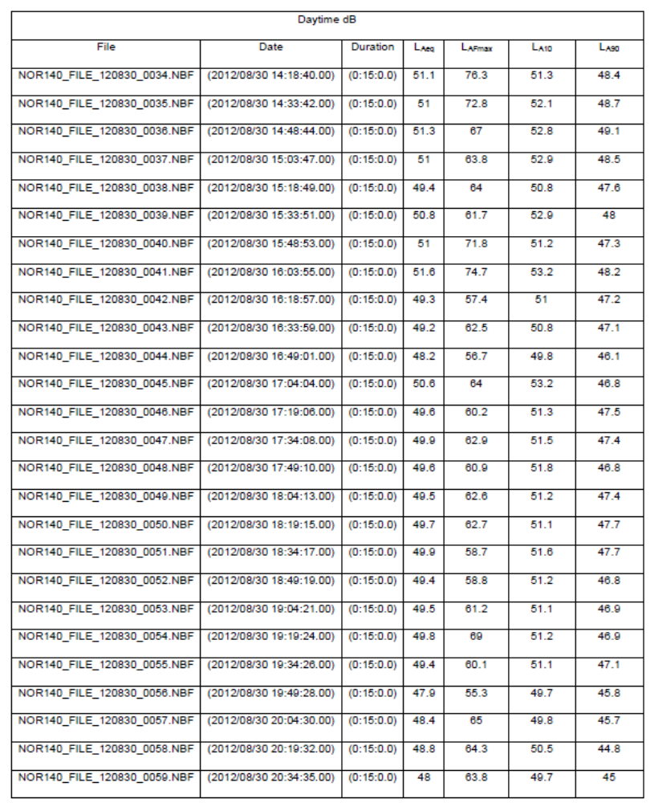

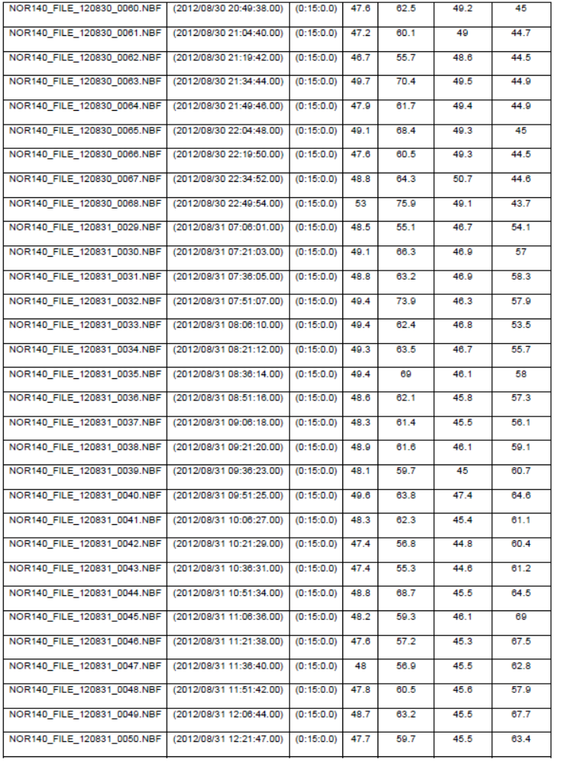

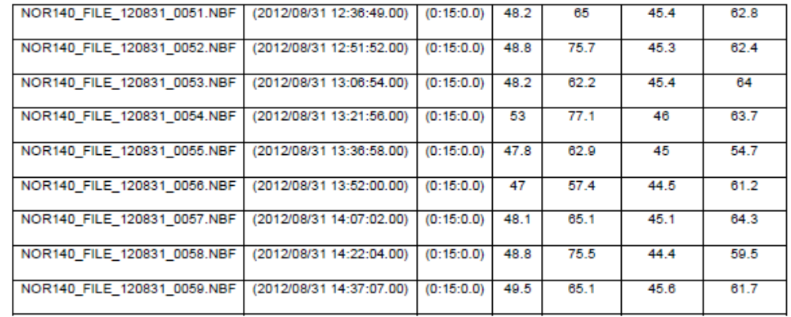

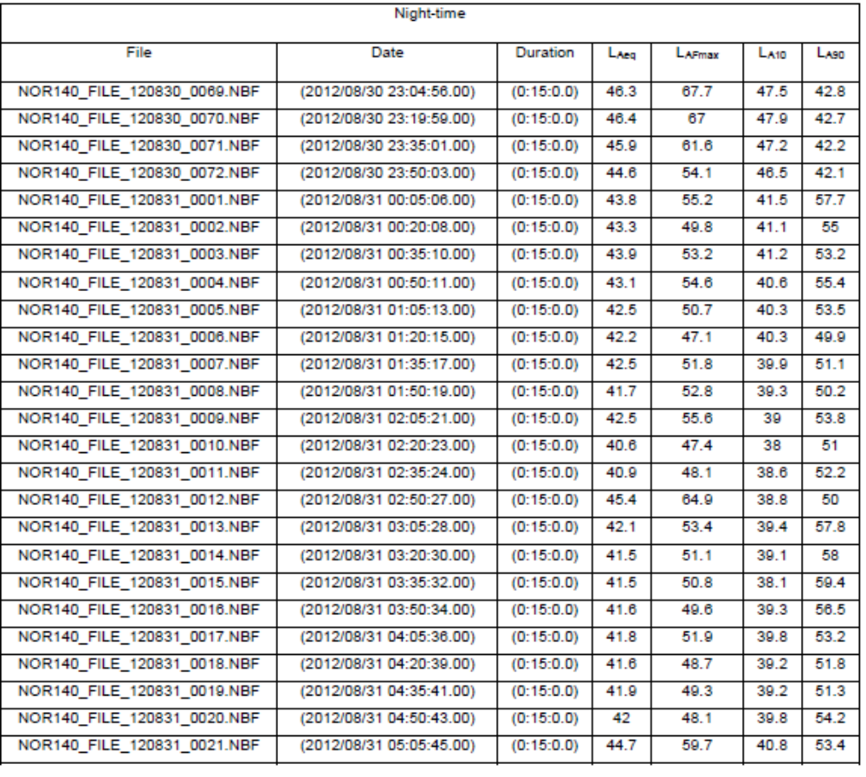

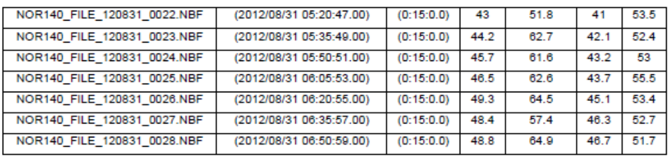

APPENDIX 2: GLOSSARY AND ACOUSTIC TERMINOLOGY
Noise is defined as unwanted sound. The human ear responds to sound over the frequency range of about 20 Hz to 20 kHz and over the audible range of 0 dB (the threshold of perception) to 140 dB (the threshold of pain). The ear does not respond equally to different frequencies of the same magnitude and is more responsive to mid-frequencies than to lower or higher frequencies.

To quantify noise in a manner that approximates to the response of the human ear, a weighting mechanism is used. This reduces the importance of lower and higher frequencies, in a similar manner to the human ear. The most widely used weighting mechanism that corresponds to the response of the human ear is the A-weighting scale. This is widely used for environmental noise measurement, and the levels are denoted as dB(A) or L_{Aeq}, L_{A90}, etc., according to the parameter being measured.

The decibel scale is logarithmic rather than linear and hence a 3 dB increase in sound level represents a doubling of the sound energy present. Judgement of sound is subjective, but as a general guide a 10 dB(A) increase can be taken to represent a doubling of loudness, whilst an increase in the order of 3 dB(A) of a steady source is generally regarded as the minimum difference needed to perceive a change.

Since environmental noise usually varies continuously from second to second it is impractical to specify the sound level of each second. As such human response has been related to various indices, which allow for the fluctuating nature of sound. These indices include;

L_{Aeq, T} - The A-weighted equivalent continuous sound pressure level. A representation of a continuous sound level containing the same amount of sound energy as the measured varying noise over the measurement period, t.
L_{A90, T} - The A-weighed sound pressure level that is exceeded for 90% of the measurement period, t. This is commonly used as the ‘Background Noise Level’ for assessing the effects of industrial noise in the UK.
L_{A10, T} - The A-weighted sound pressure level that is exceeded for 10% of the measurement period, t. This is commonly used in the UK for describing traffic noise levels.
L_{Amax} - The highest A-weighted noise level recorded during a noise measurement period.
Common Sounds on the dB(A) Scale

dB(A) | Description
140 | Threshold of pain
120 | Jet take off at 50 metres
100 | Maximum noise levels on an underground platform
80 | Kerbside of a busy urban street
60 | Busy general office
40 | Residential area at night
20 | Background in a TV and recording studio
0 | Threshold of hearing

