Lansett Consulting
Final Report - Transport Assessment

Riversdale Primary School 302A Merton Road London SW18 5JP (REF: LC-12-0079-RP1)

October 2012
Written by: FS
Reviewed by: AE
LC-12-0079-RP1

Project Sheet

Issue

Issue | Date | Status | Changes | Author | Approved
0001 | 17-09-2012 | Draft | N/A | FS | AE
This report has been prepared by Lansett Consulting Ltd with all reasonable skill, care and diligence, and taking account of the resources devoted to it by agreement with the client. Information reported herein is based on the interpretation of data collected and has been accepted in good faith as being accurate and valid. This report is for the exclusive use of the client named above; no warranties or guarantees are expressed or should be inferred by any third parties. This report may not be relied upon by other parties without written consent from Lansett Consulting Limited. Lansett Consulting Ltd disclaims any responsibility to the client and others in respect of any matters outside the agreed scope of work.

Lansett Consulting Limited (www.lansettconsulting.co.uk) Registered in England and Wales (Reg No. 06567451)
2nd Floor Thames Innovation Centre, 2 Veridon Way, Erith. Kent, DA18 4AL. United Kingdom.
Tel: +44 (0) 208 3201296 Fax: +44 (0) 208 3201011

Table of Contents
1. INTRODUCTION 6
1.1 Introduction 6
1.2 Scope 6
2 POLICY FRAMEWORK 7
2.1 Introduction 7
2.2 Local Development Framework – Adopted Development Management Policies 7
2.2.1 Policy DMT1 – Transport Impacts of Development 7
2.2.2 Policy DMT2 - Parking and Servicing 7
2.3 Local Plan Policy Compliance 9
2.4 Consultation Draft Replacement London Plan – The Spatial Development Strategy for Greater London 9
2.4.1 Policy 1.1 9
2.4.2 Policy 6.3 9
2.4.3 Policy 6.7 10
2.4.4 Policy 6.9 10
2.4.5 Policy 6.10 10
2.4.6 Policy 6.13 10
2.5 National Planning Guidance 10
3 SITE LOCATION AND CONTEXT 11
3.1 Site Location and Context 11
3.2 Existing Site Conditions 12
3.3 Existing Site Infrastructures 12
3.3.1 A218-Merton Road 12
3.3.2 Replingham Road 13
3.3.3 Vehicle Access 13
3.3.4 Car Parking 14
3.3.5 Servicing 14
3.4 Road Safety – Review of Accident Data 14
3.4.1 Standen Road/Merton Road-A218 priority junction and Replingham Road/Merton Road Signal junction 15
3.5 Traffic Counts 16
3.5.1 Conversion of Vehicles to Passenger Car Units - PCU 16
3.5.2 Standen Road/A218 Merton Road Priority Junction 16
3.5.3 Replingham Road/A218 Merton Road Signal Junction 17
4 PROPOSED DEVELOPMENT 18
4.1 Introduction 18
4.2 Background 18
4.3 Accessibility 19
4.3.1 Vehicular Access 19
4.3.2 Pedestrians 19
4.3.3 Cycling 19
4.3.4 Public Transport 19
5 PARKING AND SERVICING 19
5.1 Introduction 19
5.2 Servicing 19
5.3 Car Parking 20
6 SUSTAINABLE TRANSPORT 20
6.1 Introduction 20
6.2 School Travel Plan Framework 21
6.3 Walking and Cycling 21
6.3.1 Walking 21
6.3.2 Cycling 22
6.4 Public Transport Access 23
6.4.1 Bus 23
6.4.2 Rail 23
7 TRAFFIC GENERATION AND IMPACT 24
7.1 Introduction 24
7.2 Need for a Transport Assessment 24
7.3 Modal Split 25
7.4 Trip Generation 26
7.4.1 Arrivals and Departures 26
7.5 Trip Distribution and Assignment 27
7.6 Modelling Analysis 27
7.6.1 Assessment Years 27
7.6.2 Growth Rates 27
7.6.3 Modelling Software 28
7.6.4 Junction Assessment 28
Site 1 – Operational Assessment of the A218 – Merton Road / Replingham Road Signal Junction 29
Site 2 – Operational Assessment of the A218 – Merton Road / Standen Road Priority Junction 31
8 SUMMARY AND CONCLUSION 33
APPENDIX A - SITE LAYOUT PLAN 34
APPENDIX B - ACCIDENTS DATA 37
APPENDIX C - TRAFFIC COUNTS DETAILS 43
APPENDIX D - LINSIG OUTPUTS 49
APPENDIX E - PICARDY OUTPUTS 76
APPENDIX F – BUS TIMETABLE 112

1 INTRODUCTION

Introduction
Lansett Consulting Limited was commissioned by London Borough of Wandsworth to prepare a Transport assessment to determine and analyse the transport implications arising from the expansion of Riversdale Primary School at 302A Merton Road London SW18 5JP.

A full transport assessment is required as part of the planning application submission for the school expansion.

The proposal is to expand a section of the Primary School in order to increase the school capacity by 150 pupils. The primary school will cater for approximately 360 students comprising of 3 – 11 year olds.

This report details the full transport assessment of the proposal and has been carried out in accordance to local and national policies and guidance.

Scope
A pre application discussion was made with London Borough of Wandsworth (LBW) in September 2012 and Transport for London (TfL), for the specific purpose of clarifying issues relating to the proposals of the Transport Assessment.

Further discussions with Alex Oyebade of the LBW Highways Department confirmed that due to the anticipated impact arising from the development, Transport Assessment would provide the adequate level of assessment with further modelling of traffic impact (including junction and accident analysis) carried out to further demonstrate that likely impact will not be of significant effect on the surrounding areas.

In accordance with the requests of the Highway Authority, this report will assess and consider the existing and proposed site conditions and surrounding highway infrastructure; and also in operational terms justify the proposed level of parking provision.

The scope of the Transport Assessment has been discussed and agreed with LBW to ensure that all transport related issues are considered and proposals are in accordance with transport policy.

This report will provide support as part of the initial planning application submission for the proposed development and enable the Highway Authority, London Borough of Wandsworth, and Transport for London to assess the proposals and make an appropriate recommendation.

This report has been prepared with reference to the Guidance on Transport Assessment published by the Department for Transport in March 2007, the London Plan and the National Planning Guidance March 2012.

POLICY FRAMEWORK

Introduction
There is a range of national, regional and local policy documents that outline the transport policy framework for developments. They aim to encourage long-term sustainable development, investment in transport, and improved accessibility to non-car modes.

Local planning policy of relevance to the proposed development is detailed in the London Borough of Wandsworth Local Development Framework (LDF) - Development Management Policies Document (DMPD) adopted February 2012.

The LDF-DMPD now forms the Development Plan, alongside adopted Core Strategy for Wandsworth. Further to local policies; for transport purposes ‘National Planning Policy Framework’ represents national policy guidance.

The Greater London Authority Act 1999 (section 344) requires that Boroughs’ development plans be in ‘general conformity’ with the London Plan.

Local Development Framework – Adopted Development Management Policies
The London Borough of Wandsworth Local Development Framework – Development Management Policies forms the planning authority’s aspirations for development. Only policies of specific relevance to the proposed development will be considered within this section.

Policy DMT1 – Transport Impacts of Development
Policy DMT states that
    - Development, including changes of use, will be permitted where it does not
have a negative impact on the transport system, including public transport
capacity and the highway network.

    - Development proposals will demonstrate their effect on traffic and transport
by provision of Transport Assessments (TAs). TAs and Travel Plans may be required for smaller developments where the transport impact is expected to be significant or to affect sensitive locations.

    - Smaller scale developments that fall below the thresholds but could give rise
to transport impacts will be required to demonstrate transport impacts in a
transport statement.

    - Where developments require new or additional crossovers, it will need to be
demonstrated they would not cause a road safety hazard or interfere with the
safe operation of buses, particularly bus stops.

Policy DMT2 - Parking and Servicing
Policy DMT2 states that
Development will be permitted where:
- off-street car parking is provided subject to the maximum levels set in table 1 below and can be demonstrated that parking on site is the minimum necessary;
- cycle parking is provided in accordance with the minimum levels set out table 1 and is easily accessible to the unit it is associated with;
- The provision of off-street servicing facilities is encouraged; and
- Minimum disabled parking spaces are provided in accordance with the London Plan.

Car-free and low-car development may be permitted where:
  - the PTAL is high;
    - there is, or will be, adequate public transport capacity in the vicinityy to accommodate trips generated by the development;
- Transport Assessments demonstrate that through a combination of Car Club parking, Travel Plans and any other relevant measures that further car parking is not required; and a minimum number of disabled parking spaces are provided in accordance with the London Plan.

Table 1: Maximum Parking Standards – Policy DMT2
Use | Description | Car Spaces | Cycle Spaces | Relevant Considerations applying to appropriate levels of parking up to the maximum level
D1-Other Non-Residential Institution | Primary,Secondary School | 1 space per 10 users/visitors on site at any time (i.e. base on the maximum use at any point of the day, not the total number of users in a day) | 1 stand per 10 staff or students | Parking in non-residential  development should meet  operational needs, including  service arrangements and  commercial vehicle parking.  Additional car parking for  employees, users or visitors will  be related to:  - the nature and scale of the use;  - the extent of its likely catchment  area;  - public transport accessibility;  - alternative public parking  facilities;  - the opportunities for dual use  parking (i.e. mutually exclusive  daytime and night-time use); and  - on-street parking conditions.  Other factors that will be taken  into account include the physical  constraints of a site and the  subject to the relevant  considerations set out in this  table.  potential impact of car parking on  the street scene or adjoining  properties, particularly for  extensions, infill schemes,  conversions and change of use,  and schemes affecting the  character of a conservation area  or the setting of a listed building.  The Council may not require  off-street parking in some  circumstances, particularly in  accessible locations well served  by public transport including town  centres, in areas where public  off-street parking is available for  short-stay users, or in the case of  relatively small-scale uses serving  a mainly local catchment area.

Local Plan Policy Compliance
The Transport Assessment will establish that the proposed development does not represent an impact in transport terms and thus the policies listed above will either be complied with, or considered not applicable in terms of required mitigation.

Consultation Draft Replacement London Plan – The Spatial Development Strategy for Greater London
The draft replacement London Plan was reviewed in 2008 following the election of a new Mayor. Further to the 2008 review of the London Plan leading to formal publication of a replacement plan towards the end of 2011. Initial proposals were published in a document entitled ‘A New Plan for London’ in April 2009 – formally for consultation with the London Assembly and the GLA functional bodies (the London Development Agency, London Fire and Emergency Planning Authority, Metropolitan Police Authority and Transport for London),
The draft replacement London Plan sets out draft policies and explanatory supporting material for reasoned justification of a longer-term view of London’s development till 2031. Prior to the publication and implementation of the draft replacement Plan, the 2008 version of the London Plan will be in force and would have the legal status as part of the development plan.
The relevant policies to the development are as follows;

Policy 1.1
Policy 1.1 states that growth and change in London will be managed in order to realise the Mayor’s vision for London’s sustainable development to 2031.

Policy 6.3
Policy 6.3 states that in considering planning applications development proposals should ensure that
    - Impacts on transport capacity and the transport network, at both a corridor and local level, are fully assessed.
    - Where existing transport capacity is insufficient to allow for the travel generated by proposed developments, and no firm plans exist for an increase in capacity to cater for this, boroughs should ensure that development proposals are phased until it is known these requirements can be met, otherwise they may be refused. The cumulative impacts of development on transport requirements must be taken into account.
    - Transport assessments will be required in accordance with TfL’s Transport Assessment Best Practice Guidance for major planning applications.

Policy 6.7
The Mayor will work with TfL and boroughs to implement London wide improvements to the quality of bus, bus transit and tram services.

Policy 6.9
Policy 6.9 states that the Mayor will work with all relevant partners to bring about a significant increase in cycling in London, so that it accounts for at least 5 per cent of modal share by 2026. He will implement the central London cycle hire scheme and identify potential sites for expansion and/or additional stand alone schemes in outer London.

Policy 6.10 #
Policy 6.10 states that the Mayor will work with all relevant partners to bring about a significant increase in walking in London and ensure pedestrian environments in and around new developments emphasize the quality of the pedestrian and street space.

Policy 6.13
Policy 6.13 states that the Mayor wishes to see an appropriate balance being struck between promoting new development and preventing excessive car parking provision that can undermine cycling, walking and public transport use.

National Planning Guidance
The National Planning Policy Framework was published in March 2012 to replaced Planning Policy Guidance: Transport (PPG 13). The aim of this document is to integrate planning and transport at the national, regional, strategic and local level and to promote more sustainable transport choices. The following paragraphs of this document broadly sets out the requirements of suitable development in terms of transport implications.

34 - Plans and decisions should ensure developments that generate significant Movement are located where the need to travel will be minimised and the use of sustainable transport modes can be maximised.

35 - Plans should protect and exploit opportunities for the use of sustainable transport modes for the movement of goods or people. Therefore, developments should be located and designed where practical to

    - accommodate the efficient delivery of goods and supplies;
    - give priority to pedestrian and cycle movements, and have access to high
    - quality public transport facilities;
    - create safe and secure layouts which minimise conflicts between traffic and cyclists or pedestrians, avoiding street clutter and where appropriate establishing home zones;
    - incorporate facilities for charging plug-in and other ultra-low emission vehicles; and
    - Consider the needs of people with disabilities by all modes of transport.

SITE LOCATION AND CONTEXT

Site Location and Context
The development site is located on the edge of Merton Road – A218 and Replingham Road to the east and Pirbright Road and Replingham Road to the west. The site southern and eastern boundary is constrained by the existing road, with the remaining 2 boundaries defined by residential building to the north and Coronation gardens to the west of the site. Riversdale Primary School is located on the existing site of the development.

The development site principal environs are representative of residential streets with direct frontage access.

Figure 1 below displays the approximate boundary of the development site in its own residential context.

FIGURE 1: APPROXIMATE SITE BOUNDARY

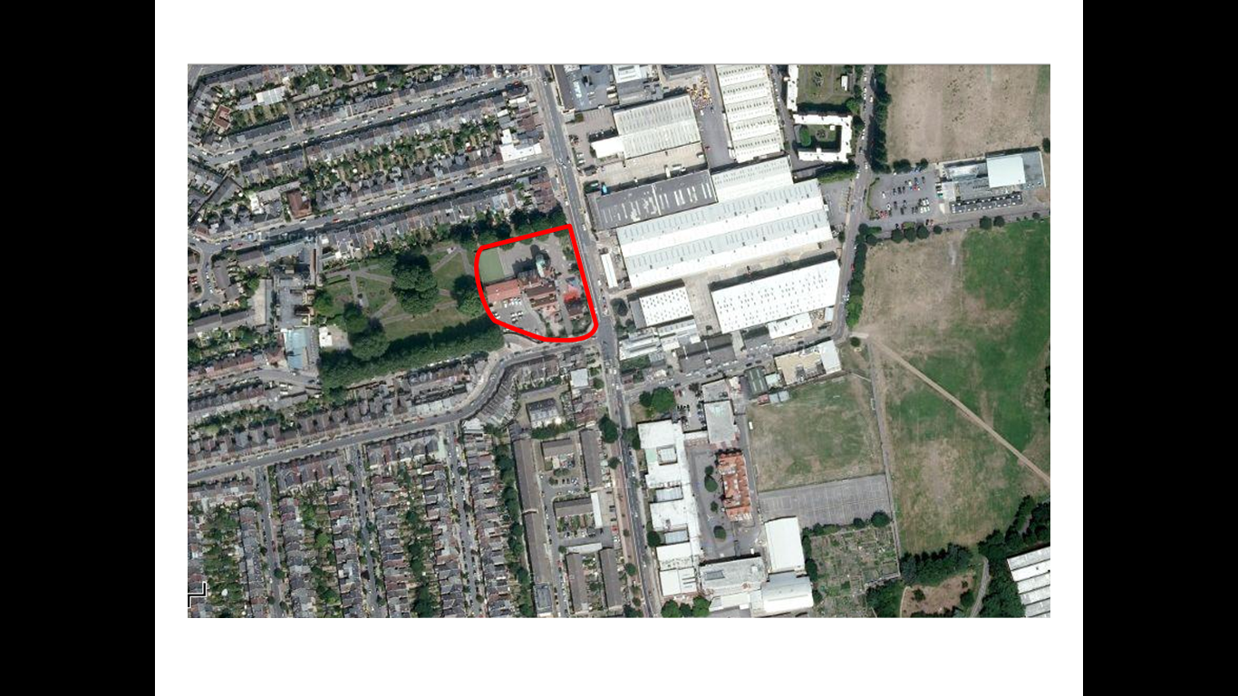

Existing Site Conditions
The school existing site is located approximately 500metres to the east of Wimbledon Park Road and adjacent the Coronation gardens. The Riversdale School sits immediately adjacent and west of the Shell Petrol Station and approximately 300metres to the south on A218- Merton Road is South fields Community College.

The school site is bordered to the south by Replingham Road and west by Coronation Gardens; to the east by the A218 – Merton Road and the north by residential buildings. Riversdale School is open between 08:00hours to 18:00hours for pupils during the term time. Morning lesson starts at 08:55hours and the final lesson end at 15:30hours for full time pupils.
The nursery pupils start time is between 08:55hours and 11:00hours (for morning only); and 13:00hours and 15:00hours (for afternoon only).

There are school activities such as breakfast club between 08:00hours and 08:55hours, sports and educational clubs between 16:30hours and 17:00hours; and after school care between 15:30hours and 18:00hours. Presently, there are 210 pupils ages 3 and 11, and 30 staff, however, it is understood that there are proposals to increase the school capacity to 360 pupils.

The facilities in the school include a large playground with a newly laid all weather playing surface, and a 10-metre swimming tank and an enclosed outdoor play area for younger children. There are also two special purpose built play area named Adrian Apparatus and Lava Land. The school catchment area is largely local mainly from Garratt Lane, Merton Road and adjoining areas, students do also come from Wandsworth, Tooting, Balham, and Thornton Heath. The school site plan is included in Appendix A.

Existing Site Infrastructures
The development site is a characteristic of a residential and commercial location there is a number of land uses and transport infrastructures in close proximity to the site. The following paragraphs describe in detail the land use and engineering profile of the surrounding streets and infrastructure that accommodate the existing site and that of the surrounding residential area.

A218-Merton Road
The A218-Merton is two-lane carriageway of approximately 11metres wide with a segregated bus lane of 3metres wide and 120meters long, forms the eastern boundary of Riversdale Primary School. Merton Road begins from the A3-Putney Road in anticlockwise and extends in south easterly direction connecting the A218 at priority junction; and extends southwards via the Granville Road/Brathway Road roundabout and at T signal junction with Replingham Road, it continues in a north- south direction connecting A218-Merton Road to A218- Durnsford Road at Ravensbury Road signal junction.

The A218-Merton Road is used by a proportion of London buses and private vehicles especially in the peak hours and there are, therefore, many bus stops along its length. In the area close to Riversdale Primary School of the carriageway, there is a bus stop along the bus lane for the northbound traffic, located approximately 70metres to the east of the development site, this stop is used every day of the week.

The southbound bus stop is located on the other side of the carriageway close to the Shell Petrol Service Station. The east and west side of the carriageway comprises mixture of land use types such as industrial, residential, and commercial.

Replingham Road
The existing development site is located on the edge of Replingham T-signal junction with A218-Merton Road. The Replingham Road is a two-way single carriageway road, approximately 6.5 metres wide and predominantly residential and commercial used mainly to provide a link between the A218-Merton Road and Wimbledon Park Road to the east.

Vehicle Access
The site is ringed with major roads A218-Merton Road, Replingham Road and Pirtbright Road. From the A218-Merton road there is a left and right turn access into Replingham Road via the signal junction. The Wimbledon Park Road is accessible from the southwest via Replingham Road. The school can also be access from the west via the Pirbright Road and at priority junction onto Replingham Road.
The A3 can be reached to the north of A218-Merton Road. The site can also be accessed from the east of Merton Road via the A217-Garratt Lane with a left turn access into Merton Lane and a right turn via the signal junction into Replingham Road opposite the development site.
This extensive network of major routes passing so close to the site means that it can easily be reached by car.
FIGURE 1: THE SITE SURROUNDING HIGHWAY NETWORK
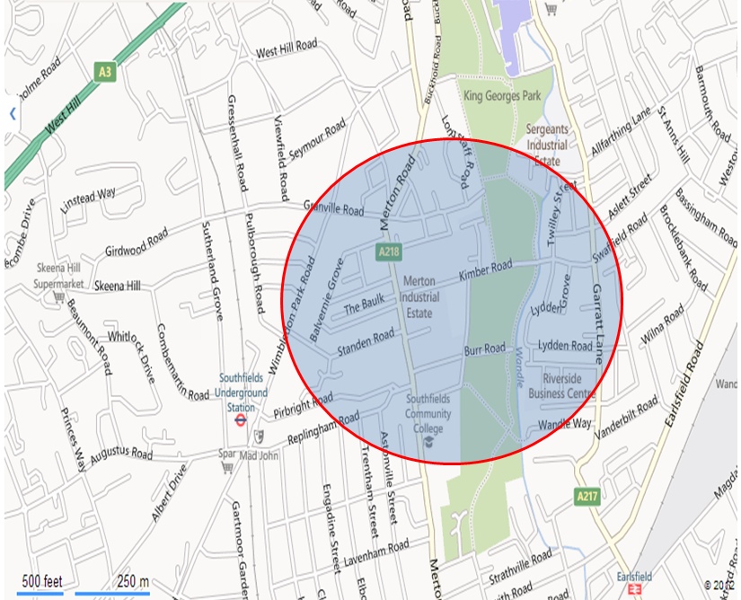

Car Parking
Riversdale Primary School car parking is currently arranged over the site using the car parking spaces to the southwest and smaller parking areas and parallel bays along the internal site access road. The school currently has a provision for 20 car parking spaces each for staff and visitors including disabled parking spaces.

Servicing
Service vehicles access existing Riversdale Primary School building from the east via the A218-Merton Road, and from the west via the Wimbledon Park Road. All deliveries – are delivered within the allocated time in the area.

Road Safety – Review of Accident Data
An analysis has been undertaken of the personal injury road traffic accidents data on the local road network in the vicinity of the site. Historic data was provided by Transport for London covering the 3-year period May 2010-May 2012. The detailed outputs and location plan are included in Appendix B.

Standen Road/Merton Road-A218 priority junction and Replingham Road/Merton Road Signal junction
The highway network examined included: - A218-Merton Road/Standen Road and A218-Merton Road/Replingham Road Signal junction. A slight injury accident was recorded on A218/Standen Road priority junction

Table 2 summarises the number of accidents by severity for each 1 year period up to May 2012 for the section including the Standen Road and A218 Merton Road priority junction

Table 2: Standen Road/A218 Merton Road Accident Summary
Severity/Months To | 12/05/2010 | 12/05/2011 | 12/05/2012 | Total | Pct
Fatal | 0 | 0 | 0 | 0 | 0.0%
Serious | 0 | 0 | 0 | 0 | 0.0%
Slight | 0 | 0 | 1 | 1 | 100%
Total | 0 | 0 | 1 | 1
Pct | 0.0% | 0.0% | 100.0%
Source: Transport for London

Table 3 summarises the number of accidents by severity for each 1 year period up to May 2012 for the section including the Replingham Road and A218 Merton Road signal junction.Two slights injuries and one serious accident were recorded on A218/Replingham Road signal junction.

Table 3: Replingham Road/A218 Merton Road Accident Summary
Severity/Months To | 12/05/2010 | 12/05/2011 | 12/05/2012 | Total | Pct
Fatal | 0 | 0 | 0 | 0 | 0.0%
Serious | 0 | 0 | 1 | 1 | 33.3%
Slight | 0 | 1 | 1 | 2 | 66.7%
Total | 0 | 1 | 2 | 3
Pct | 0.0% | 33.3% | 66.7%
Source: Transport for London

Between 05 May 2010 and 05 May 2012, all but one accident were recorded as slight with the other being serious throughout the three year period at the two junctions under consideration. None of the accidents involve pedestrians and cyclist. The cause of the accident recorded as serious was as a result of recklessness and carelessness on the part of the driver.

From table 2 and 3 above, it can be inferred that there was a low level of accidents recorded during the five year period. A detailed examination of the type and severity of personal injury accidents that occurred in the vicinity of the proposed development site concluded that there are no specific road safety issues. The type of accidents that occurred are not due to the road layout and an increase in sustainable mode of travel – walking and cycling flow to the development will not cause an increase in accidents.

Traffic Counts
A series of turning traffic counts were undertaken at the Standen Road/A218 Merton Road priority junction and Replingham Road/A218 Merton Road signal junction on Tuesday the 9th of October 2012. For the purpose of this study data collection for the morning peak was undertaken between the hours of 07:00 to 09:00 (AM Peak) and evening peak undertaken between the hours of 15:00 to 17:00 (PM Peak).

Conversion of Vehicles to Passenger Car Units - PCU
The traffic flows have been converted into passenger car units (PCU) based on the following assumptions:

    - Pedal Cycle – 0.2 PCU
    - Motor Cycle – 0.4 PCU
    - Cars and Light Goods Vehicles – 1.0 PCU
    - Medium Goods Vehicles – 1.5 PCU
    - Heavy Goods Vehicles – 2.3 PCU
    - Bus and Coaches – 2.0 PCU.

Standen Road/A218 Merton Road Priority Junction
Table 4 and 5 summarises the Standen Road/A218 Merton Road traffic counts for the AM and PM Peak.

Table 4: Standen Road/A218 Merton Road – AM Peak 07:00 To 09:00

Approach | A | B | C | Total
A - A218 – Merton Road South | 0 | 20 | 715 | 735
B - Standen Road | 29 | 0 | 56 | 85
C- A218 – Merton Road North | 363 | 26 | 0 | 389
Total | 392 | 46 | 771 | 1209

Table 5: Standen Road/A218 Merton Road – PM Peak 16:00 To 18:00

Approach | A | B | C | Total
A - A218 – Merton Road South | 0 | 18 | 580 | 598
B - Standen Road | 11 | 0 | 33 | 44
C- A218 – Merton Road North | 25 | 491 | 0 | 516
Total | 36 | 509 | 613 | 1158

Replingham Road/A218 Merton Road Signal Junction
Table 6 and 7 summarises the Replingham Road/A218 Merton Road traffic counts for the AM and PM Peak.

Table 6: Replingham Road/A218 Merton Road – AM Peak 07:00 To 09:00

Approach | A | B | C | Total
A - A218 – Merton Road South | 0 | 612 | 117 | 729
B - A218 – Merton Road North | 336 | 0 | 70 | 406
C- Replingham Road | 112 | 128 | 0 | 240
Total | 448 | 740 | 187 | 1375

Table 7: Replingham Road/A218 Merton Road – PM Peak 16:00 To 18:00

Approach | A | B | C | Total
A - A218 – Merton Road South | 0 | 489 | 131 | 620
B - A218 – Merton Road North | 408 | 0 | 117 | 525
C- Replingham Road | 127 | 115 | 0 | 242
Total | 535 | 604 | 248 | 1387

PROPOSED DEVELOPMENT

Introduction
This chapter provides a general description of the proposed development and associated transport infrastructure and examines the potential modes of travel to the site.

Background
The school currently has a capacity for 210 pupils, 30 full equivalent staff members (27 full time, 3 part time) and 5 lunchtime meal supervisors. The age range of students is between 3-11years old. The development proposal relates to the expansion of a section of the school building to increase the school student’s capacity by 150 students from 210 to 360pupils.
The ground floor is proposed as 2 reception classes, reception hall, dining hall, 2 classrooms, nursery, kitchen, and delivery areas. The 6 classrooms, staff room and kitchen, hall and reception area are proposed to be on the first floor and the mezzanine will serve as the girls and boys toilets and staircase areas. The proposal is to reduce the existing car parking spaces.

Accessibility

Vehicular Access
It is proposed that vehicular access to the development site will be taken via the existing signal junction on A218-Merton Road, Wimbledon Park Road and Pirbright Road and access directly to the site on Replingham Road opposite the development site. The proposal for the design of the vehicle access will remain unchanged – cars and delivery vehicles will access the development site via east through the Replingham Road off A218-Merton Road and via west through Wimbledon Park Road and Pirbright Road. There are no pick up / drop off facilities but there is a pay and display parking facilities on Pirbright Road for parents.

Pedestrians
For pedestrians, access to the school will be via the school main entrance on Merton Road. It is expected that this pedestrian access will remain unchanged as a result of the expansion of the school.

Cycling
It is anticipated that the development will not attract significant number of cyclist however; there is provision for extra 4 cycle stands, in addition to the existing 4 cycle stands. This level of cycle parking provision is adequate as sets out in the draft cycle parking standards in the LBW wide primary policy.

Public Transport
As the proposed development is in the same geographic area as the existing Riversdale Primary School, accessibility by public transport will be broadly as described in Chapter 6. A218-Merton Road will remain the primary area from which students and staff can access bus services. The stops on this street are within 100m walking distance to the development site. The Southfields Underground station and Earlsfield train station are within walking distances to the development site.

PARKING AND SERVICING

Introduction
The following paragraphs consider the implications for servicing and parking implications arising from the development.

Servicing
The servicing vehicles areas are designed such that, vehicles access and exit the service yard from the school main entrance on Replingham Road off A218- Merton Road. The vehicular movement associated with the service vehicles occurs within the school building therefore removing the likely issues relating to traffic, visual and acoustic of the expansion of the primary school on the A218-Merton Road and Replingham Road.

The anticipated delivery vehicles operational pattern is such that, deliveries will be delivered by a box van with 1 allocated space adjacent the new extension area, close to the school dining hall. It is expected that access for emergency services will remain unchange via the two gates on Replingham Road.

Car Parking
The development proposal is designed such that the existing 15 car parking spaces will be reduced to 9 to give way for the expansion of the school building. There will also be provision for 2 disabled parking spaces located near the entrance to the new school extension. The Pirbright Road adjacent the school currently has provision for approximately 15 pay and display car parking spaces which can be used as drop off and pick up of the school pupils.

It is anticipated that the development is not expected to generate a significant number of vehicle trips as pupils are most likely to walk to attend school from the local residents. Thus, chapter 7 of this document will further demonstrate that the increase in the school capacity by 150 pupils will not increase the highway traffic to such a level that will be detrimental to the capacity of the local network. However, the level of car and disable parking provision is adequate as set out in the Borough of Wandsworth maximum car parking standards.

SUSTAINABLE TRANSPORT

Introduction
This section considers proposed private primary school development in terms of its accessibility by sustainable transport modes such as walking, cycling and public transport. The majority of the students that will be attending the school are expected to be living within 2km which is deemed an acceptable walking distance in PPG13. A cycling distance of 5km is also deemed acceptable which opens the accessibility of the proposed development further. An assessment has been carried out to determine any insufficiencies in sustainable infrastructure that may provide barrier to wider use of the facilities in the proposed school.

School Travel Plan Framework
The Riversdale Primary School Travel Plan currently have a School Travel Plan that was produced in July 2010. This document will be updated to reflect changes in the school travel pattern and highlight the need to continue to encourage staff and students to travel by sustainable transport modes. The introduction of car share scheme would encourage a reduced level of single occupancy vehicle trips amongst staff in particular and would reduce the demand for car parking spaces. Though, the proposed school car parking spaces is acceptable and within the LBW maximum car parking standards, targets within the Travel Plan would look to reduce the number of car parking spaces at the school over time and encourage walking and cycling.

The School Travel Plan mode split will be used to set targets to reduce the amount of single occupancy vehicle trips and increase the amount of staff and students who travel to school by walking, cycling and public transport.

The following issues will be considered as part of updating the School Travel Plan;

- Reduction in car parking

- Catchment areas and post codes plots for students and staff to establish the viability for students and staff to walk and cycle or use public transport.

- Increase in cycle parking if required

Walking and Cycling

Walking
The major roads within the school catchment area for pedestrian access are A218-Merton Road, Pirbright Street and Replingham Road. Pedestrians travelling from the east and the south must cross the A218-Merton Road via Replingham Road signal crossing, and pedestrians travelling from the north must walk along the footpath on both sides of Merton Road carriageway.

Measures have, however, been taken to aid pedestrians in the area of the site. The location of the development site means that streets are lit, and footpaths are provided on the carriageway. The footpath by the School pedestrian entrance on Merton Road is metalled and appropriately lit for easy and safe pedestrian movements.

As shown in figure 2 below, the school facilities lie in the centre of a large residential and commercial area, with the majority accessible by walking less than 1km. Within a wider 1.6km radius (approx. 1mile) from the school, 70% of all pupils can be accommodated (as stated in the School 2010 Travel Plan). It is therefore recognised that walking trips to and from the school would represent a significant modal share, given the relatively short distance between origin and destination.

FIGURE 2: 1KM Walking distance

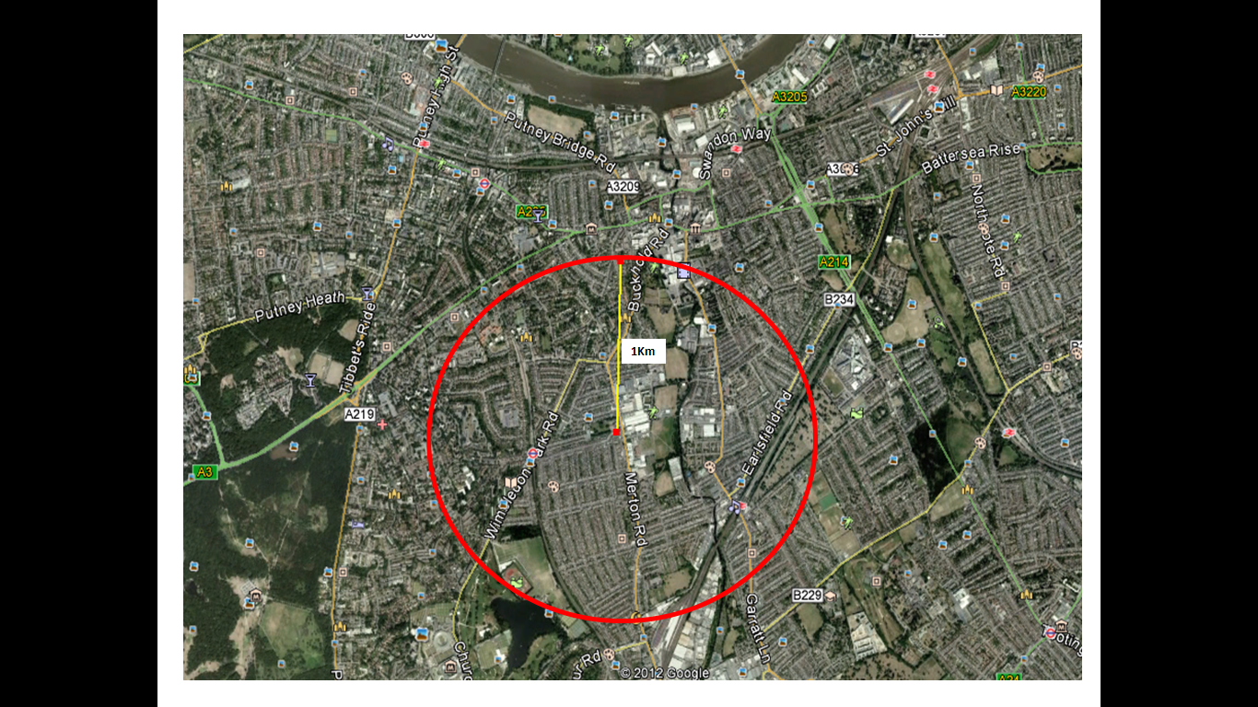

The pedestrian infrastructure provision within the school catchment areas is deemed appropriate for the residential, school and small scale commercial use imparted to it.

In this respect local footways are represented by 2m-2.5m width footways and occasional segregated 2m wide footpaths penetrating through large blocks of residential housing especially along the Replingham Road and Pirbright Street to the west of the School premises are subject to appropriate levels of street lighting.

The level of vehicle flows and observed vehicle speeds, ensure that controlled crossing of carriageways on Merton Road- A218 and Replingham Road can be safe and convenient and provide a further function of activity, resulting in psychological traffic calming.

These controlled crossing provide safe and secure access for pedestrians to and from the school.

It is therefore concluded that surrounding pedestrian infrastructure, can accommodate the current significant use arising from the school and any intensification arising from the development, without mitigation or alteration.

Cycling
In terms of cycling, the bus lane on the northbound Merton Road is used as the designated cycle routes, while southbound Merton Road footways is designated as ‘off road cycle route ‘which provide a safe access to the School site. However, like walking access, traffic flows are not considered heavy enough to dominate the local environment and thus would not materially conflict with on-carriageway cycle movements.
In order to cater for potential modal shift, in addition to the existing 4 cycle stands, 4 secured and well lit Sheffield type cycle stands will be provided. The shower facilities in the swimming pool area will be used for the benefit of cyclist. Thus, the proposed cycling facilities are deemed adequate for the expansion of the school. It is proposed that the use of the cycle parking will be regularly monitored as part of the School Travel Plan obligations to determine their suitability.

Public Transport Access
The Merton Road – A218 and Replingham Road is accessible locations within the School catchment area being well served by bus and rail services.

Bus
As mentioned previously, the A218-Merton Road north and south bound provides access for bus services. A bus stop is located approximately 100m on Merton Road to the development site. A seating and shelter facilities are provided with bus timetable information provided by Transport for London. The bus services that operate along this route are listed in Table 3. The daytime frequencies are also listed in the table below.

Table 3: Merton Road Bus Stops

Stops | Bus Numbers | Direction | Frequencies
West Hill/Standen Road | 156 | Towards Wimbledon-Clapham Junction-Vauxhall | Every 8mins, then every 12mins: Mon-Fri  Every 10mins, 8mins, then every 12mins: Sat  Every 15mins, then every 12mins:Sun

The frequency of buses arriving at these stops is high, with buses arriving once every 8mins or sooner on all. Detailed timetable information for bus 156 is available in Appendix F.

Rail
The development site enjoys the close proximity of Southfields Underground Station (Districts Line) which is approximately 5mins walk away; and 15mins walk away from Earlsfields train station (South West Trains). These stations provides frequent and direct rail links to Central London, West London, North London, and East London and other parts of the country.

TRAFFIC GENERATION AND IMPACT

Introduction
The following chapter concisely considers the impact resulting from the development and determines the level of detail required to aid the LBW Highway Authority, to formulate a recommendation upon the planning submission.

Need for a Transport Assessment
As previously mentioned in Chapter 1, discussions with the Highway Authority concluded that a Transport assessment would provide the appropriate level of detail required to enable a recommendation to be reached. This conclusion is primarily based upon the fact that the proposed development will not generate a significant number of vehicle trips in order to increase the vehicle movements during the peak hours. It is also further acknowledged that vehicle movement during the school operational hours will not be materially intensified to such a degree that would create detrimental highway capacity, safety or sustainability implications.

Modal Split
In order to estimate the impact of the proposed development, the total persons trips for all modes have been derived from the 2010 Riversdale Primary School Travel Plans. The staff and students survey undertaken in July 2010 determined the mode split for travel to and from the Merton Road site. Table 9 and 10 below summarises the modal split for Riversdale primary school staff and students.
Table 9: Riversdale Primary School pupils Mode Split

Mode of Travel | Numbers | % Modal Split
Walk | 122 | 61.9
Cycle | 2 | 1.0
Car alone(single household) | 42 | 21.3
Car Share(with another household) | 8 | 4.1
Bus | 17 | 8.6
Tube/ Train | 6 | 3.0
Other | 0 | 0.0
Total | 197 | 99.9
Source: Riversdale Primary School Travel Plan July 2010

Table 10: Riversdale Primary School Staff Mode Split

Mode of Travel | Numbers | % Modal Split
Walk | 12 | 57.1
Cycle | 0 | 0.0
Car alone(single household) | 8 | 38.1
Car Share(with another household) | 0 | 0.0
Bus | 0 | 0.0
Tube/ Train | 1 | 4.8
Other | 0 | 0.0
Total | 21 | 100
Source: Riversdale Primary School Travel Plan July 2010

The pupils and staff modal split for the school development as in Table 9 and 10 suggest there would be 42 car trips for pupils and 8 car trips for staff based on 210 students and 30 members of staff as at the time of the survey.
However, it can be observed that 38.1% of staff and 21.3% of pupils travel to school by car, thus based on the increase in the school capacity by 150 students; 14 staff and 72 students will travel to school by car.

Trip Generation

Arrivals and Departures
When examining the peak demand placed on the network the peak times for arrivals and departures to the development site need to be determined. More importantly, however, when considering the impact of the development on traffic in the area is the number of trips being generated during the peak times of usage of the highway network.

The trip generation for the proposed development based on estimated vehicle trips for pupils and staff have been considered using the 2010 mode split data, therefore the total vehicles trips are estimated as shown in Table 11.

Table 11: Riversdale Primary SCHOOL DEVELOPMENT Trips

2010 Journey to School (Staff) – Car Trips | 8
2010 Journey to School (Pupils) – Car Trips | 42
Total | 50
2010 Trips Growth to 2012 | 61
Estimated Development Trips (Staff) - Cars | 6
Estimated Development Trips (Pupils) - Cars | 30
Total Development Trips Staff + Students | 97

The pupils and staff estimated trip generation (arrivals and departures) for the proposed development are summarised in the table below:
Table 12: Trip Generation for the Proposed Development
Land Use | AM Peak |  | PM Peak
Land Use | Arr. | Dep. | Arr. | Dep.
Primary School (Staff) | 10 | 8 | 9 | 9
Primary School (Pupils) | 44 | 35 | 39 | 40
Total | 54 | 43 | 48 | 49

The above data is assumed to be an accurate representation of the pattern of arrivals and departures by the pupils and staff of the Riversdale primary school.
The demand trips created for the proposed development as estimated above is a robust assessment of the total number of peak hour trips to be generated by the school. However, given the fact that the anticipated staff and pupils are likely to be locally based, it is expected that the greater proportion of trips will arrive at the site on foot; therefore the proposed development is unlikely to have a significant impact on the amenity and the operation of the local highway network.

Trip Distribution and Assignment
The estimated development trips to the school have been distributed to the local highway network based on the existing pattern of trips as shown in Table 13
Table 13: Trip Distribution for the Proposed Development
Land Use | AM Peak  Arr.  Dep.
A218 – Merton Road South | 27%
A218 Merton Road North | 24%
Replingham Road | 49%

Modelling Analysis

Assessment Years
In addition to the Base Year 2012 discussed in Section 3 the following assessment year have been assessed;
- Base Year 2014 Without Development Traffic
- Base year 2014 With Development Traffic
And as stated previously, the peak periods to be assessed are
AM – 08:00 – 09:00 hours
PM – 15:15 – 16:15 hours

Growth Rates
The anticipated completion year for the proposed development is 2014. And growth adjustments are applied to the base year to reflect the future traffic demand as a result of the increasing population. The growth factor for the assessment year was established by using TEMPRO 6.2 for Wandsworth local and national growth rates.

The growth factor of 1.22 has been used for the AM and PM Peak.

Modelling Software
Priority junctions have been modelled using PICADY 8.0. PICADY is a computer program produced by TRL for predicting capacities, queues and delays at major/minor priority junctions.

The PICADY capacity assessment results are summarised using the following:

- Ratio of Flow to Capacity (RFC) – where the RFC is 0.85, the approach is nearing capacity and queues will begin to form. Where the RFC exceeds 1.00, the approach is at capacity and significant queues will form
- Queue - measured in PCUs
- Delay – measured in minutes per vehicle.

The signalised junctions have been modelled using LINSIG Version 3 produced by JCT Consultancy Limited . Linsig is a computer software package for the assessment and design of traffic signal junctions. For the purpose of this assessment the following results are summarised;

- Practical Reserve Capacity (PRC) - The PRC is calculated from the maximum degree of saturation on a Lane controlled by the Stage Stream and is a measure of how much additional traffic could pass through a junction controlled whilst maintaining a maximum degree of saturation of 90% on all all lanes.

- Degree of Saturation – is the ratio of flow to capacity for a lane

- Delay - Average Delay per PCU in seconds for each lane averaged over the modelled time period

- Mean Maximum Queue – measured in PCUs, it represents the maximum queue within a typical cycle averaged over all the cycles within the modelled time period.

Junction Assessment
For the purpose of this study, detailed LINSIG and PICARDY traffic modelling assessment has been undertaken at Standen Road /A218-Merton Road T-junction and Replingham Road/A218-Merton Road Signal Junction for the following scenarios:-

- Base Year 2012 AM and PM
- Completion Year 2014 AM and PM Peak for “with” and “without development”

Site 1 – Operational Assessment of the A218 – Merton Road / Replingham Road Signal Junction
A218 Merton Road/Replingham Road signalised junction has been modelled using LinSig V3 software. Due to lack of controller specification data, the modeller have assigned the appropriate phases to the traffic movements and pedestrian crossings; along with a staging based upon the images from Google Street View.
OS map and Google Earth images have been also used to calculate the intergreen timing between the stages. As per the Google Earth images, the northbound bus lane on A218 Merton Road (north) arm operates between Monday to Friday 7am – 10am. Therefore, the AM model is modelled such that only buses use this lane whilst PM model is modelled such that this lane is open to all traffic.
The PCUs traffic data in Appendix C have been used for the assessment of the following scenarios and the results of the LINSIG assessment can be viewed in Appendix D
The junction geometry and LINSIG outputs for the 2012 and 2014 base year is summarised in Appendix D. Table 14 summarises the baseline condition results for the morning and evening peak periods.

Table 14: A218 Merton Road/Replingham Road Base Year 2012 AM & PM Peak
Approach | Lane | 08:00 – 09:00 |  | 15:15 – 16:15
Approach | Lane | Deg of Sat | Queue | Deg of Sat | Queue
A128 (S) | Lane 1 | 16.2% | 2 | 38.7% | 7
A128 (S) | Lane 2 | 64.1% | 16 | 41.0% | 8
Replingham Road | Lane 1 | 64.5% | 8 | 50.5% | 7
A128 (N) | Lane 1 | 35.8% | 7 | 50.1% | 10
A128 (N) | Lane 2 | 31.7% | 1 | 40.5% | 3
Practical Reserve Capacity |  | +39.5% |  | +78.2%
Note: Lane 1 is the nearside lane
The above Table 14 shows that the junction operates within the capacity with the maximum degree of saturation of 64.1% on A218 (South arm) offside lane and 16 vehicles queuing and 64.5% on Replingham Road with eight vehicles queuing in AM peak period.
Tables 15 and 16 below demonstrate the 2014 with and without development scenarios for AM peak and PM peak period respectively.
Table 15: A218 Merton Road/Replingham Road Base Year & Base Plus Development 2014 AM Peak
Approach | Lane | 2014 Base |  | 2014 Base plus development |  | Difference in queues
Approach | Lane | Deg of Sat | Queue | Deg of Sat | Queue | Difference in queues
A128 (S) | Lane 1 | 19.6% | 3 | 23.8% | 4 | +1
A128 (S) | Lane 2 | 78.3% | 22 | 80.9% | 23 | +1
Replingham Road | Lane 1 | 78.5% | 11 | 87.1% | 14 | +3
A128 (N) | Lane 1 | 43.7% | 9 | 45.2% | 9 | 0
A128 (N) | Lane 2 | 62.2% | 2 | 86.2% | 4 | +2
Practical Reserve Capacity |  | +14.6% |  | +3.4%
Note: Lane 1 is the nearside lane
Table 16: A218 Merton Road/Replingham Road Base Year & Base Plus Development 2014 PM Peak
Approach | Lane | 2014 Base |  | 2014 Base plus development |  | Difference in queues
Approach | Lane | Deg of Sat | Queue | Deg of Sat | Queue | Difference in queues
A128 (S) | Lane 1 | 46.7% | 9 | 47.4% | 9 | 0
A128 (S) | Lane 2 | 48.8% | 10 | 50.0% | 10 | 0
Replingham Road | Lane 1 | 63.1% | 9 | 75.6% | 12 | +3
A128 (N) | Lane 1 | 59.9% | 13 | 58.8% | 13 | 0
A128 (N) | Lane 2 | 62.0% | 5 | 74.3% | 6 | +1
Practical Reserve Capacity |  | +42.6% |  | +19.1%
Note: Lane 1 is the nearside lane
Tables 15 and 16 show that there is very little difference in the results between without and with development scenarios for both AM and PM peak periods. The maximum degree of saturation is 87.1% on Replingham Road with 14 vehicles queuing in AM peak period for the 2014 base plus development scenario.

Site 2 – Operational Assessment of the A218 – Merton Road / Standen Road Priority Junction
A218 Merton Road/Standen Road priority T-junction has been modelled using TRL PICADY 8.0 software. The junction geometry has been based upon OS map and Google Earth images.
The PCUs traffic data in Appendix C have been used for the assessment of the following scenarios and the results of the PICADY model ouputs can be viewed in Appendix E
Table 17 below shows the 2012 base year analysis.

Table 17: A218 Merton Road/Standen Road Base Year 2012 AM & PM Peak
 | 08:00 – 09:00 |  | 15:15 – 16:15
 | RFC | Queue (PCU) | RFC | Queue (PCU)
Standen Road (LT) | 0.14 | 0 | 0.07 | 0
Standen Road (RT) | 0.13 | 0 | 0.05 | 0
A218 – Ahead/RT | 0.06 | 0 | 0.05 | 0

The above Table 17 shows that the junction operates well within the capacity with the maximum RFC of 0.14 on Standen Road with no vehicles queuing in AM peak period.
Tables 18 and 19 below demonstrate the 2014 with and without development scenarios for AM peak and PM peak period respectively.
Table 18: A218 Merton Road/Standen Road Base Year & Base Plus Development Year 2014 AM Peak
 | 2014 Base |  | 2014 Base plus development |  | Difference in queues
 | RFC | Queue (PCU) | RFC | Queue (PCU) | Difference in queues
Standen Road (LT) | 0.15 | 0 | 0.19 | 0 | 0
Standen Road (RT) | 0.16 | 0 | 0.20 | 0 | 0
A218 – Ahead/RT | 0.08 | 0 | 0.08 | 0 | 0

Table 19: A218 Merton Road/Standen Road Base Year & Base Plus Development Year 2014 PM Peak
 | 2014 Base |  | 2014 Base plus development |  | Difference in queues
 | RFC | Queue (PCU) | RFC | Queue (PCU) | Difference in queues
Standen Road (LT) | 0.09 | 0 | 0.10 | 0 | 0
Standen Road (RT) | 0.07 | 0 | 0.07 | 0 | 0
A218 – Ahead/RT | 0.07 | 0 | 0.13 | 0 | 0

Tables 18 and 19 show that there is no difference in the results with respect to queues between without and with development scenarios for both AM and PM peak periods. The maximum RFC is 0.20 on Standen Road with no vehicles queuing in AM peak period for 2014 base plus development scenario.
The results of the junction assessment show that in operational terms there are no existing capacity problems at the assessed junctions, thus, the increase in the school capacity will not be of significant effect on the surrounding highway network.

SUMMARY AND CONCLUSION
The development proposals seek to expand the existing school building to increase its capacity from the existing 210 pupils by 150 pupils. The location of the development site means the site has a high level of accessibility by all modes. There are adequate pedestrian facilities on junctions close to the site, including a signalised pedestrian crossings and pedestrianised streets. Vehicle access to the proposed development would remain as existing – off the A218-Merton Road.

A number of bus stops are located on Merton Road, providing access to a number of bus routes serving much of Wandsworth and South West London. Southfields Underground Station and Earlsfields railway station are within walking distance of Riversdale Primary School providing access to the underground and national rail network.

In terms of parking, there are controlled on-street car parks in close proximity to the site. Dedicated staff and disabled car parking is also available. There is also provision for 8 secure cycle parking on site.

The A new School Travel Plan will be provided for the school to encourage the pupils and staff to travel to school by sustainable modes of transport. The nature of the land uses means the development peak will not coincide with the highway peak. The development’s combined peak period person trips were generated.

In terms of traffic generation, the traffic analysis carried out indicates that the proposed development is likely to generate 97 vehicular trips in the school’s as a result of the school expansion. The predicted additional trips will not have a detrimental effect on the surrounding junction. The majority of trips that will be generated at the new primary school site are already on the network currently accessing facilities and will be reassigned.

The junction analysis contained within this report suggests that the given the three modelled scenarios there are no capacity issues relating to the A218-Merton Road/Standen Road priority junction and Replingham Road/A218-Merton Road signal junction.

In conclusion, the proposed school expansion is acceptable for the following reasons:

- The form proposed accords with the adopted transport policies of the London Borough of Wandsworth;

- It is in a highly accessible location; and

- Given the above, the highway infrastructure associated with the proposed development would not prejudice highway safety hence, it is considered that there are no highway grounds on which to refuse the proposed development planning permission

APPENDIX A - SITE LAYOUT PLAN

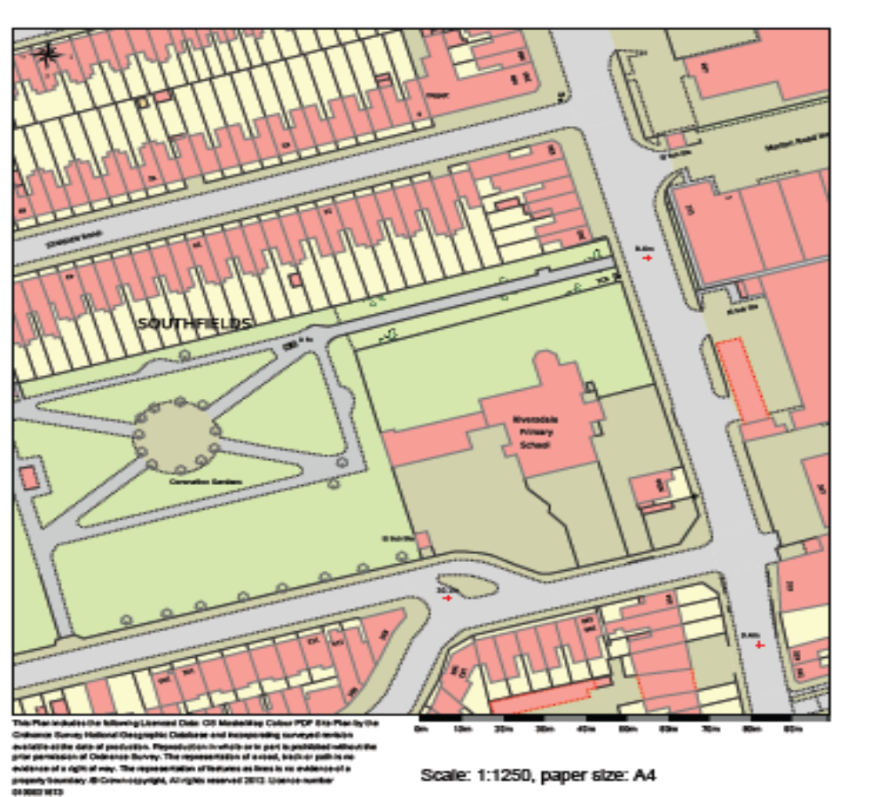

 | Riversdale Primary School | LC-12-0079-RP1
 | Riversdale Primary School | Figure No.1

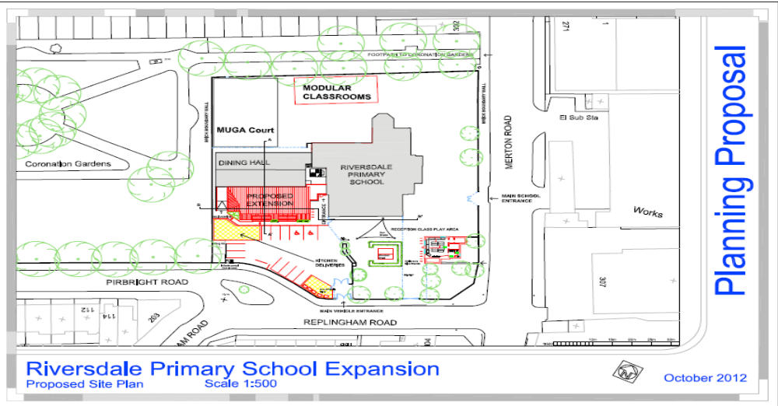

 | Riversdale Primary School | LC-12-0079-RP1
 | Riversdale Primary School | Figure No.1

APPENDIX B - ACCIDENTS DATA

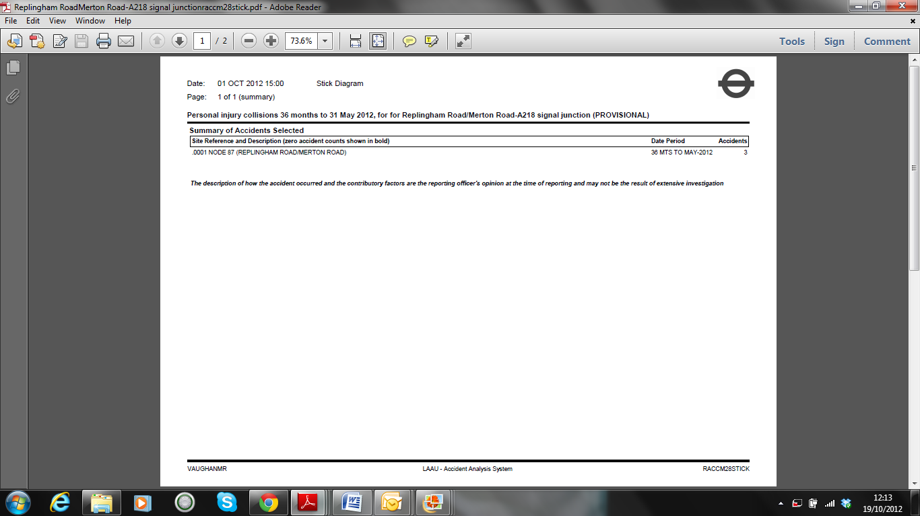
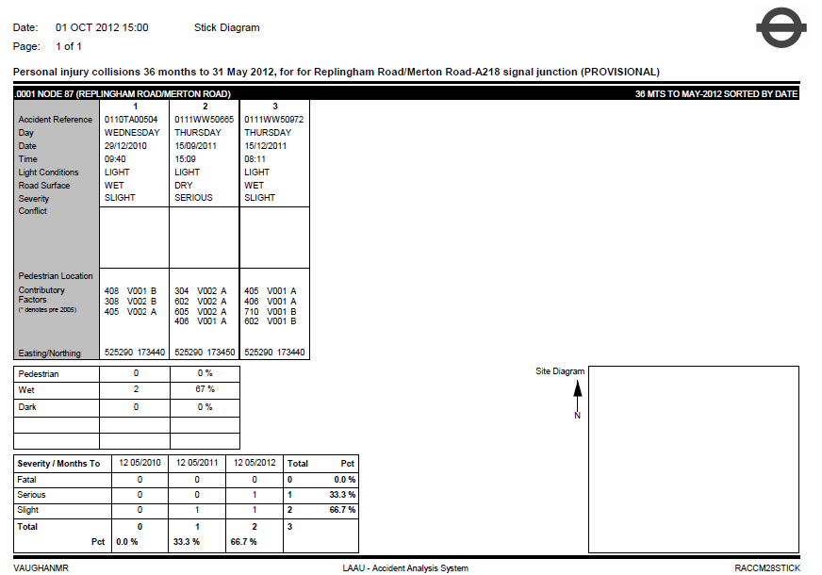
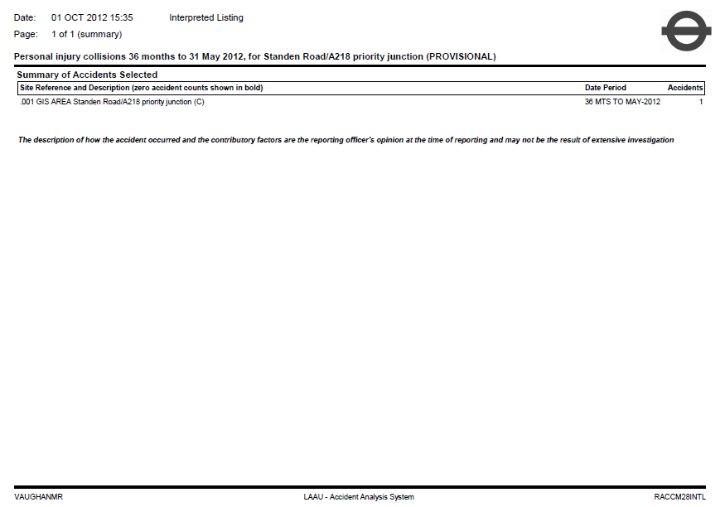

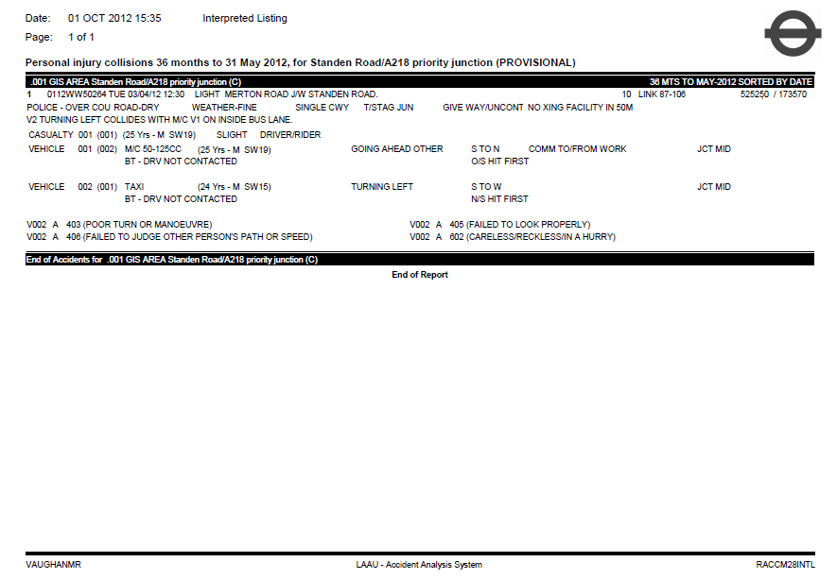

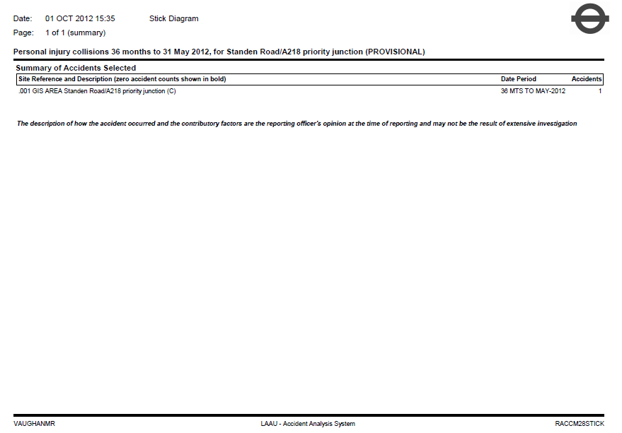

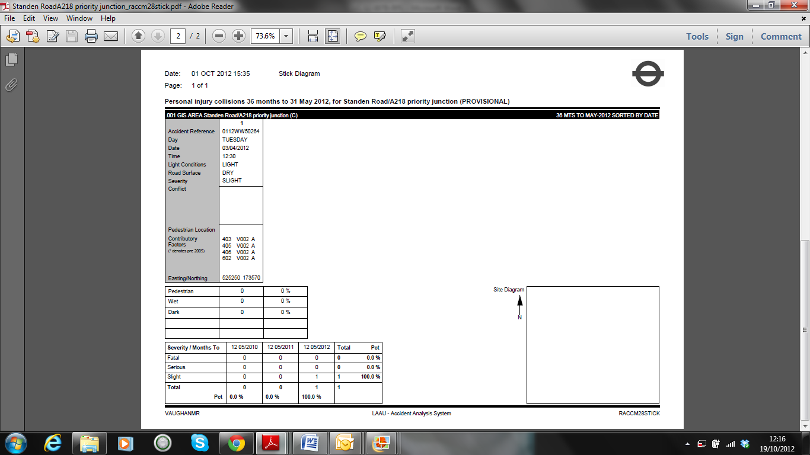

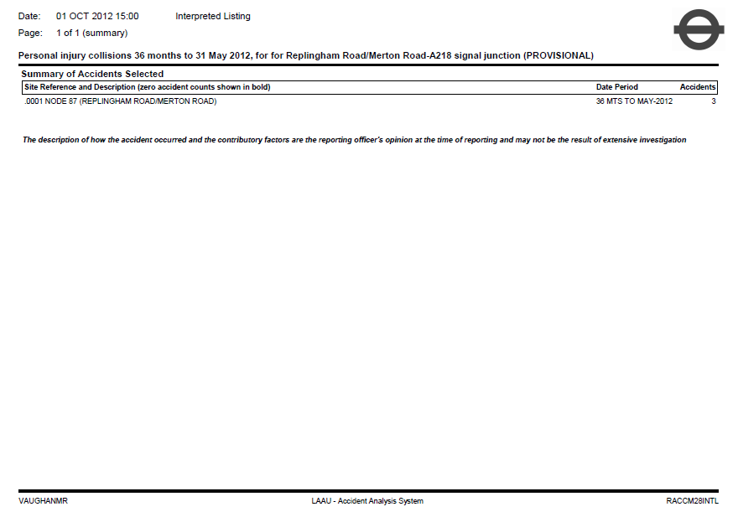

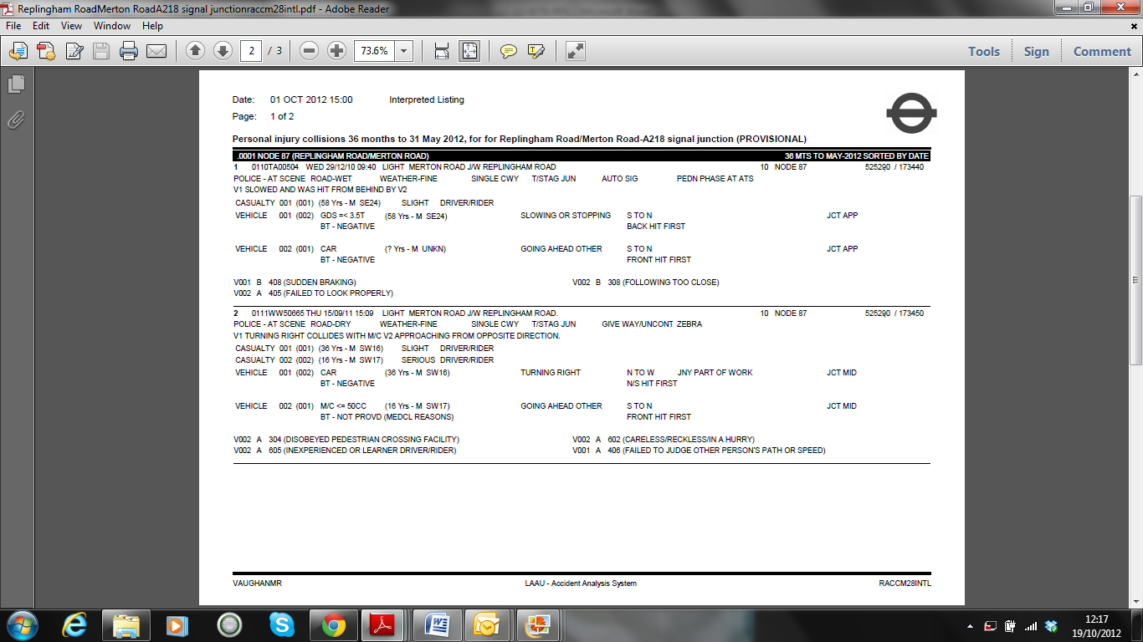
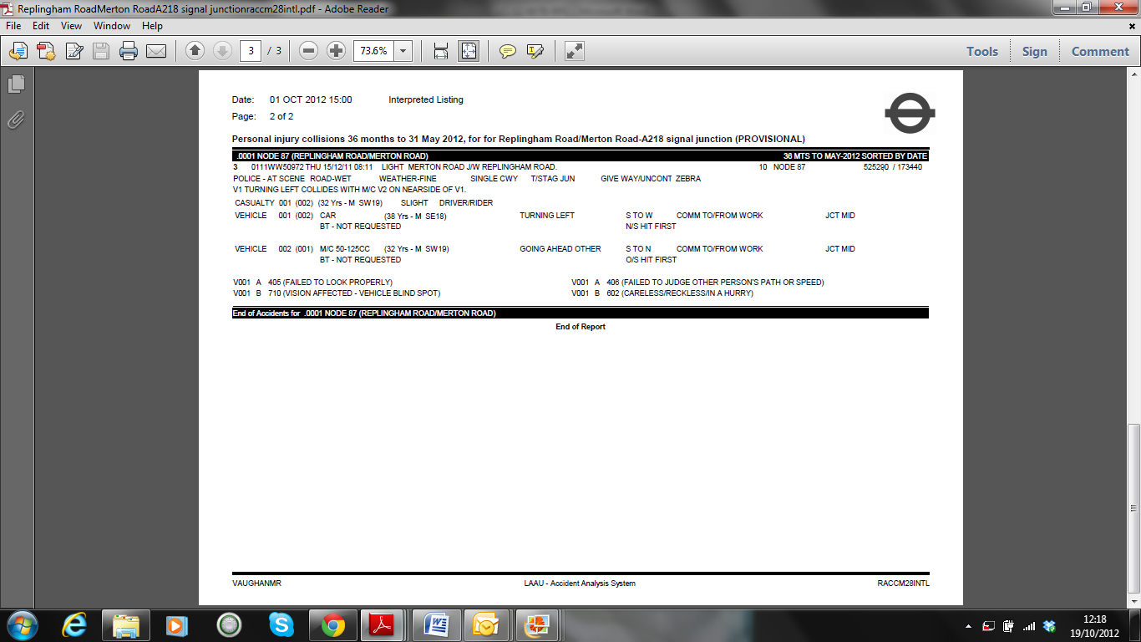

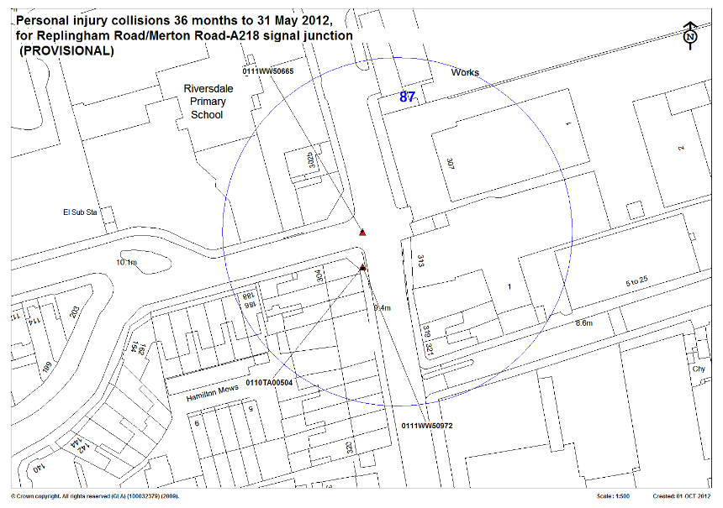

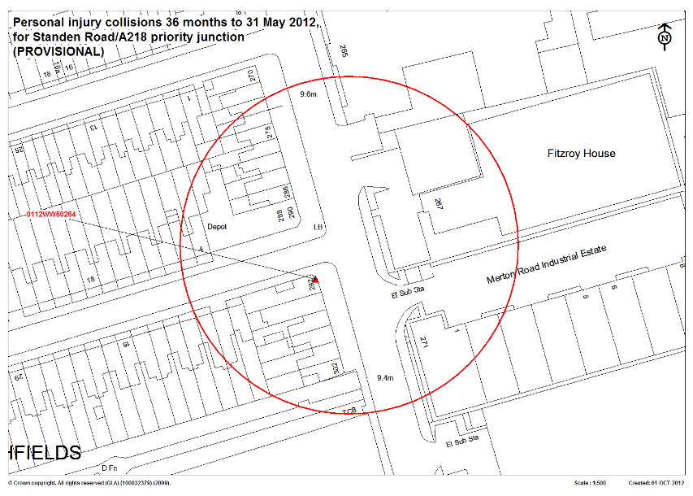

APPENDIX C - TRAFFIC COUNTS DETAILS

A218 – Merton Road North
360
AM 26 363
PM 491 25
E | F
D
C

AM PM
56 33
29 11

Standen Road

B | A

AM 20 715
PM 18 580
A218-Merton Road South

Standen Road/A218 –Merton Road Priority Junction – Base Year 2012 Flows (in PCUs)

A218 – Merton Road North
360
AM 32 443
PM 599 31
E | F
D
C

AM PM
68 40
35 13

Standen Road

B | A

AM 25 872
PM 22 708
A218-Merton Road South

Standen Road/A218 –Merton Road Priority Junction – Base Year 2014 Flows without development (in PCUs)

A218 – Merton Road North
360
AM 32 443
PM 599 31
E | F
D
C

AM PM
68 40
35 13

Standen Road

B | A

AM 26 900
PM 23 730
A218-Merton Road South

Standen Road/A218 –Merton Road Priority Junction – Base Year 2014 Flows with development (in PCUs)

 |  |  |  |  | A | B | C | D | E | F
Base Year 2012 AM |  |  |  |  | 715 | 20 | 29 | 56 | 26 | 363
Base Year 2012 PM |  |  |  |  | 580 | 18 | 11 | 33 | 491 | 25
Base Year 201 4AM Without Dev |  |  |  |  | 872 | 25 | 35 | 68 | 32 | 443
Base Year 2014PM Without Dev |  |  |  |  | 708 | 22 | 13 | 40 | 599 | 31
Base Year 201 4AM With Dev |  |  |  |  | 900 | 26 | 35 | 68 | 32 | 460
Base Year 2014PM With Dev |  |  |  |  | 730 | 23 | 13 | 40 | 599 | 54

B
A218-Merton Road North
AM 70 336 0
PM 117 408 0
AM PM
128 127

0 0

112 115

C
Replingham Road

AM 110 612 0
A218 – Merton Road South
PM 131 489 0

A
Replingham Road/A218 Merton Road Signal Junction - Base Year 2012 Flows in PCUs
 |  |  |  |  |  |  |  | A | B | C | D | Total
A | A218-Merton Road South |  |  |  |  |  |  | 0 | 612 | 117 | 0 | 729
B | A218-Merton Road North |  |  |  |  |  |  | 336 | 0 | 70 | 0 | 407
C | Replingham Road |  |  |  |  |  |  | 112 | 128 | 0 | 0 | 240
D | Local |  |  |  |  |  |  | 0 | 0 | 0 | 0 | 0
Base Year 2012 AM
 |  |  |  |  |  |  |  | A | B | C | D
A | A218-Merton Road South |  |  |  |  |  |  | 0 | 489 | 131 | 0 | 619
B | A218-Merton Road North |  |  |  |  |  |  | 408 | 0 | 117 | 0 | 524
C | Replingham Road |  |  |  |  |  |  | 127 | 115 | 0 | 0 | 241
D | Local |  |  |  |  |  |  | 0 | 0 | 0 | 0 | 0
Base Year 2012 PM

B
A218-Merton Road North
AM 86 410 0
PM 142 497 0
AM PM
156 140

0 0

136 154

C
Replingham Road

AM 143 746 0
A218 – Merton Road South
PM 160 596 0

A
Replingham Road/A218 Merton Road Signal Junction - Base Year 2014 without development Flows in PCUs
 |  |  |  |  |  |  |  | A | B | C | D
A | A218-Merton Road South |  |  |  |  |  |  | 0 | 746 | 143 | 0 | 890
B | A218-Merton Road North |  |  |  |  |  |  | 410 | 0 | 86 | 0 | 496
C | Replingham Road |  |  |  |  |  |  | 136 | 156 | 0 | 0 | 293
D | Local |  |  |  |  |  |  | 0 | 0 | 0 | 0 | 0
Base Year 2014 AM
 |  |  |  |  |  |  |  | A | B | C | D
A | A218-Merton Road South |  |  |  |  |  |  | 0 | 596 | 160 | 0 | 756
B | A218-Merton Road North |  |  |  |  |  |  | 497 | 0 | 142 | 0 | 639
C | Replingham Road |  |  |  |  |  |  | 154 | 140 | 0 | 0 | 294
D | Local |  |  |  |  |  |  | 0 | 0 | 0 | 0 | 0
Base Year 2014 PM

B
A218-Merton Road North
AM 103 410 0
PM 165 497 0
AM PM
186 163

0 0

161 179

C
Replingham Road

AM 169 746 0
A218 – Merton Road South
PM 186 596 0

A
Replingham Road/A218 Merton Road Signal Junction - Base Year 2014 with development Flows in PCUs
 |  |  |  |  |  |  |  | A | B | C | D | Total
A | A218-Merton Road South |  |  |  |  |  |  | 0 | 746 | 169 | 0 | 915
B | A218-Merton Road North |  |  |  |  |  |  | 410 | 0 | 103 | 0 | 513
C | Replingham Road |  |  |  |  |  |  | 161 | 186 | 0 | 0 | 347
D | Local |  |  |  |  |  |  | 0 | 0 | 0 | 0 | 0
Base plus Development Year 2014 AM
 |  |  |  |  |  |  |  | A | B | C | D | Total
A | A218-Merton Road South |  |  |  |  |  |  | 0 | 596 | 186 | 0 | 782
B | A218-Merton Road North |  |  |  |  |  |  | 497 | 0 | 165 | 0 | 663
C | Replingham Road |  |  |  |  |  |  | 179 | 163 | 0 | 0 | 342
D | Local |  |  |  |  |  |  | 0 | 0 | 0 | 0 | 0
Base plus Development Year 2014

APPENDIX D - LINSIG OUTPUTS

ADL Output

Traffic Flows, Desired
Scenario 1: '2012 AM Base Flows' (FG1: '2012 AM Base Flows', Plan 1: 'Network Control Plan 1')
Desired Flow :
 | Destination
Origin |  | A | B | C | Tot.
Origin | A | 0 | 612 | 117 | 729
Origin | B | 336 | 0 | 70 | 406
Origin | C | 112 | 128 | 0 | 240
Origin | Tot. | 448 | 740 | 187 | 1375

Scenario 2: '2012 PM BAse Flows' (FG2: '2012 PM Base Flows', Plan 1: 'Network Control Plan 1')
Desired Flow :
 | Destination
Origin |  | A | B | C | Tot.
Origin | A | 0 | 489 | 131 | 620
Origin | B | 408 | 0 | 117 | 525
Origin | C | 127 | 115 | 0 | 242
Origin | Tot. | 535 | 604 | 248 | 1387

Scenario 3: '2014 AM Base Flows' (FG3: '2014 AM without development', Plan 1: 'Network Control Plan 1')
Desired Flow :
 | Destination
Origin |  | A | B | C | Tot.
Origin | A | 0 | 746 | 143 | 889
Origin | B | 410 | 0 | 86 | 496
Origin | C | 136 | 156 | 0 | 292
Origin | Tot. | 546 | 902 | 229 | 1677

Scenario 4: '2014 PM Base Flows' (FG4: '2014 PM without development', Plan 1: 'Network Control Plan 1')
Desired Flow :
 | Destination
Origin |  | A | B | C | Tot.
Origin | A | 0 | 596 | 160 | 756
Origin | B | 497 | 0 | 142 | 639
Origin | C | 154 | 140 | 0 | 294
Origin | Tot. | 651 | 736 | 302 | 1689

Scenario 5: '2014 AM Base + Dev' (FG5: '2014 AM with development', Plan 1: 'Network Control Plan 1')
Desired Flow :
 | Destination
Origin |  | A | B | C | Tot.
Origin | A | 0 | 746 | 169 | 915
Origin | B | 410 | 0 | 103 | 513
Origin | C | 161 | 186 | 0 | 347
Origin | Tot. | 571 | 932 | 272 | 1775

Scenario 6: '2014 PM Base + Dev' (FG6: '2014 PM with development', Plan 1: 'Network Control Plan 1')
Desired Flow :
 | Destination
Origin |  | A | B | C | Tot.
Origin | A | 0 | 596 | 186 | 782
Origin | B | 497 | 0 | 165 | 662
Origin | C | 179 | 163 | 0 | 342
Origin | Tot. | 676 | 759 | 351 | 1786

Scenario 1: '2012 AM Base Flows' (FG1: '2012 AM Base Flows', Plan 1: 'Network Control Plan 1')
Stage Sequence Diagram

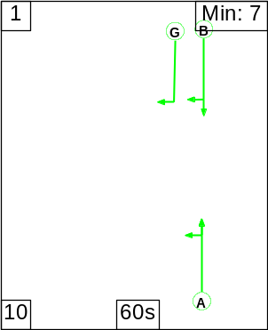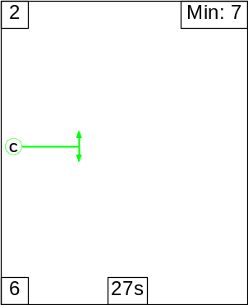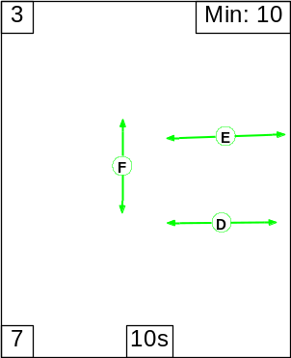

Signal Timings Diagram
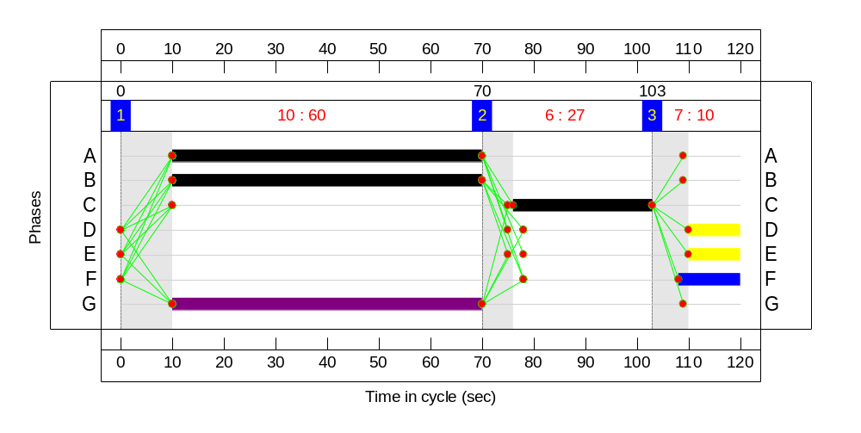

Network Results
Item | Lane Description | Lane Type | Controller Stream | Position In Filtered Route | Full Phase | Arrow Phase | Num Greens | Total Green (s) | Arrow Green (s) | Demand Flow (pcu) | Sat Flow (pcu/Hr) | Capacity (pcu) | Deg Sat (%)
Network | - | - | N/A | - | - |  | - | - | - | - | - | - | 64.5%
Unnamed Junction | - | - | N/A | - | - |  | - | - | - | - | - | - | 64.5%
1/1 | A218 (S) Ahead Left | U | N/A | N/A | A |  | 1 | 60 | - | 125 | 1520 | 773 | 16.2%
1/2 | A218 (S) Ahead | U | N/A | N/A | A |  | 1 | 60 | - | 604 | 1855 | 943 | 64.1%
2/1 |  | U | N/A | N/A | - |  | - | - | - | 8 | Inf | Inf | 0.0%
2/2 |  | U | N/A | N/A | - |  | - | - | - | 732 | Inf | Inf | 0.0%
3/1 | A218 (N) Ahead | U | N/A | N/A | B |  | 1 | 60 | - | 336 | 1845 | 938 | 35.8%
3/2 | A218 (N) Right | O | N/A | N/A | B | G | 1 | 60 | 60 | 70 | 1607 | 221 | 31.7%
4/1 |  | U | N/A | N/A | - |  | - | - | - | 187 | Inf | Inf | 0.0%
5/1 |  | U | N/A | N/A | - |  | - | - | - | 448 | Inf | Inf | 0.0%
6/1 | Replingham Road Left Right | U | N/A | N/A | C |  | 1 | 27 | - | 240 | 1594 | 372 | 64.5%
Ped Link: P1 | Unnamed Ped Link | - | N/A | - | D |  | 1 | 10 | - | 0 | - | 0 | 0.0%
Ped Link: P2 | Unnamed Ped Link | - | N/A | - | E |  | 1 | 10 | - | 0 | - | 0 | 0.0%
Ped Link: P3 | Unnamed Ped Link | - | N/A | - | F |  | 1 | 12 | - | 0 | - | 0 | 0.0%

Item | Arriving (pcu) | Leaving (pcu) | Turners In Gaps (pcu) | Turners When Unopposed (pcu) | Turners In Intergreen (pcu) | Uniform Delay (pcuHr) | Rand + Oversat Delay (pcuHr) | Storage Area Uniform Delay (pcuHr) | Total Delay (pcuHr) | Av. Delay Per PCU (s/pcu) | Max. Back of Uniform Queue (pcu) | Rand + Oversat Queue (pcu) | Mean Max Queue (pcu)
Network | - | - | 70 | 0 | 0 | 8.9 | 2.4 | 0.4 | 11.7 | - | - | - | -
Unnamed Junction | - | - | 70 | 0 | 0 | 8.9 | 2.4 | 0.4 | 11.7 | - | - | - | -
1/1 | 125 | 125 | - | - | - | 0.5 | 0.1 | - | 0.6 | 18.6 | 2.2 | 0.1 | 2.3
1/2 | 604 | 604 | - | - | - | 3.6 | 0.9 | - | 4.5 | 26.8 | 14.6 | 0.9 | 15.5
2/1 | 8 | 8 | - | - | - | 0.0 | 0.0 | - | 0.0 | 0.0 | 0.0 | 0.0 | 0.0
2/2 | 732 | 732 | - | - | - | 0.0 | 0.0 | - | 0.0 | 0.0 | 0.0 | 0.0 | 0.0
3/1 | 336 | 336 | - | - | - | 1.7 | 0.3 | - | 1.9 | 20.7 | 6.7 | 0.3 | 7.0
3/2 | 70 | 70 | 70 | 0 | 0 | 0.3 | 0.2 | 0.4 | 0.9 | 48.1 | 1.2 | 0.2 | 1.4
4/1 | 187 | 187 | - | - | - | 0.0 | 0.0 | - | 0.0 | 0.0 | 0.0 | 0.0 | 0.0
5/1 | 448 | 448 | - | - | - | 0.0 | 0.0 | - | 0.0 | 0.0 | 0.0 | 0.0 | 0.0
6/1 | 240 | 240 | - | - | - | 2.8 | 0.9 | - | 3.7 | 55.0 | 7.2 | 0.9 | 8.1
Ped Link: P1 | 0 | 0 | - | - | - | - | - | - | - | - | - | - | -
Ped Link: P2 | 0 | 0 | - | - | - | - | - | - | - | - | - | - | -
Ped Link: P3 | 0 | 0 | - | - | - | - | - | - | - | - | - | - | -
C1 PRC for Signalled Lanes (%): 39.5 Total Delay for Signalled Lanes (pcuHr): 11.68 Cycle Time (s): 120
PRC Over All Lanes (%): 39.5 Total Delay Over All Lanes(pcuHr): 11.68

Scenario 2: '2012 PM BAse Flows' (FG2: '2012 PM Base Flows', Plan 1: 'Network Control Plan 1')
Stage Sequence Diagram
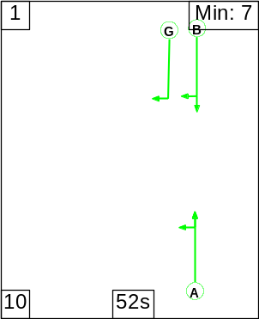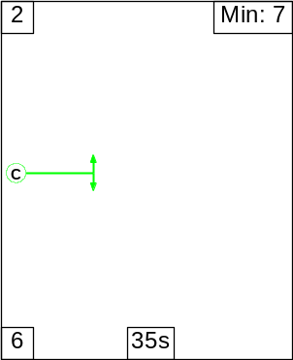

Signal Timings Diagram
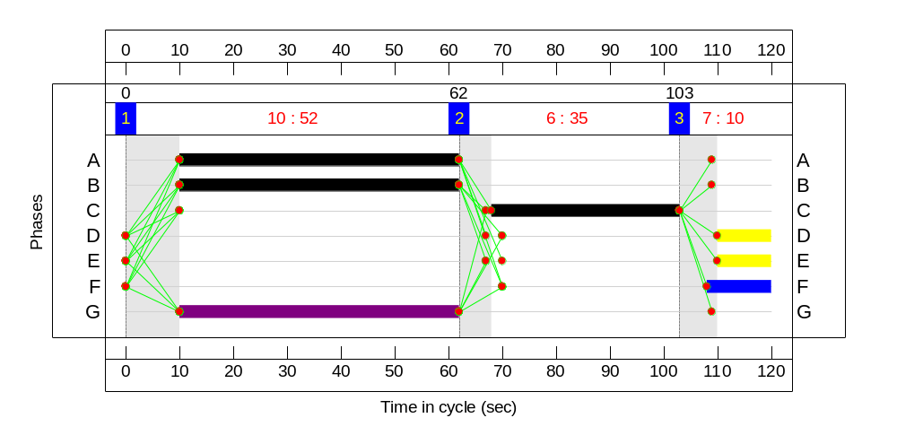

Network Results
Item | Lane Description | Lane Type | Controller Stream | Position In Filtered Route | Full Phase | Arrow Phase | Num Greens | Total Green (s) | Arrow Green (s) | Demand Flow (pcu) | Sat Flow (pcu/Hr) | Capacity (pcu) | Deg Sat (%)
Network | - | - | N/A | - | - |  | - | - | - | - | - | - | 50.5%
Unnamed Junction | - | - | N/A | - | - |  | - | - | - | - | - | - | 50.5%
1/1 | A218 (S) Ahead Left | U | N/A | N/A | A |  | 1 | 52 | - | 284 | 1661 | 734 | 38.7%
1/2 | A218 (S) Ahead | U | N/A | N/A | A |  | 1 | 52 | - | 336 | 1855 | 819 | 41.0%
2/1 |  | U | N/A | N/A | - |  | - | - | - | 153 | Inf | Inf | 0.0%
2/2 |  | U | N/A | N/A | - |  | - | - | - | 451 | Inf | Inf | 0.0%
3/1 | A218 (N) Ahead | U | N/A | N/A | B |  | 1 | 52 | - | 408 | 1845 | 815 | 50.1%
3/2 | A218 (N) Right | O | N/A | N/A | B | G | 1 | 52 | 52 | 117 | 1607 | 289 | 40.5%
4/1 |  | U | N/A | N/A | - |  | - | - | - | 248 | Inf | Inf | 0.0%
5/1 |  | U | N/A | N/A | - |  | - | - | - | 535 | Inf | Inf | 0.0%
6/1 | Replingham Road Left Right | U | N/A | N/A | C |  | 1 | 35 | - | 242 | 1597 | 479 | 50.5%
Ped Link: P1 | Unnamed Ped Link | - | N/A | - | D |  | 1 | 10 | - | 0 | - | 0 | 0.0%
Ped Link: P2 | Unnamed Ped Link | - | N/A | - | E |  | 1 | 10 | - | 0 | - | 0 | 0.0%
Ped Link: P3 | Unnamed Ped Link | - | N/A | - | F |  | 1 | 12 | - | 0 | - | 0 | 0.0%

Item | Arriving (pcu) | Leaving (pcu) | Turners In Gaps (pcu) | Turners When Unopposed (pcu) | Turners In Intergreen (pcu) | Uniform Delay (pcuHr) | Rand + Oversat Delay (pcuHr) | Storage Area Uniform Delay (pcuHr) | Total Delay (pcuHr) | Av. Delay Per PCU (s/pcu) | Max. Back of Uniform Queue (pcu) | Rand + Oversat Queue (pcu) | Mean Max Queue (pcu)
Network | - | - | 117 | 0 | 0 | 9.7 | 2.0 | 0.3 | 12.0 | - | - | - | -
Unnamed Junction | - | - | 117 | 0 | 0 | 9.7 | 2.0 | 0.3 | 12.0 | - | - | - | -
1/1 | 284 | 284 | - | - | - | 1.8 | 0.3 | - | 2.1 | 26.6 | 6.3 | 0.3 | 6.6
1/2 | 336 | 336 | - | - | - | 2.1 | 0.3 | - | 2.5 | 26.6 | 7.6 | 0.3 | 7.9
2/1 | 153 | 153 | - | - | - | 0.0 | 0.0 | - | 0.0 | 0.0 | 0.0 | 0.0 | 0.0
2/2 | 451 | 451 | - | - | - | 0.0 | 0.0 | - | 0.0 | 0.0 | 0.0 | 0.0 | 0.0
3/1 | 408 | 408 | - | - | - | 2.7 | 0.5 | - | 3.2 | 28.4 | 9.7 | 0.5 | 10.2
3/2 | 117 | 117 | 117 | 0 | 0 | 0.7 | 0.3 | 0.3 | 1.4 | 43.5 | 2.9 | 0.3 | 3.2
4/1 | 248 | 248 | - | - | - | 0.0 | 0.0 | - | 0.0 | 0.0 | 0.0 | 0.0 | 0.0
5/1 | 535 | 535 | - | - | - | 0.0 | 0.0 | - | 0.0 | 0.0 | 0.0 | 0.0 | 0.0
6/1 | 242 | 242 | - | - | - | 2.3 | 0.5 | - | 2.8 | 42.2 | 6.7 | 0.5 | 7.2
Ped Link: P1 | 0 | 0 | - | - | - | - | - | - | - | - | - | - | -
Ped Link: P2 | 0 | 0 | - | - | - | - | - | - | - | - | - | - | -
Ped Link: P3 | 0 | 0 | - | - | - | - | - | - | - | - | - | - | -
C1 PRC for Signalled Lanes (%): 78.2 Total Delay for Signalled Lanes (pcuHr): 12.05 Cycle Time (s): 120
PRC Over All Lanes (%): 78.2 Total Delay Over All Lanes(pcuHr): 12.05

Scenario 3: '2014 AM Base Flows' (FG3: '2014 AM without development', Plan 1: 'Network Control Plan 1')
Stage Sequence Diagram

Signal Timings Diagram
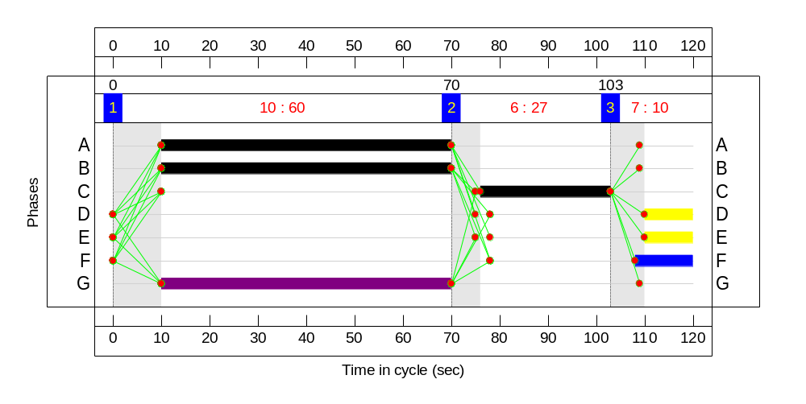

Network Results
Item | Lane Description | Lane Type | Controller Stream | Position In Filtered Route | Full Phase | Arrow Phase | Num Greens | Total Green (s) | Arrow Green (s) | Demand Flow (pcu) | Sat Flow (pcu/Hr) | Capacity (pcu) | Deg Sat (%)
Network | - | - | N/A | - | - |  | - | - | - | - | - | - | 78.5%
Unnamed Junction | - | - | N/A | - | - |  | - | - | - | - | - | - | 78.5%
1/1 | A218 (S) Ahead Left | U | N/A | N/A | A |  | 1 | 60 | - | 151 | 1517 | 771 | 19.6%
1/2 | A218 (S) Ahead | U | N/A | N/A | A |  | 1 | 60 | - | 738 | 1855 | 943 | 78.3%
2/1 |  | U | N/A | N/A | - |  | - | - | - | 8 | Inf | Inf | 0.0%
2/2 |  | U | N/A | N/A | - |  | - | - | - | 894 | Inf | Inf | 0.0%
3/1 | A218 (N) Ahead | U | N/A | N/A | B |  | 1 | 60 | - | 410 | 1845 | 938 | 43.7%
3/2 | A218 (N) Right | O | N/A | N/A | B | G | 1 | 60 | 60 | 86 | 1607 | 138 | 62.2%
4/1 |  | U | N/A | N/A | - |  | - | - | - | 229 | Inf | Inf | 0.0%
5/1 |  | U | N/A | N/A | - |  | - | - | - | 546 | Inf | Inf | 0.0%
6/1 | Replingham Road Left Right | U | N/A | N/A | C |  | 1 | 27 | - | 292 | 1594 | 372 | 78.5%
Ped Link: P1 | Unnamed Ped Link | - | N/A | - | D |  | 1 | 10 | - | 0 | - | 0 | 0.0%
Ped Link: P2 | Unnamed Ped Link | - | N/A | - | E |  | 1 | 10 | - | 0 | - | 0 | 0.0%
Ped Link: P3 | Unnamed Ped Link | - | N/A | - | F |  | 1 | 12 | - | 0 | - | 0 | 0.0%

Item | Arriving (pcu) | Leaving (pcu) | Turners In Gaps (pcu) | Turners When Unopposed (pcu) | Turners In Intergreen (pcu) | Uniform Delay (pcuHr) | Rand + Oversat Delay (pcuHr) | Storage Area Uniform Delay (pcuHr) | Total Delay (pcuHr) | Av. Delay Per PCU (s/pcu) | Max. Back of Uniform Queue (pcu) | Rand + Oversat Queue (pcu) | Mean Max Queue (pcu)
Network | - | - | 86 | 0 | 0 | 11.6 | 4.8 | 0.8 | 17.2 | - | - | - | -
Unnamed Junction | - | - | 86 | 0 | 0 | 11.6 | 4.8 | 0.8 | 17.2 | - | - | - | -
1/1 | 151 | 151 | - | - | - | 0.7 | 0.1 | - | 0.8 | 19.0 | 2.7 | 0.1 | 2.8
1/2 | 738 | 738 | - | - | - | 4.9 | 1.8 | - | 6.7 | 32.7 | 19.9 | 1.8 | 21.7
2/1 | 8 | 8 | - | - | - | 0.0 | 0.0 | - | 0.0 | 0.0 | 0.0 | 0.0 | 0.0
2/2 | 894 | 894 | - | - | - | 0.0 | 0.0 | - | 0.0 | 0.0 | 0.0 | 0.0 | 0.0
3/1 | 410 | 410 | - | - | - | 2.1 | 0.4 | - | 2.5 | 22.1 | 8.5 | 0.4 | 8.9
3/2 | 86 | 86 | 86 | 0 | 0 | 0.4 | 0.8 | 0.8 | 2.0 | 82.4 | 1.5 | 0.8 | 2.3
4/1 | 229 | 229 | - | - | - | 0.0 | 0.0 | - | 0.0 | 0.0 | 0.0 | 0.0 | 0.0
5/1 | 546 | 546 | - | - | - | 0.0 | 0.0 | - | 0.0 | 0.0 | 0.0 | 0.0 | 0.0
6/1 | 292 | 292 | - | - | - | 3.5 | 1.7 | - | 5.3 | 64.8 | 9.1 | 1.7 | 10.8
Ped Link: P1 | 0 | 0 | - | - | - | - | - | - | - | - | - | - | -
Ped Link: P2 | 0 | 0 | - | - | - | - | - | - | - | - | - | - | -
Ped Link: P3 | 0 | 0 | - | - | - | - | - | - | - | - | - | - | -
C1 PRC for Signalled Lanes (%): 14.6 Total Delay for Signalled Lanes (pcuHr): 17.24 Cycle Time (s): 120
PRC Over All Lanes (%): 14.6 Total Delay Over All Lanes(pcuHr): 17.24

Scenario 4: '2014 PM Base Flows' (FG4: '2014 PM without development', Plan 1: 'Network Control Plan 1')
Stage Sequence Diagram
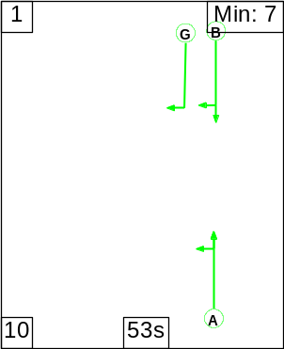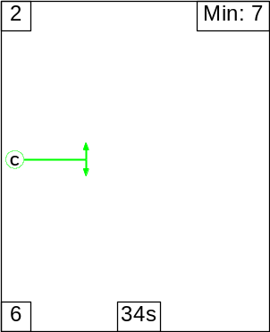

Signal Timings Diagram
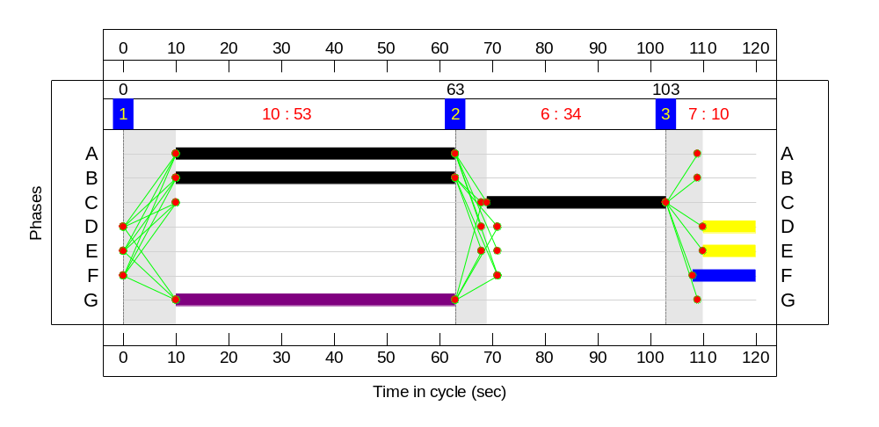

Network Results
Item | Lane Description | Lane Type | Controller Stream | Position In Filtered Route | Full Phase | Arrow Phase | Num Greens | Total Green (s) | Arrow Green (s) | Demand Flow (pcu) | Sat Flow (pcu/Hr) | Capacity (pcu) | Deg Sat (%)
Network | - | - | N/A | - | - |  | - | - | - | - | - | - | 63.1%
Unnamed Junction | - | - | N/A | - | - |  | - | - | - | - | - | - | 63.1%
1/1 | A218 (S) Ahead Left | U | N/A | N/A | A |  | 1 | 53 | - | 349 | 1662 | 748 | 46.7%
1/2 | A218 (S) Ahead | U | N/A | N/A | A |  | 1 | 53 | - | 407 | 1855 | 835 | 48.8%
2/1 |  | U | N/A | N/A | - |  | - | - | - | 189 | Inf | Inf | 0.0%
2/2 |  | U | N/A | N/A | - |  | - | - | - | 547 | Inf | Inf | 0.0%
3/1 | A218 (N) Ahead | U | N/A | N/A | B |  | 1 | 53 | - | 497 | 1845 | 830 | 59.9%
3/2 | A218 (N) Right | O | N/A | N/A | B | G | 1 | 53 | 53 | 142 | 1607 | 229 | 62.0%
4/1 |  | U | N/A | N/A | - |  | - | - | - | 302 | Inf | Inf | 0.0%
5/1 |  | U | N/A | N/A | - |  | - | - | - | 651 | Inf | Inf | 0.0%
6/1 | Replingham Road Left Right | U | N/A | N/A | C |  | 1 | 34 | - | 294 | 1597 | 466 | 63.1%
Ped Link: P1 | Unnamed Ped Link | - | N/A | - | D |  | 1 | 10 | - | 0 | - | 0 | 0.0%
Ped Link: P2 | Unnamed Ped Link | - | N/A | - | E |  | 1 | 10 | - | 0 | - | 0 | 0.0%
Ped Link: P3 | Unnamed Ped Link | - | N/A | - | F |  | 1 | 12 | - | 0 | - | 0 | 0.0%

Item | Arriving (pcu) | Leaving (pcu) | Turners In Gaps (pcu) | Turners When Unopposed (pcu) | Turners In Intergreen (pcu) | Uniform Delay (pcuHr) | Rand + Oversat Delay (pcuHr) | Storage Area Uniform Delay (pcuHr) | Total Delay (pcuHr) | Av. Delay Per PCU (s/pcu) | Max. Back of Uniform Queue (pcu) | Rand + Oversat Queue (pcu) | Mean Max Queue (pcu)
Network | - | - | 142 | 0 | 0 | 12.3 | 3.3 | 0.5 | 16.1 | - | - | - | -
Unnamed Junction | - | - | 142 | 0 | 0 | 12.3 | 3.3 | 0.5 | 16.1 | - | - | - | -
1/1 | 349 | 349 | - | - | - | 2.2 | 0.4 | - | 2.7 | 27.5 | 8.0 | 0.4 | 8.5
1/2 | 407 | 407 | - | - | - | 2.6 | 0.5 | - | 3.1 | 27.5 | 9.5 | 0.5 | 10.0
2/1 | 189 | 189 | - | - | - | 0.0 | 0.0 | - | 0.0 | 0.0 | 0.0 | 0.0 | 0.0
2/2 | 547 | 547 | - | - | - | 0.0 | 0.0 | - | 0.0 | 0.0 | 0.0 | 0.0 | 0.0
3/1 | 497 | 497 | - | - | - | 3.4 | 0.7 | - | 4.2 | 30.2 | 12.4 | 0.7 | 13.2
3/2 | 142 | 142 | 142 | 0 | 0 | 1.0 | 0.8 | 0.5 | 2.3 | 59.4 | 3.8 | 0.8 | 4.6
4/1 | 302 | 302 | - | - | - | 0.0 | 0.0 | - | 0.0 | 0.0 | 0.0 | 0.0 | 0.0
5/1 | 651 | 651 | - | - | - | 0.0 | 0.0 | - | 0.0 | 0.0 | 0.0 | 0.0 | 0.0
6/1 | 294 | 294 | - | - | - | 3.0 | 0.8 | - | 3.9 | 47.3 | 8.5 | 0.8 | 9.3
Ped Link: P1 | 0 | 0 | - | - | - | - | - | - | - | - | - | - | -
Ped Link: P2 | 0 | 0 | - | - | - | - | - | - | - | - | - | - | -
Ped Link: P3 | 0 | 0 | - | - | - | - | - | - | - | - | - | - | -
C1 PRC for Signalled Lanes (%): 42.6 Total Delay for Signalled Lanes (pcuHr): 16.15 Cycle Time (s): 120
PRC Over All Lanes (%): 42.6 Total Delay Over All Lanes(pcuHr): 16.15

Scenario 5: '2014 AM Base + Dev' (FG5: '2014 AM with development', Plan 1: 'Network Control Plan 1')
Stage Sequence Diagram
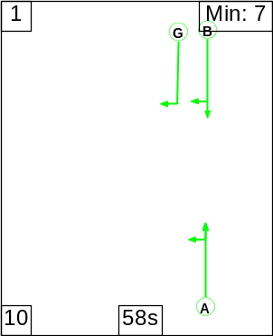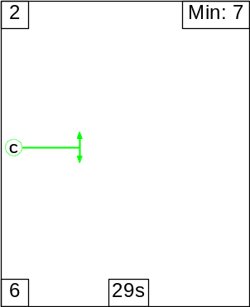

Signal Timings Diagram
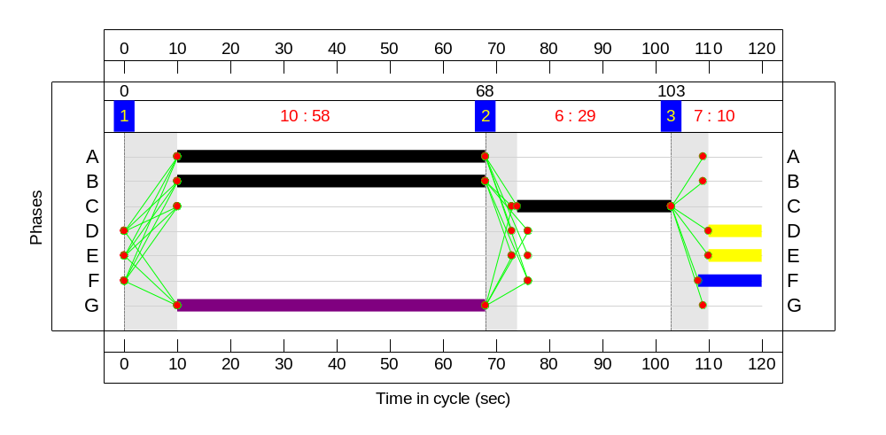

Network Results
Item | Lane Description | Lane Type | Controller Stream | Position In Filtered Route | Full Phase | Arrow Phase | Num Greens | Total Green (s) | Arrow Green (s) | Demand Flow (pcu) | Sat Flow (pcu/Hr) | Capacity (pcu) | Deg Sat (%)
Network | - | - | N/A | - | - |  | - | - | - | - | - | - | 87.1%
Unnamed Junction | - | - | N/A | - | - |  | - | - | - | - | - | - | 87.1%
1/1 | A218 (S) Ahead Left | U | N/A | N/A | A |  | 1 | 58 | - | 177 | 1515 | 745 | 23.8%
1/2 | A218 (S) Ahead | U | N/A | N/A | A |  | 1 | 58 | - | 738 | 1855 | 912 | 80.9%
2/1 |  | U | N/A | N/A | - |  | - | - | - | 8 | Inf | Inf | 0.0%
2/2 |  | U | N/A | N/A | - |  | - | - | - | 924 | Inf | Inf | 0.0%
3/1 | A218 (N) Ahead | U | N/A | N/A | B |  | 1 | 58 | - | 410 | 1845 | 907 | 45.2%
3/2 | A218 (N) Right | O | N/A | N/A | B | G | 1 | 58 | 58 | 103 | 1607 | 119 | 86.2%
4/1 |  | U | N/A | N/A | - |  | - | - | - | 272 | Inf | Inf | 0.0%
5/1 |  | U | N/A | N/A | - |  | - | - | - | 571 | Inf | Inf | 0.0%
6/1 | Replingham Road Left Right | U | N/A | N/A | C |  | 1 | 29 | - | 347 | 1594 | 399 | 87.1%
Ped Link: P1 | Unnamed Ped Link | - | N/A | - | D |  | 1 | 10 | - | 0 | - | 0 | 0.0%
Ped Link: P2 | Unnamed Ped Link | - | N/A | - | E |  | 1 | 10 | - | 0 | - | 0 | 0.0%
Ped Link: P3 | Unnamed Ped Link | - | N/A | - | F |  | 1 | 12 | - | 0 | - | 0 | 0.0%

Item | Arriving (pcu) | Leaving (pcu) | Turners In Gaps (pcu) | Turners When Unopposed (pcu) | Turners In Intergreen (pcu) | Uniform Delay (pcuHr) | Rand + Oversat Delay (pcuHr) | Storage Area Uniform Delay (pcuHr) | Total Delay (pcuHr) | Av. Delay Per PCU (s/pcu) | Max. Back of Uniform Queue (pcu) | Rand + Oversat Queue (pcu) | Mean Max Queue (pcu)
Network | - | - | 67 | 0 | 36 | 13.2 | 8.1 | 0.9 | 22.2 | - | - | - | -
Unnamed Junction | - | - | 67 | 0 | 36 | 13.2 | 8.1 | 0.9 | 22.2 | - | - | - | -
1/1 | 177 | 177 | - | - | - | 0.9 | 0.2 | - | 1.0 | 20.7 | 3.4 | 0.2 | 3.5
1/2 | 738 | 738 | - | - | - | 5.3 | 2.1 | - | 7.3 | 35.9 | 20.7 | 2.1 | 22.8
2/1 | 8 | 8 | - | - | - | 0.0 | 0.0 | - | 0.0 | 0.0 | 0.0 | 0.0 | 0.0
2/2 | 924 | 924 | - | - | - | 0.0 | 0.0 | - | 0.0 | 0.0 | 0.0 | 0.0 | 0.0
3/1 | 410 | 410 | - | - | - | 2.3 | 0.4 | - | 2.7 | 23.6 | 8.9 | 0.4 | 9.3
3/2 | 103 | 103 | 67 | 0 | 36 | 0.7 | 2.4 | 0.9 | 4.0 | 139.1 | 1.9 | 2.4 | 4.3
4/1 | 272 | 272 | - | - | - | 0.0 | 0.0 | - | 0.0 | 0.0 | 0.0 | 0.0 | 0.0
5/1 | 571 | 571 | - | - | - | 0.0 | 0.0 | - | 0.0 | 0.0 | 0.0 | 0.0 | 0.0
6/1 | 347 | 347 | - | - | - | 4.2 | 3.0 | - | 7.2 | 74.4 | 11.1 | 3.0 | 14.1
Ped Link: P1 | 0 | 0 | - | - | - | - | - | - | - | - | - | - | -
Ped Link: P2 | 0 | 0 | - | - | - | - | - | - | - | - | - | - | -
Ped Link: P3 | 0 | 0 | - | - | - | - | - | - | - | - | - | - | -
C1 PRC for Signalled Lanes (%): 3.4 Total Delay for Signalled Lanes (pcuHr): 22.20 Cycle Time (s): 120
PRC Over All Lanes (%): 3.4 Total Delay Over All Lanes(pcuHr): 22.20

Scenario 6: '2014 PM Base + Dev' (FG6: '2014 PM with development', Plan 1: 'Network Control Plan 1')
Stage Sequence Diagram
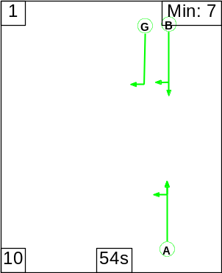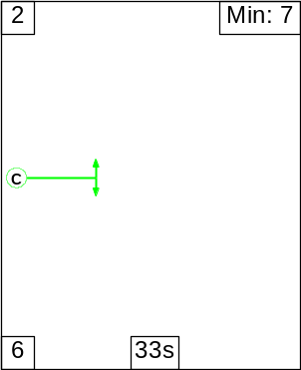

Signal Timings Diagram
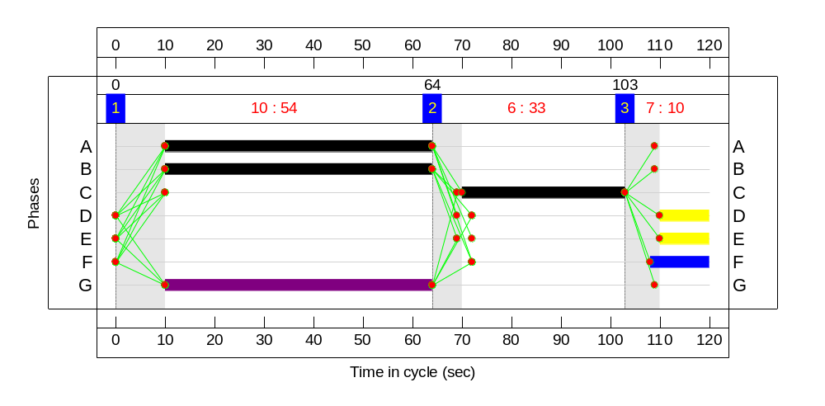

Network Results
Item | Lane Description | Lane Type | Controller Stream | Position In Filtered Route | Full Phase | Arrow Phase | Num Greens | Total Green (s) | Arrow Green (s) | Demand Flow (pcu) | Sat Flow (pcu/Hr) | Capacity (pcu) | Deg Sat (%)
Network | - | - | N/A | - | - |  | - | - | - | - | - | - | 75.6%
Unnamed Junction | - | - | N/A | - | - |  | - | - | - | - | - | - | 75.6%
1/1 | A218 (S) Ahead Left | U | N/A | N/A | A |  | 1 | 54 | - | 357 | 1642 | 753 | 47.4%
1/2 | A218 (S) Ahead | U | N/A | N/A | A |  | 1 | 54 | - | 425 | 1855 | 850 | 50.0%
2/1 |  | U | N/A | N/A | - |  | - | - | - | 171 | Inf | Inf | 0.0%
2/2 |  | U | N/A | N/A | - |  | - | - | - | 588 | Inf | Inf | 0.0%
3/1 | A218 (N) Ahead | U | N/A | N/A | B |  | 1 | 54 | - | 497 | 1845 | 846 | 58.8%
3/2 | A218 (N) Right | O | N/A | N/A | B | G | 1 | 54 | 54 | 165 | 1607 | 222 | 74.3%
4/1 |  | U | N/A | N/A | - |  | - | - | - | 351 | Inf | Inf | 0.0%
5/1 |  | U | N/A | N/A | - |  | - | - | - | 676 | Inf | Inf | 0.0%
6/1 | Replingham Road Left Right | U | N/A | N/A | C |  | 1 | 33 | - | 342 | 1597 | 452 | 75.6%
Ped Link: P1 | Unnamed Ped Link | - | N/A | - | D |  | 1 | 10 | - | 0 | - | 0 | 0.0%
Ped Link: P2 | Unnamed Ped Link | - | N/A | - | E |  | 1 | 10 | - | 0 | - | 0 | 0.0%
Ped Link: P3 | Unnamed Ped Link | - | N/A | - | F |  | 1 | 12 | - | 0 | - | 0 | 0.0%

Item | Arriving (pcu) | Leaving (pcu) | Turners In Gaps (pcu) | Turners When Unopposed (pcu) | Turners In Intergreen (pcu) | Uniform Delay (pcuHr) | Rand + Oversat Delay (pcuHr) | Storage Area Uniform Delay (pcuHr) | Total Delay (pcuHr) | Av. Delay Per PCU (s/pcu) | Max. Back of Uniform Queue (pcu) | Rand + Oversat Queue (pcu) | Mean Max Queue (pcu)
Network | - | - | 165 | 0 | 0 | 13.2 | 4.5 | 0.7 | 18.4 | - | - | - | -
Unnamed Junction | - | - | 165 | 0 | 0 | 13.2 | 4.5 | 0.7 | 18.4 | - | - | - | -
1/1 | 357 | 357 | - | - | - | 2.2 | 0.5 | - | 2.7 | 27.0 | 8.2 | 0.5 | 8.7
1/2 | 425 | 425 | - | - | - | 2.7 | 0.5 | - | 3.2 | 27.1 | 9.9 | 0.5 | 10.4
2/1 | 171 | 171 | - | - | - | 0.0 | 0.0 | - | 0.0 | 0.0 | 0.0 | 0.0 | 0.0
2/2 | 588 | 588 | - | - | - | 0.0 | 0.0 | - | 0.0 | 0.0 | 0.0 | 0.0 | 0.0
3/1 | 497 | 497 | - | - | - | 3.3 | 0.7 | - | 4.0 | 29.2 | 12.1 | 0.7 | 12.9
3/2 | 165 | 165 | 165 | 0 | 0 | 1.3 | 1.4 | 0.7 | 3.3 | 71.8 | 4.7 | 1.4 | 6.1
4/1 | 351 | 351 | - | - | - | 0.0 | 0.0 | - | 0.0 | 0.0 | 0.0 | 0.0 | 0.0
5/1 | 676 | 676 | - | - | - | 0.0 | 0.0 | - | 0.0 | 0.0 | 0.0 | 0.0 | 0.0
6/1 | 342 | 342 | - | - | - | 3.7 | 1.5 | - | 5.2 | 55.1 | 10.4 | 1.5 | 11.9
Ped Link: P1 | 0 | 0 | - | - | - | - | - | - | - | - | - | - | -
Ped Link: P2 | 0 | 0 | - | - | - | - | - | - | - | - | - | - | -
Ped Link: P3 | 0 | 0 | - | - | - | - | - | - | - | - | - | - | -
C1 PRC for Signalled Lanes (%): 19.1 Total Delay for Signalled Lanes (pcuHr): 18.44 Cycle Time (s): 120
PRC Over All Lanes (%): 19.1 Total Delay Over All Lanes(pcuHr): 18.44

Full Input Data

Network Layout Diagram
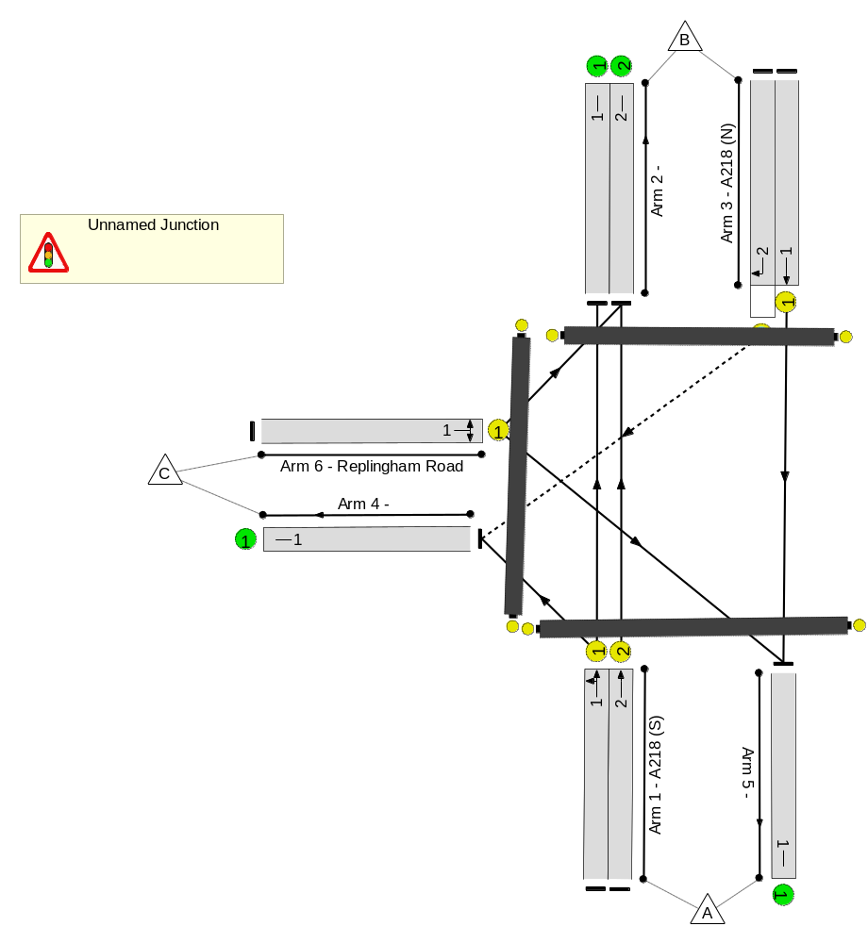

Phase Diagram
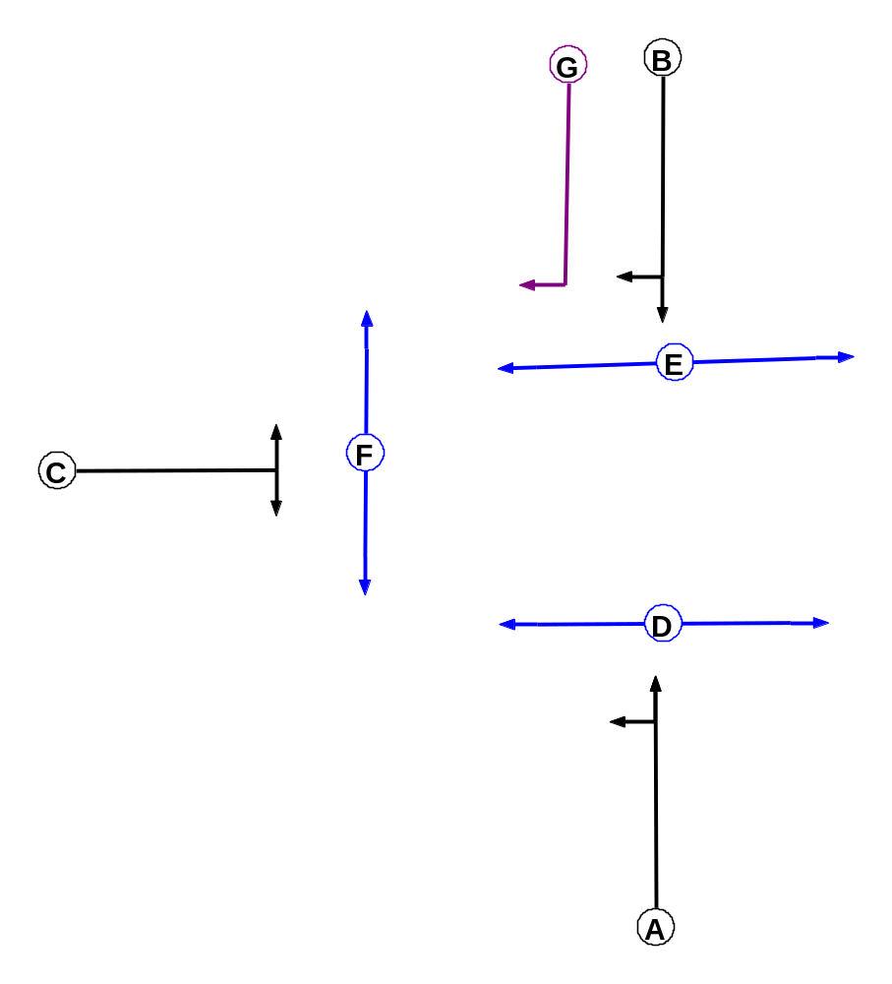

Phase Input Data
Phase Name | Phase Type | Assoc. Phase | Street Min | Cont Min
A | Traffic |  | 7 | 7
B | Traffic |  | 7 | 7
C | Traffic |  | 7 | 7
D | Pedestrian |  | 10 | 10
E | Pedestrian |  | 10 | 10
F | Pedestrian |  | 10 | 10
G | Ind. Arrow | B | 4 | 4

Phase Intergreens Matrix
 | Starting Phase
Terminating  Phase |  | A | B | C | D | E | F | G
Terminating  Phase | A | - | - | 6 | 5 | 8 | 8 | -
Terminating  Phase | B | - | - | 5 | 8 | 5 | 8 | -
Terminating  Phase | C | 6 | 6 | - | 7 | 7 | 5 | 6
Terminating  Phase | D | 10 | 10 | 10 | - | - | - | 10
Terminating  Phase | E | 10 | 10 | 10 | - | - | - | 10
Terminating  Phase | F | 10 | 10 | 10 | - | - | - | 10
Terminating  Phase | G | - | - | 5 | 8 | 5 | 8 | -

Phases in Stage
Stage No. | Phases in Stage
1 | A B G
2 | C
3 | D E F

Stage Diagram
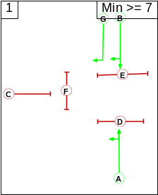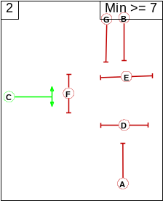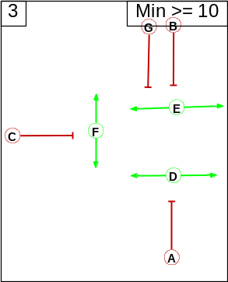

Phase Delays
Term. Stage | Start Stage | Phase | Type | Value | Cont value
There are no Phase Delays defined

Prohibited Stage Change
 | To Stage
From  Stage |  | 1 | 2 | 3
From  Stage | 1 |  | 6 | 8
From  Stage | 2 | 6 |  | 7
From  Stage | 3 | 10 | 10

Give-Way Lane Input Data
Junction: Unnamed Junction
Lane | Movement | Max Flow  when  Giving Way  (PCU/Hr) | Opposing  Lane | Opp. Lane  Coeff. | Opp.  Mvmnts. | Right Turn  Storage (PCU) | Non-Blocking  Storage  (PCU) | RTF | Right Turn  Move up (s) | Max Turns  in Intergreen  (PCU)
3/2  (A218 (N)) | 4/1 (Right) | 1439 | 1/1 | 1.09 | 1/1 | 2.00 | - | 0.50 | 2 | 2.00
3/2  (A218 (N)) | 4/1 (Right) | 1439 | 1/2 | 1.09 | 1/2

Lane Input Data
Junction: Unnamed Junction
Lane | Lane  Type | Phases | Start  Disp. | End  Disp. | Physical  Length  (PCU) | Sat Flow  Type | Def User  Saturation  Flow  (PCU/Hr) | Lane  Width  (m) | Gradient | Nearside  Lane | Turns | Turning  Radius  (m)
1/1  (A218 (S)) | U | A | 2 | 3 | 5.0 | Geom | - | 2.10 | 0.00 | Y | Arm 2 Ahead | Inf
 |  |  |  |  |  |  |  |  |  |  | Arm 4 Left | 7.00
1/2  (A218 (S)) | U | A | 2 | 3 | 60.0 | Geom | - | 2.40 | 0.00 | Y | Arm 2 Ahead | Inf
2/1 | U |  | 2 | 3 | 60.0 | Inf | - | - | - | - | - | -
2/2 | U |  | 2 | 3 | 60.0 | Inf | - | - | - | - | - | -
3/1  (A218 (N)) | U | B | 2 | 3 | 60.0 | Geom | - | 2.30 | 0.00 | Y | Arm 5 Ahead | Inf
3/2  (A218 (N)) | O | B G | 2 | 3 | 5.0 | Geom | - | 2.60 | 0.00 | Y | Arm 4 Right | 9.00
4/1 | U |  | 2 | 3 | 60.0 | Inf | - | - | - | - | - | -
5/1 | U |  | 2 | 3 | 60.0 | Inf | - | - | - | - | - | -
6/1  (Replingham Road) | U | C | 2 | 3 | 60.0 | Geom | - | 2.50 | 0.00 | Y | Arm 2 Left | 8.00
 |  |  |  |  |  |  |  |  |  |  | Arm 5 Right | 10.00

APPENDIX E - PICARDY OUTPUTS

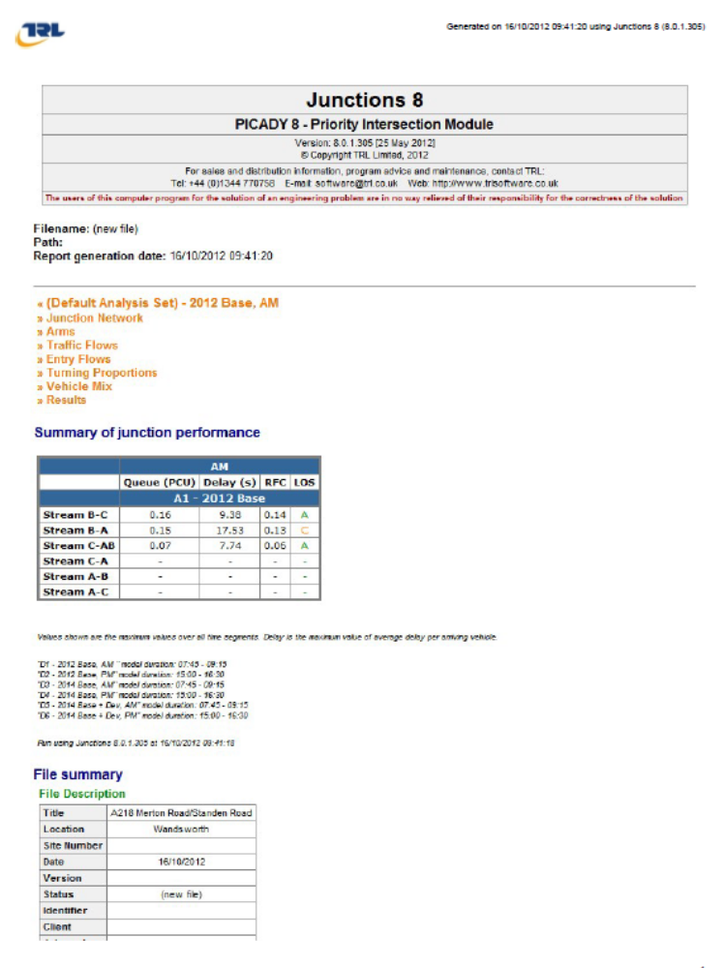
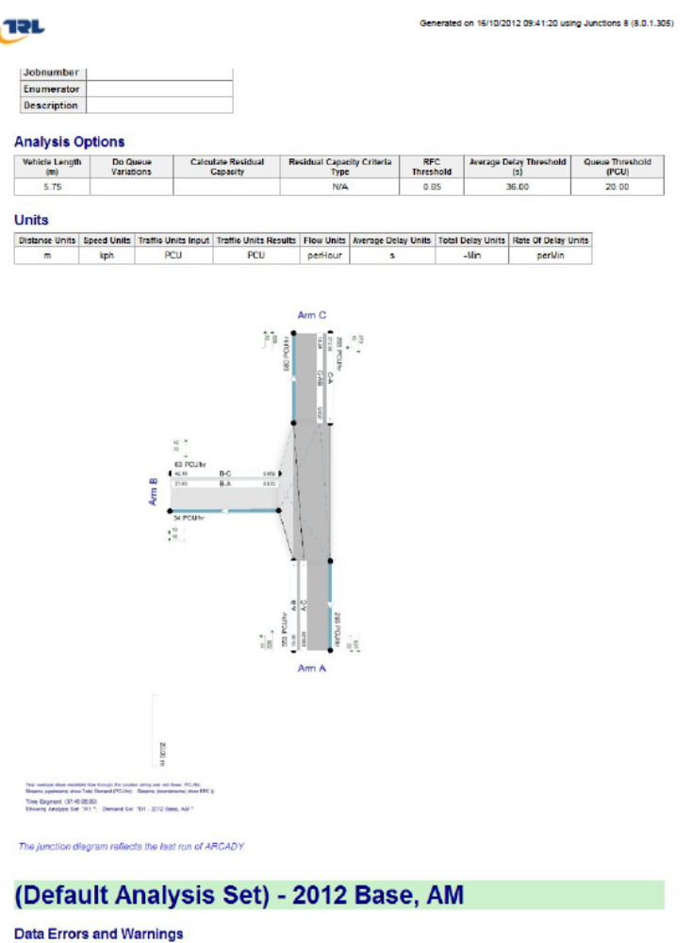

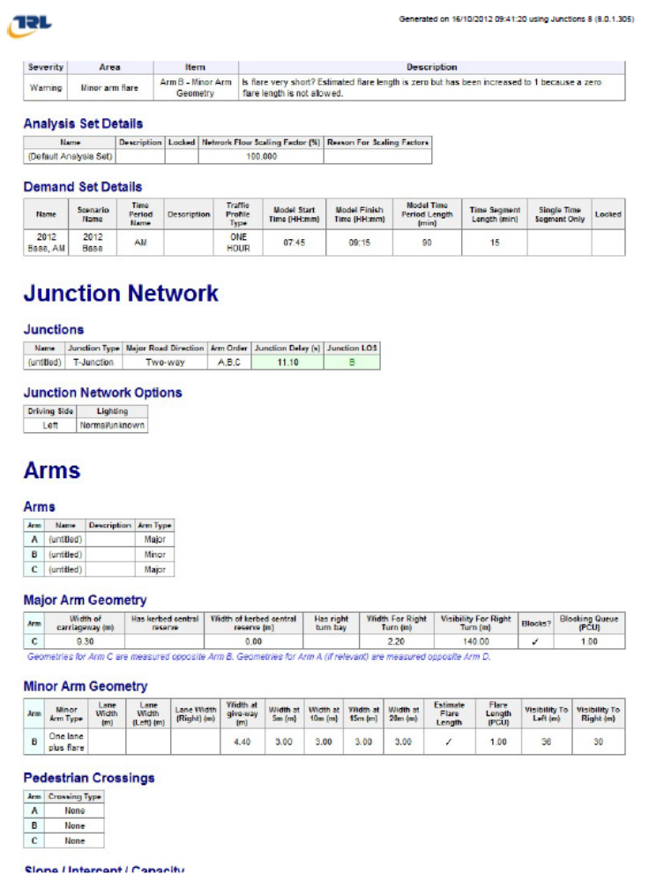

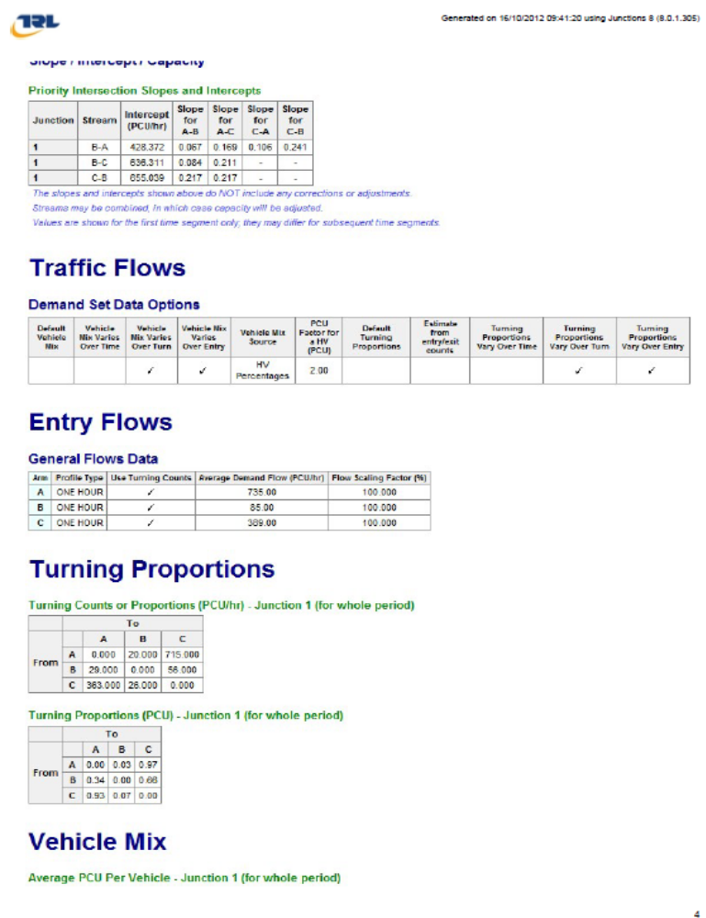

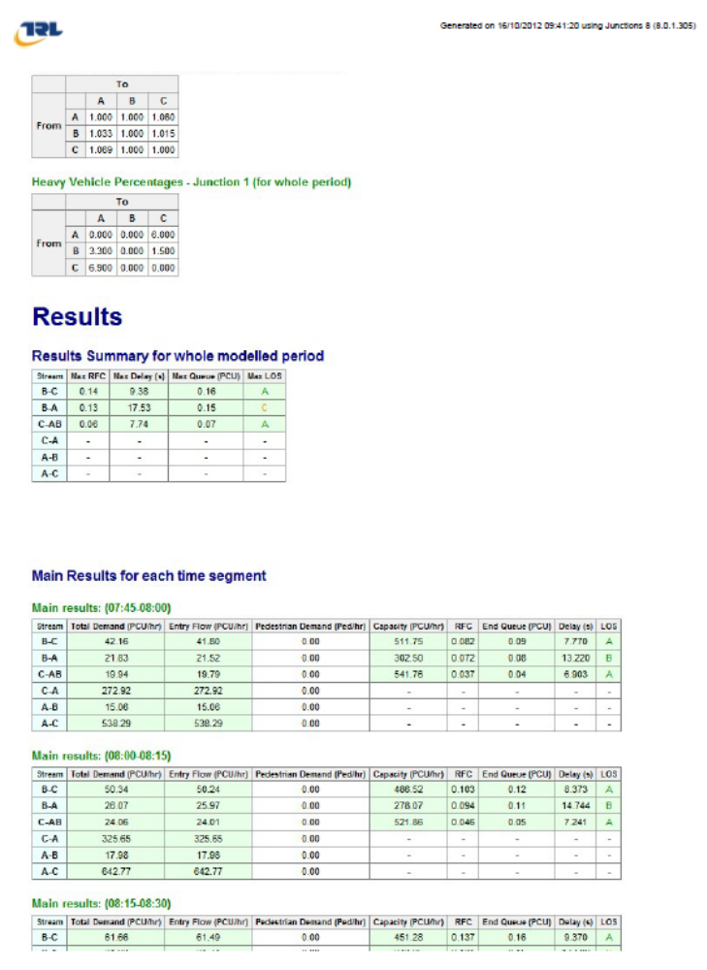
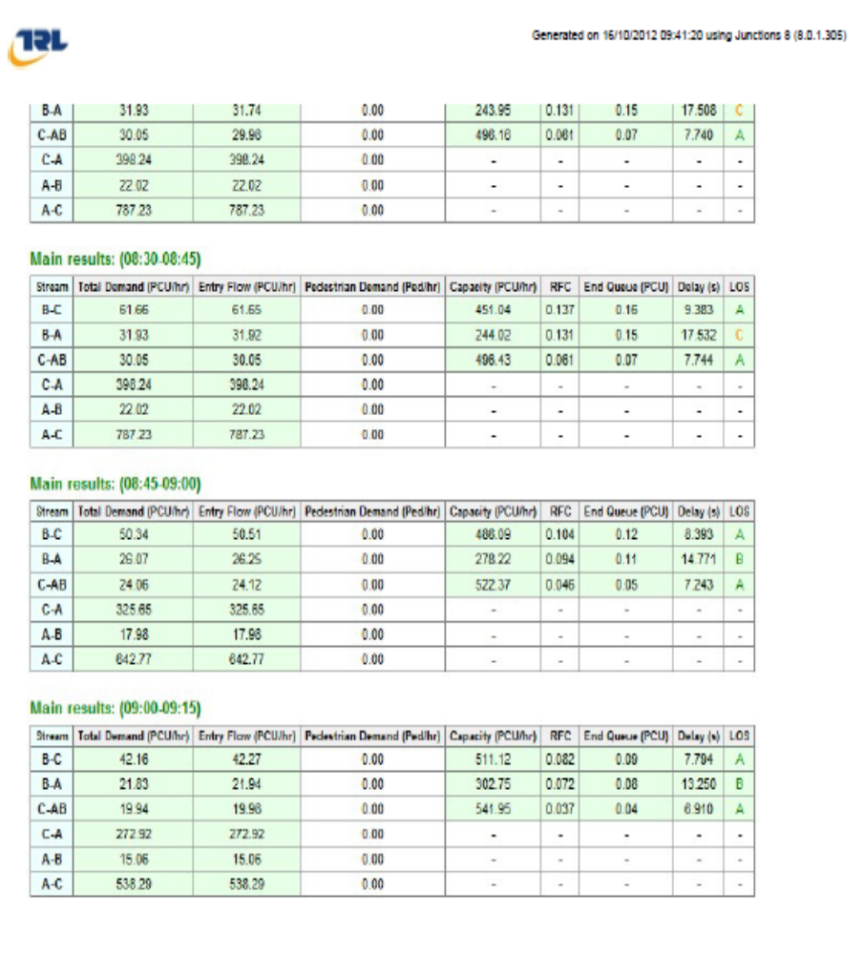

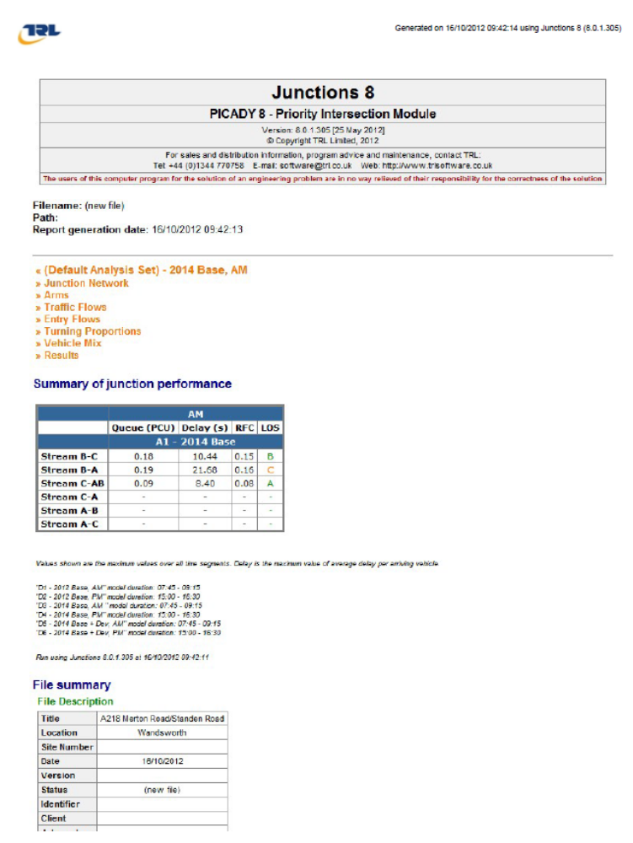
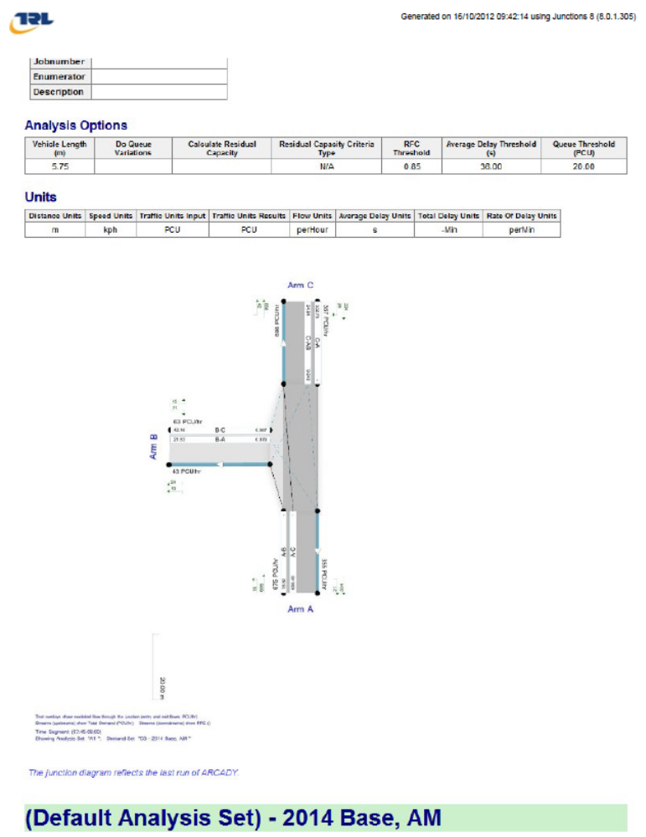

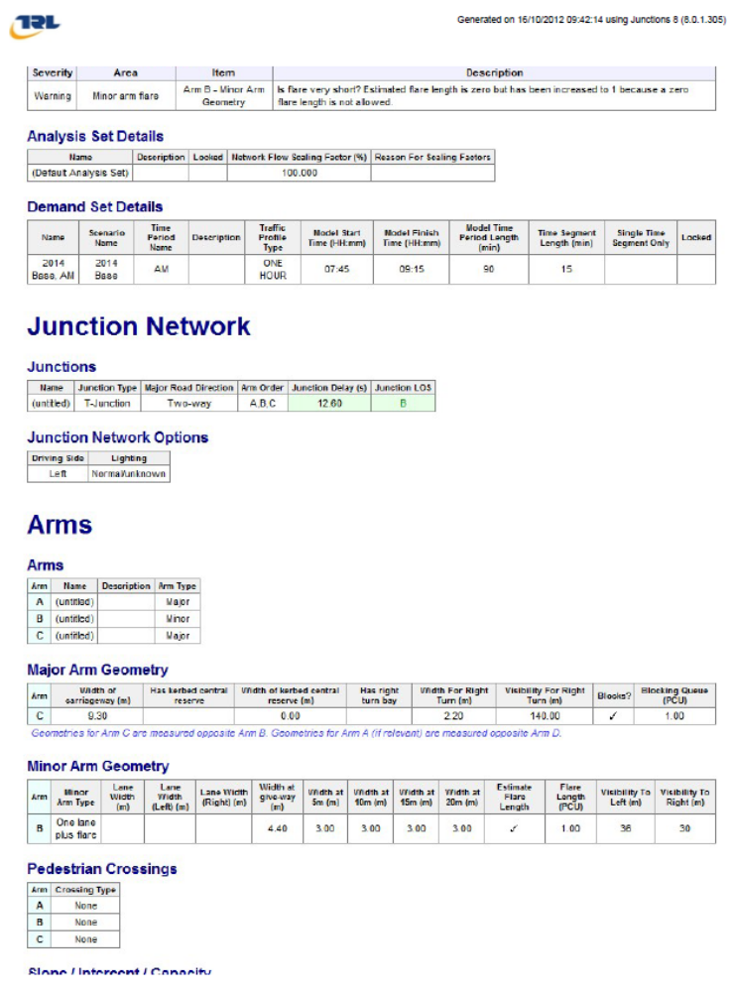
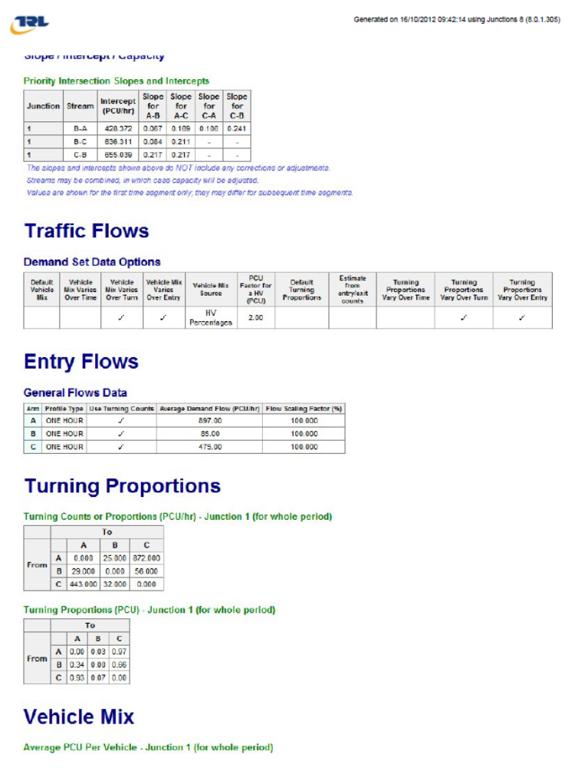
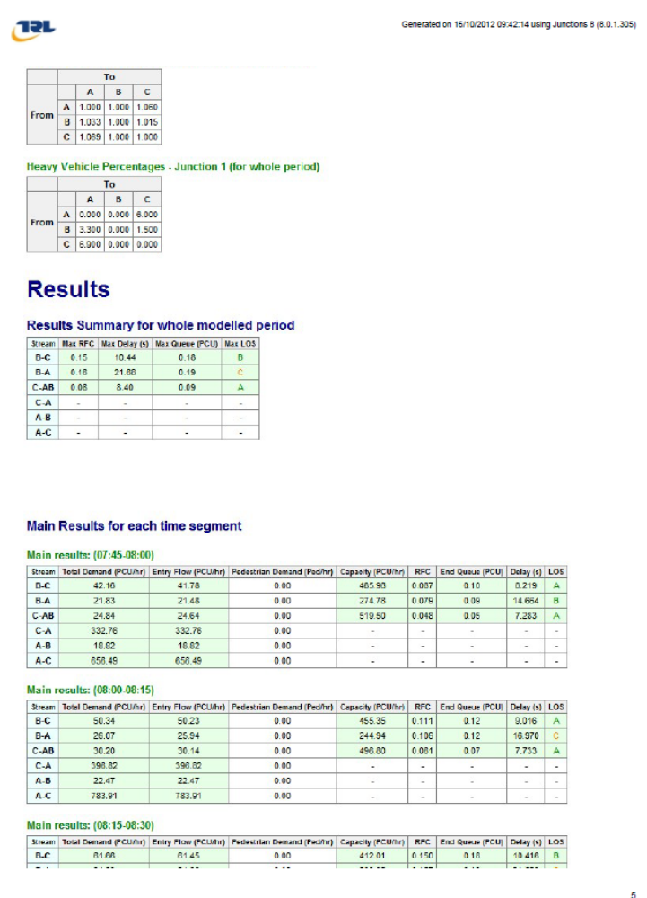

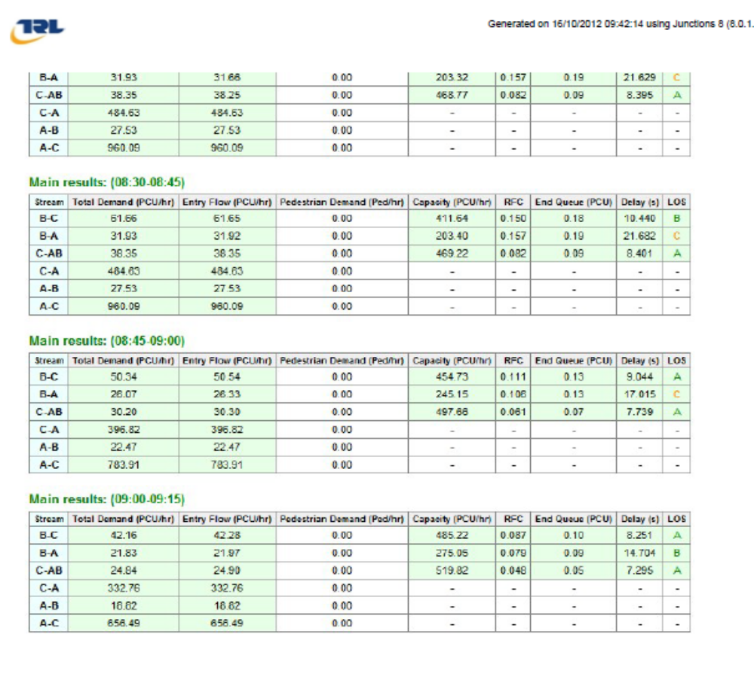

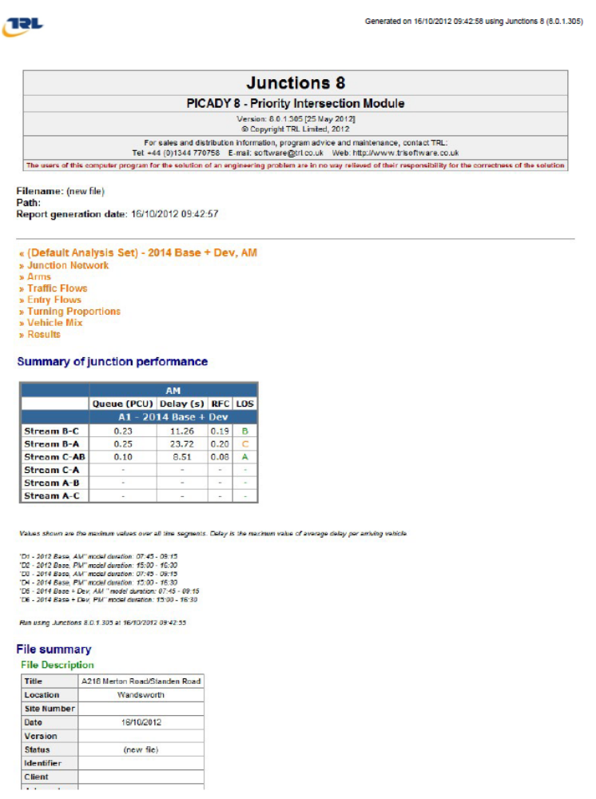

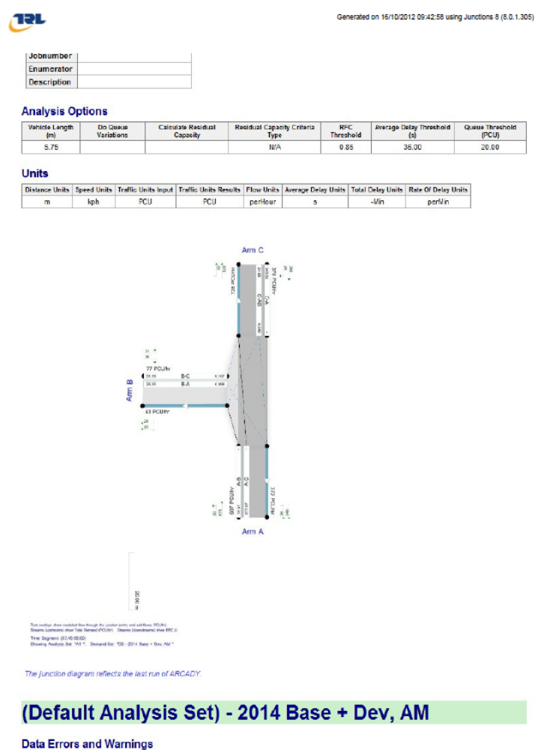
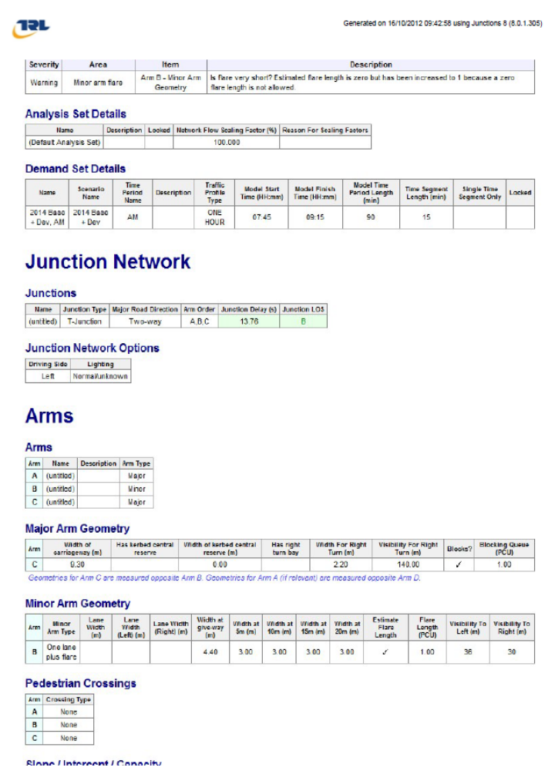

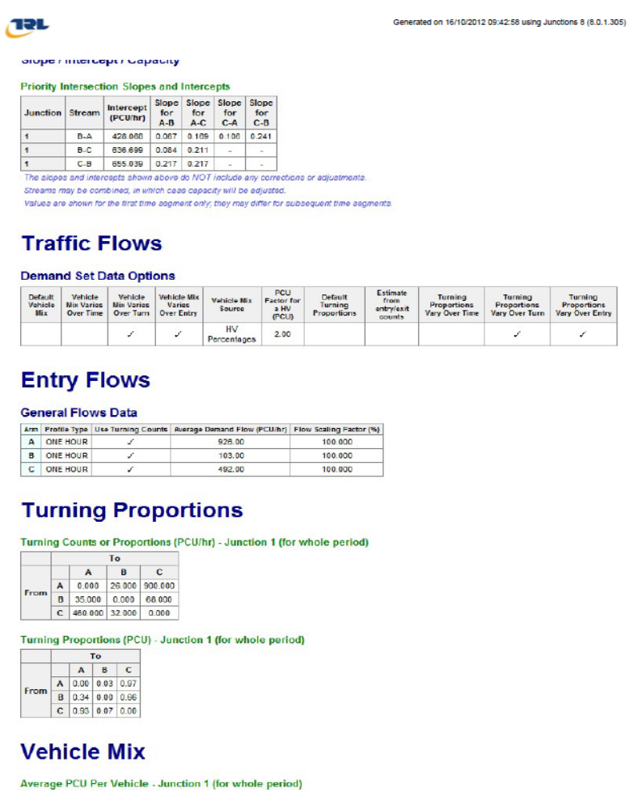

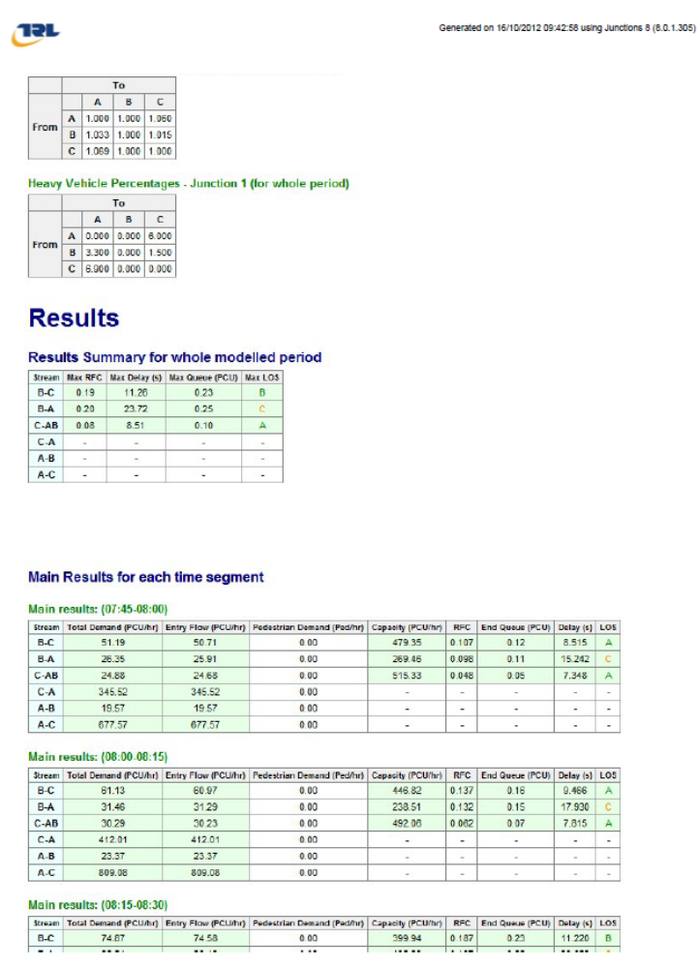

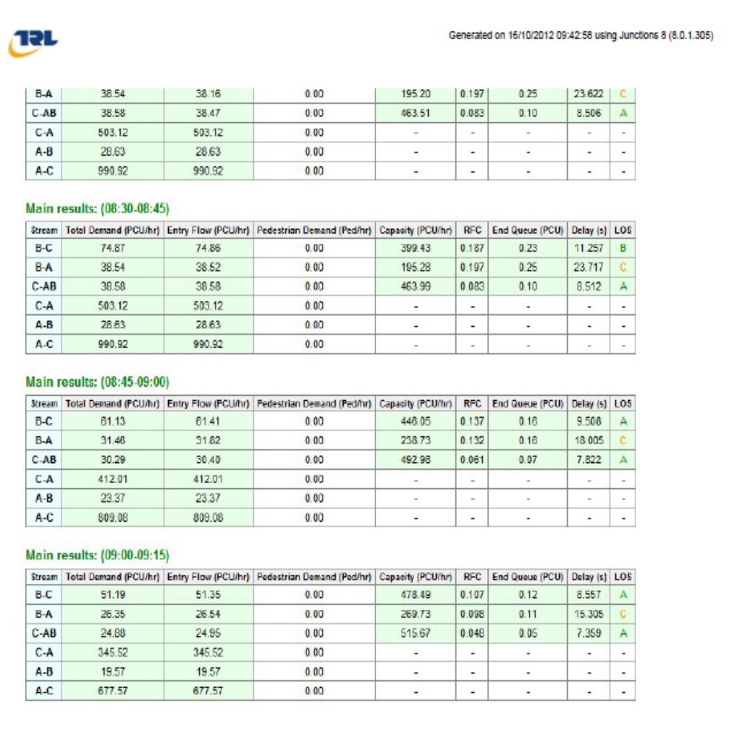

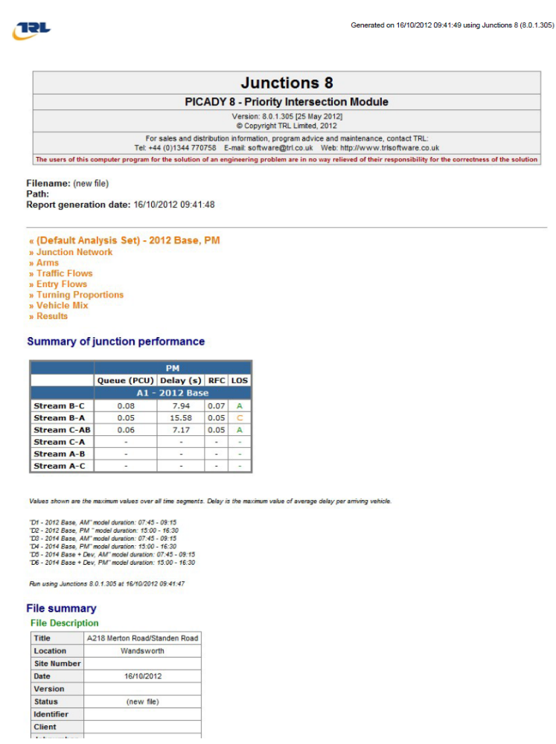

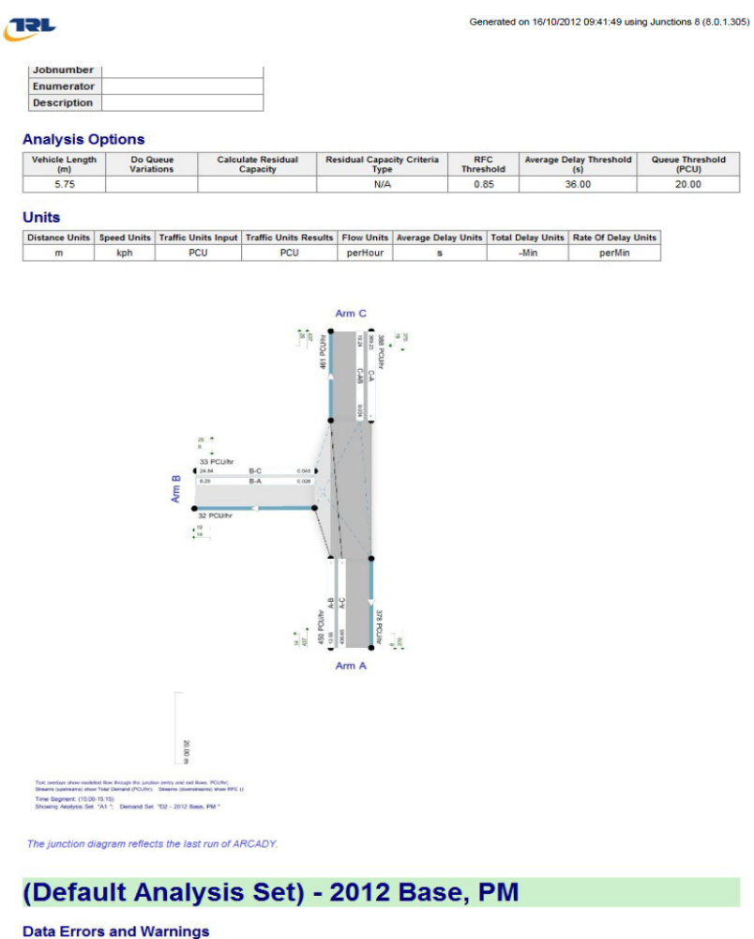

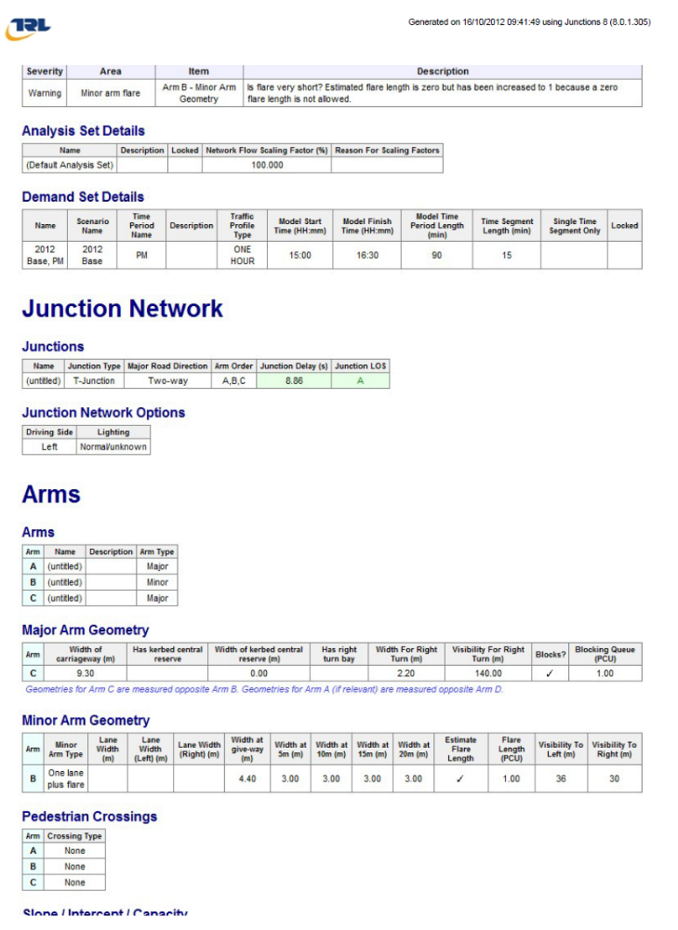
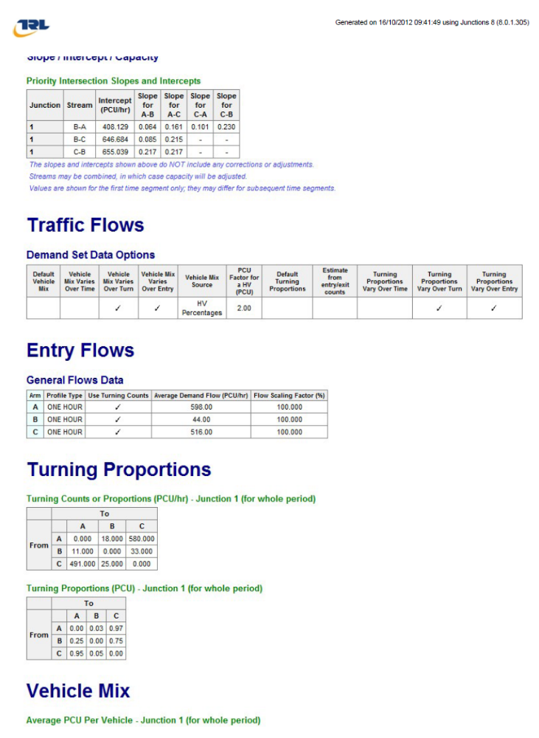
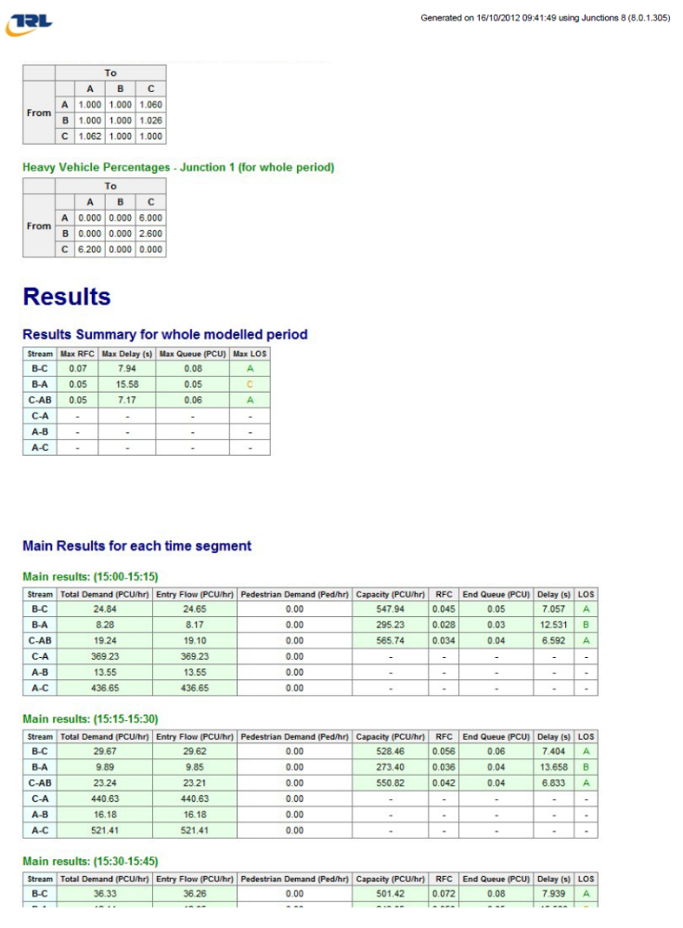
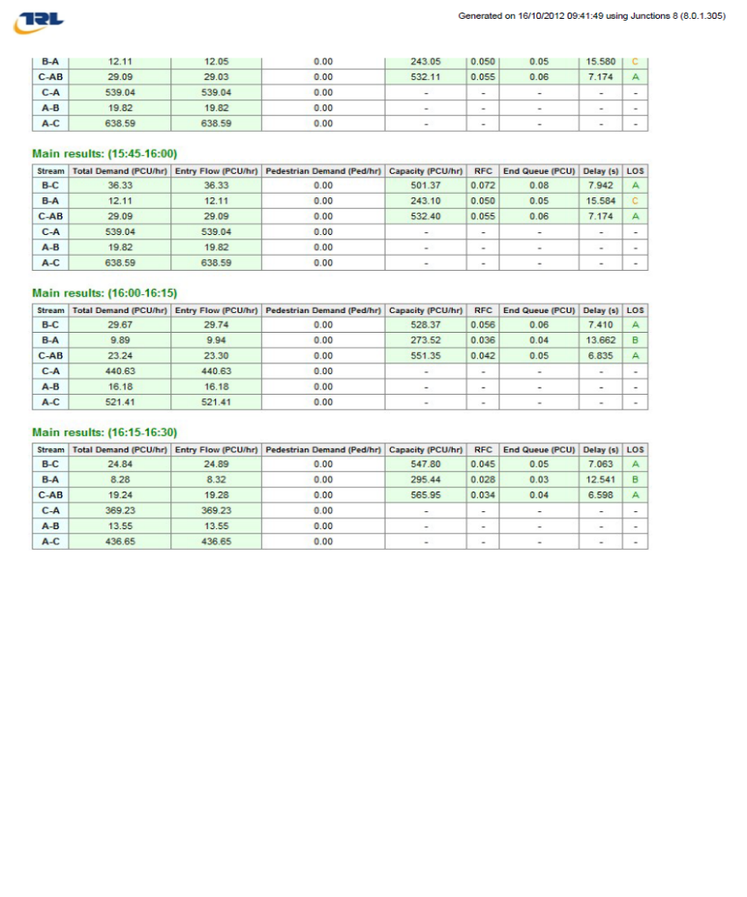

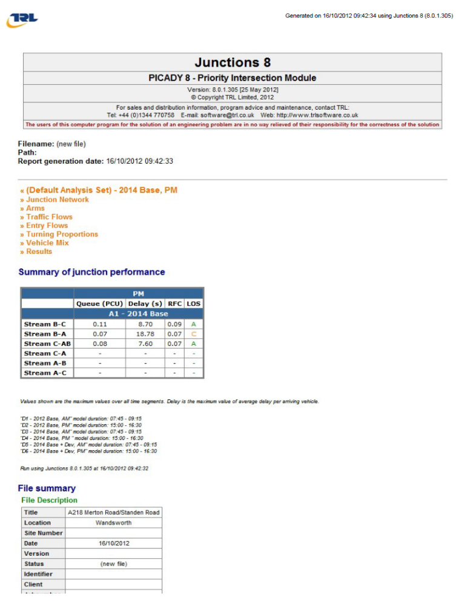
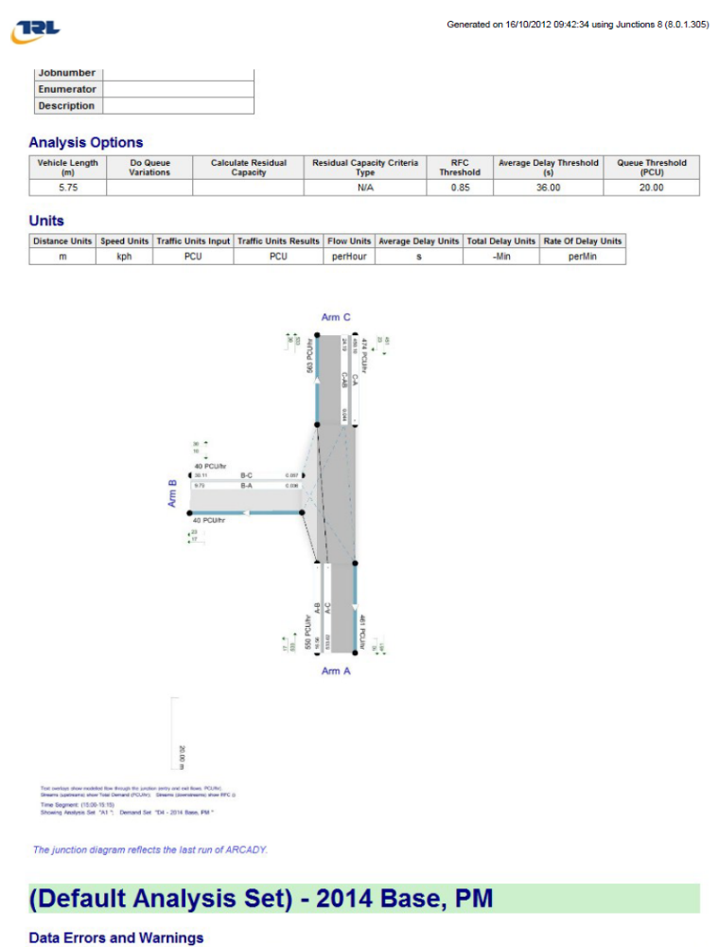

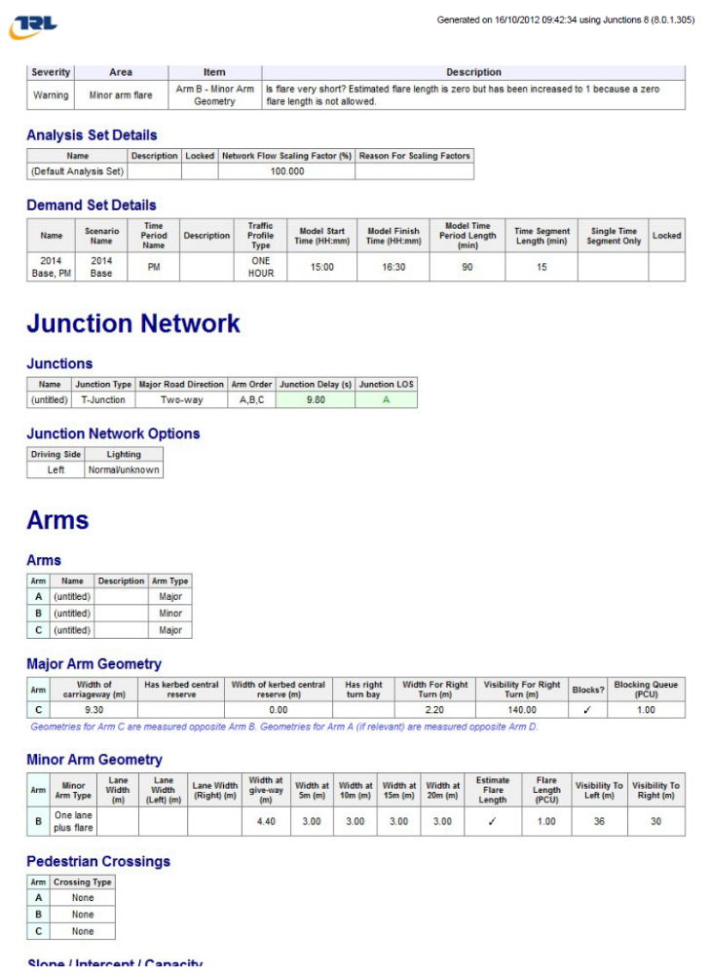
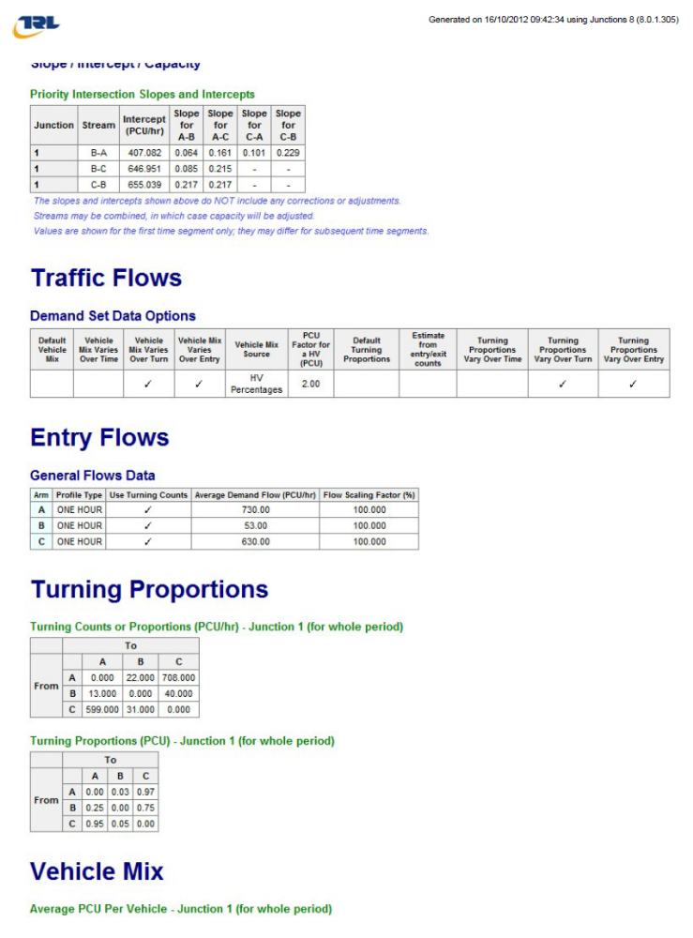
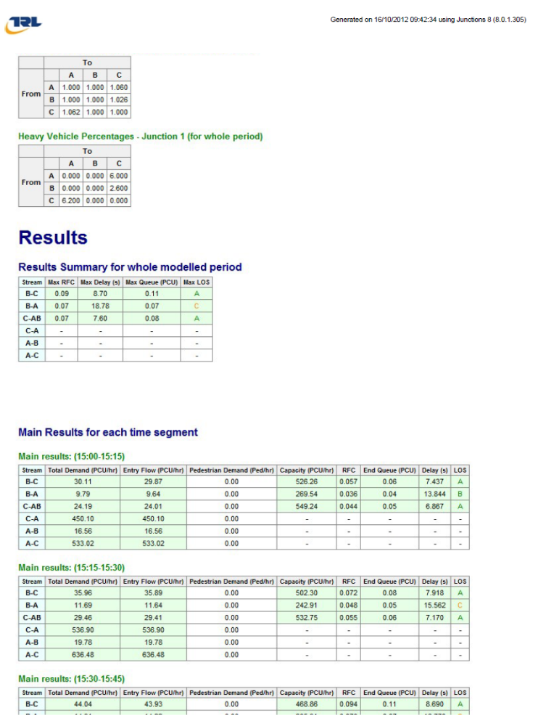

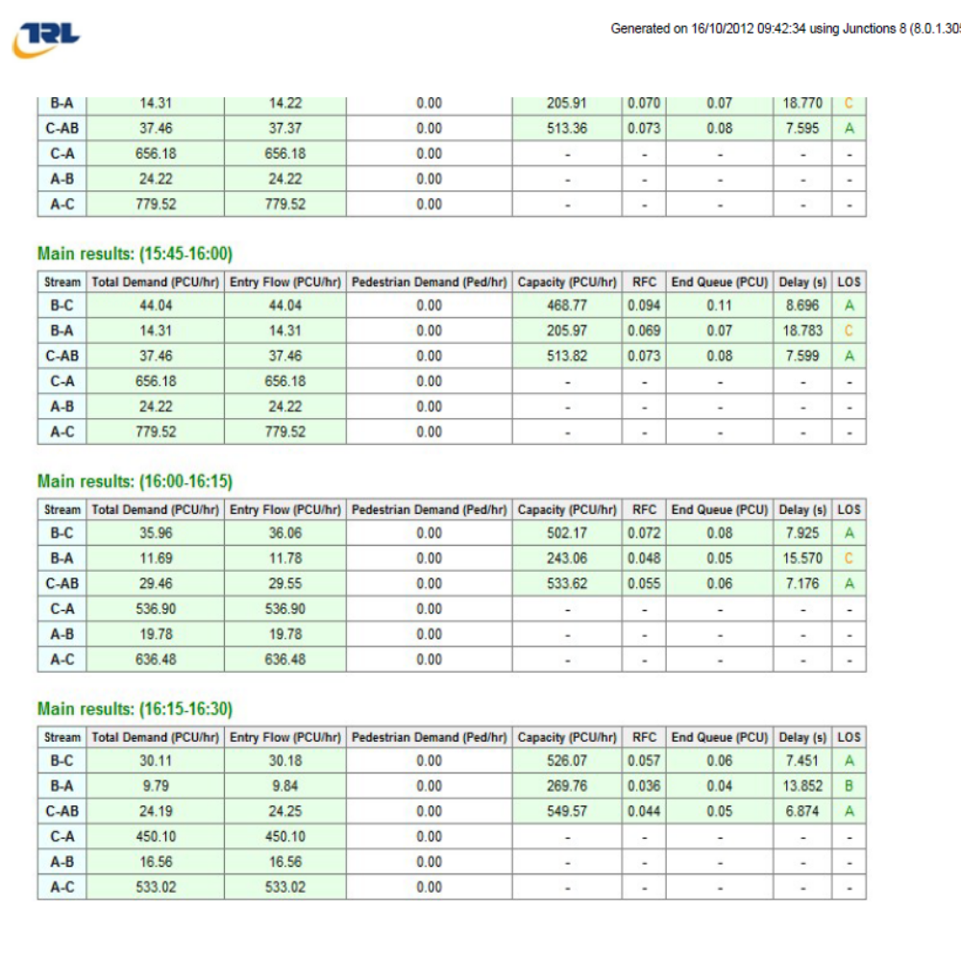

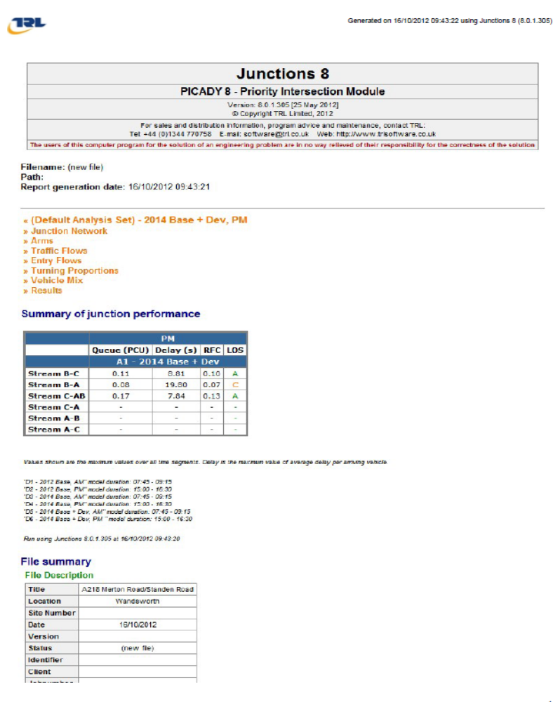

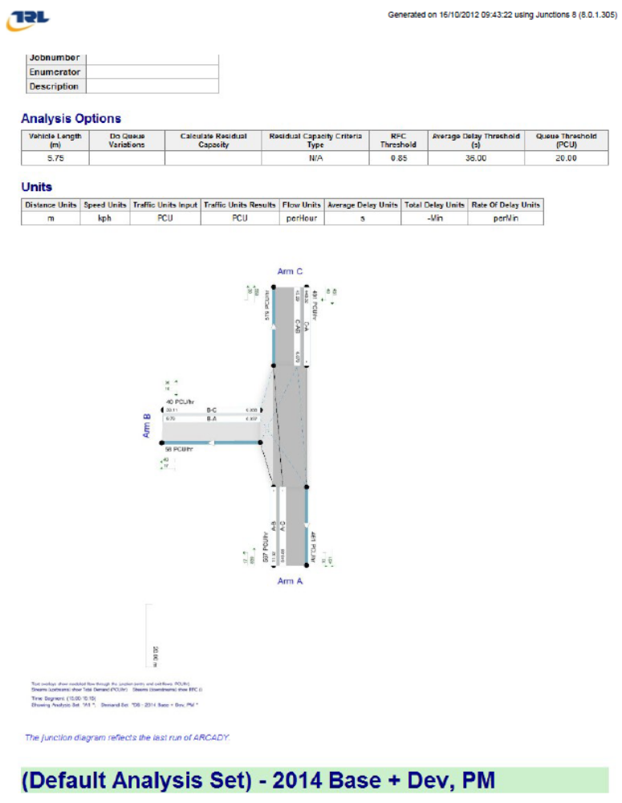
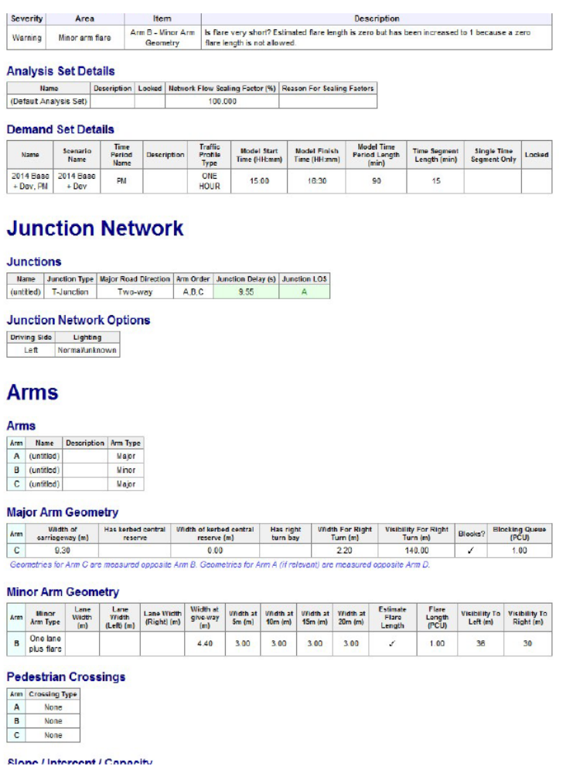

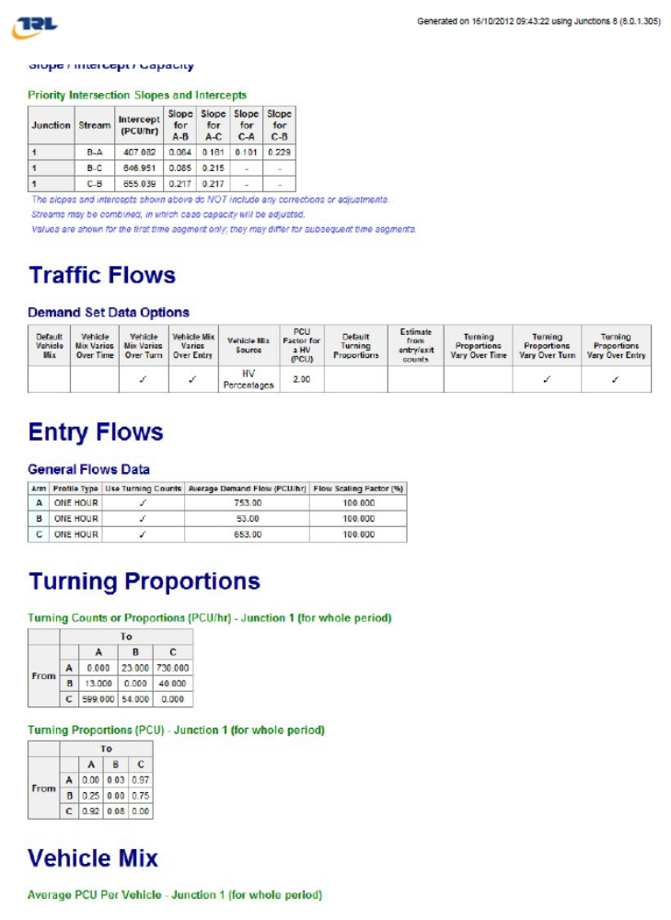
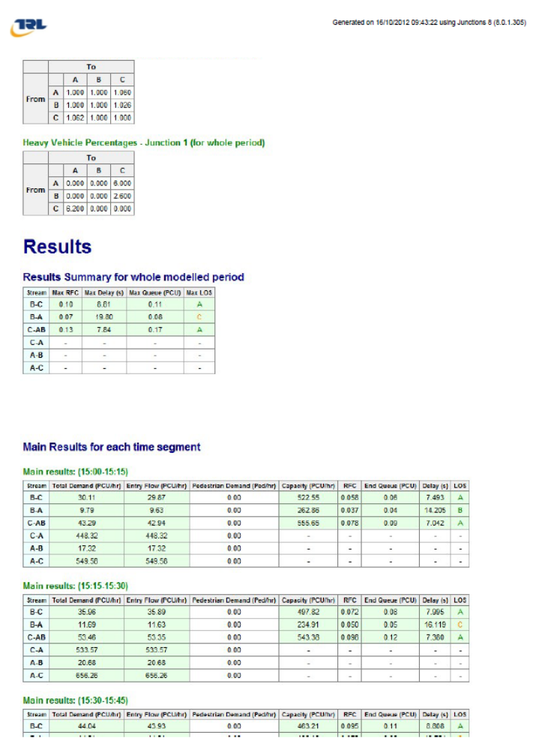

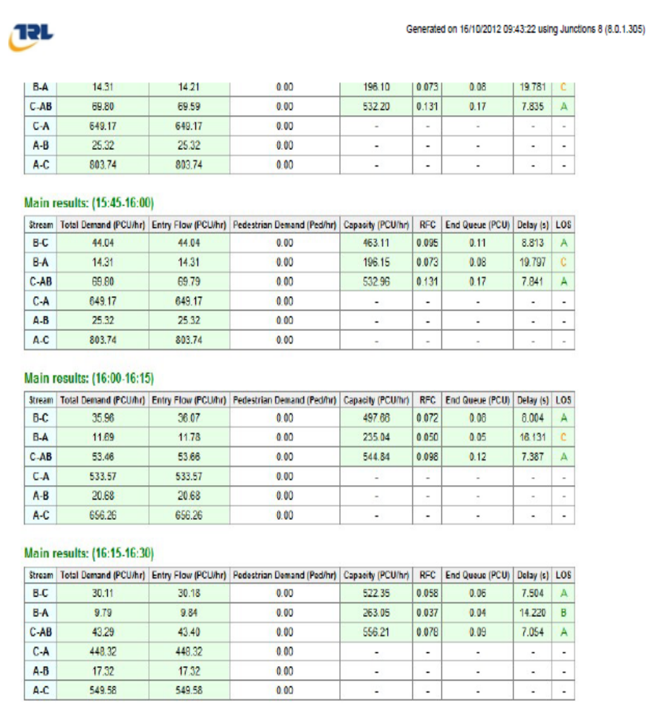

APPENDIX F – BUS TIMETABLE

